Introduction to D/A Conversion

Applications

- Multistep ADCs
- High-Resolution Displays
- Waveform Synthesis
- Complex Modulation Formats
- Instrumentation
- Storage of Analog Info in Digital Form

Basics

DAC
D
(m bits)
A

A = α D
D is dimensionless ➔ α sets both the full scale and the dimension of A.
Example: α = I_{REF} ➔ A = I_{REF} D
α = V_{REF} ➔ A = V_{REF} D
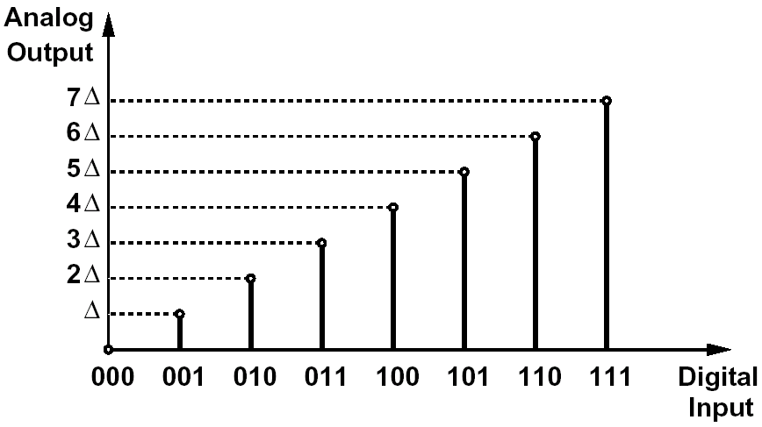
For voltages, it’s easier to generate fractions of V_{REF} rather than its multiples:
A = (V_{REF}/2^{m})* D

➔ D/A conversion can be viewed as a reference division or multip-lication function. The precision is determined by how accurately the reference is multiplied or subdivided, and the speed depends on how fast each level can be selected and established at the output.
Digital Codes

Four types of digital codes are frequently used in D/A and A/D converters
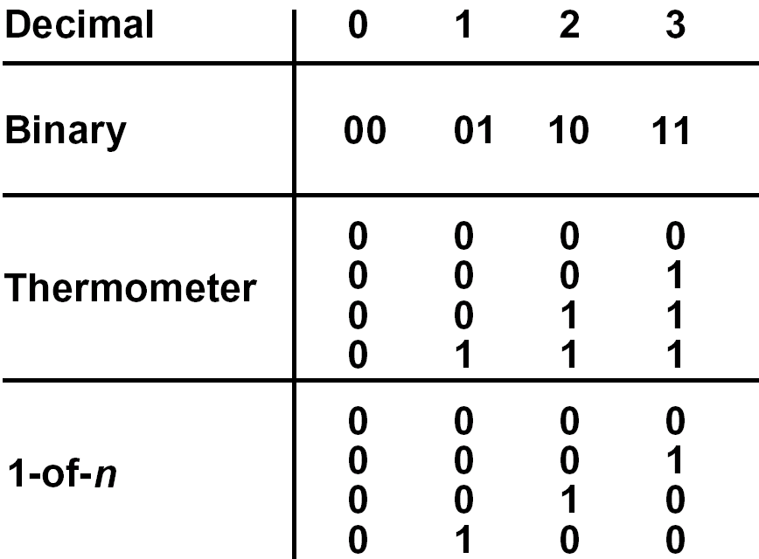

Thermometer and 1-of-n codes are not as compact as other codes, but they occur in many places.

Performance Metrics
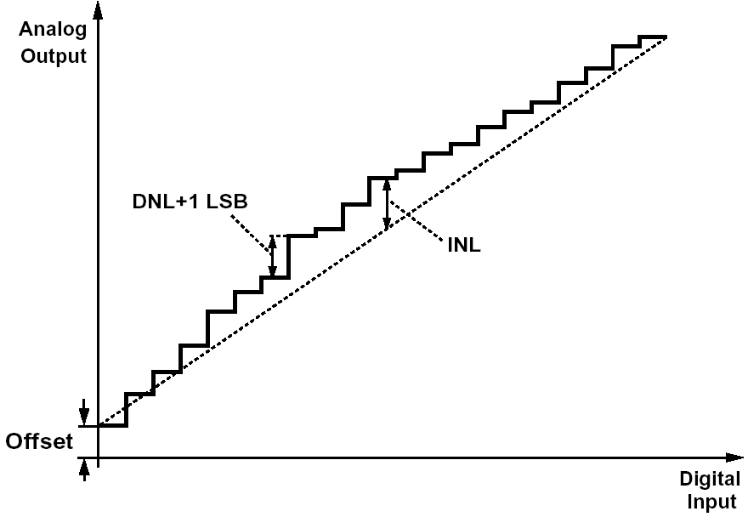
- Differential Nonlinearity (DNL) is the maximum deviation in the output step size from the ideal value of 1 LSB. = V_{FS}/2^{m}

- Integral Nonlinearity (INL) is the maximum deviation of the input/output characteristic from a straight line passed through its end points.
The difference between the characteristic and the straight line is called the INL profile.

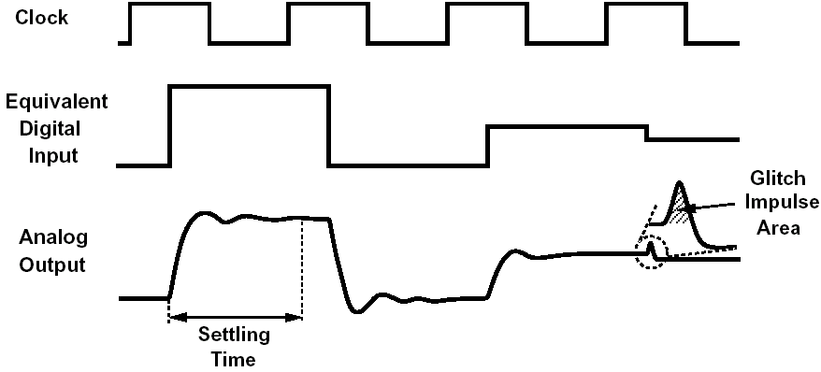
- Settling Time is the time required for the output to experience a full-scale transition and settle within a specified error band around its final value.

- Glitch Impulse Area is the maximum area under any extraneous glitch that appears at the output after the input code changes.

- SNDR is the ratio of the signal power to the total noise and harmonic distortion at the output when the input is a digital sinusoid.

DAC Analysis Procedure:

- Understand how a voltage, current, or charge reference can be divided or multiplied.

- Analyze the sources of nonlinearity (gradients, mismatches, ...).

- Analyze speed limitations.

Reference Division and Multiplication

Voltage Division

A simple m-bit DAC:
Vout
m bits
R
R
R
R
Vref
Vref/2
2^{m}R/4
V_{DD}
1-of-n code

- Need 2^{m} resistor segments. As m↑, either Thevenin resistance ↑ or power dissipation in the ladder must ↑.
- Resistor mismatch introduces DNL and INL.

Example: Linear Gradient
How to reduce this effect?

Effect of Random Mismatch:

R = (ρ L / w t) + 2R_{C}

How to find the total mismatch in R? Use total differential:
L
W
t
silicide

Nonlinearity due to Random Mismatch [Kuboki, TCAS, June 82]:

- Assume a probability density function for the value of each resistor;
- Find the PDF for each tap voltage;
- Calculate mean and standard deviation.

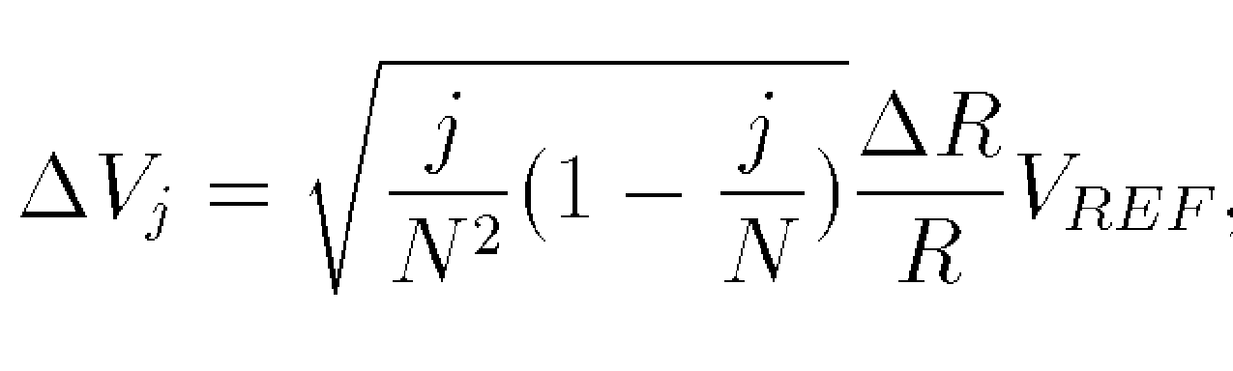
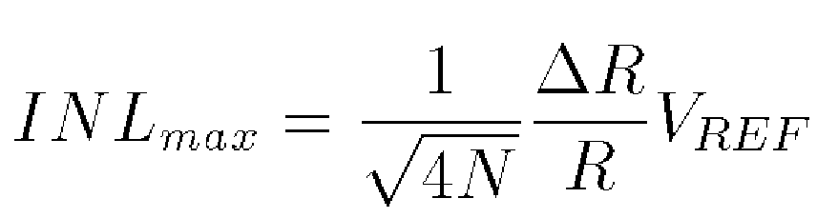

Important Conclusion: If ∆R/R remains constant, as N↑, ∆V_{j max} ↓.

- If express ∆V_{j max} in LSB:

This suggests that if we go from 8 bits to 10 bits, resistor matching must improve by a factor of 2 (rather than 4).

This trend exists any time a large number of random variables are added to each other.

Current Division & Multiplication

Division:
Uniform Binary
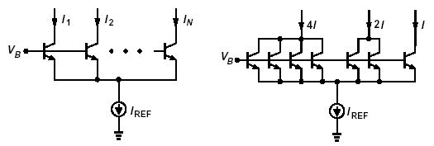

- I_{REF} consumes voltage headroom.
- I_{REF} requires a very large device.

Multiplication:
I_{out}
I1
I2
Iref
“Current-steering
DAC”

Binary & Segmented Arrays

Segmented Binary
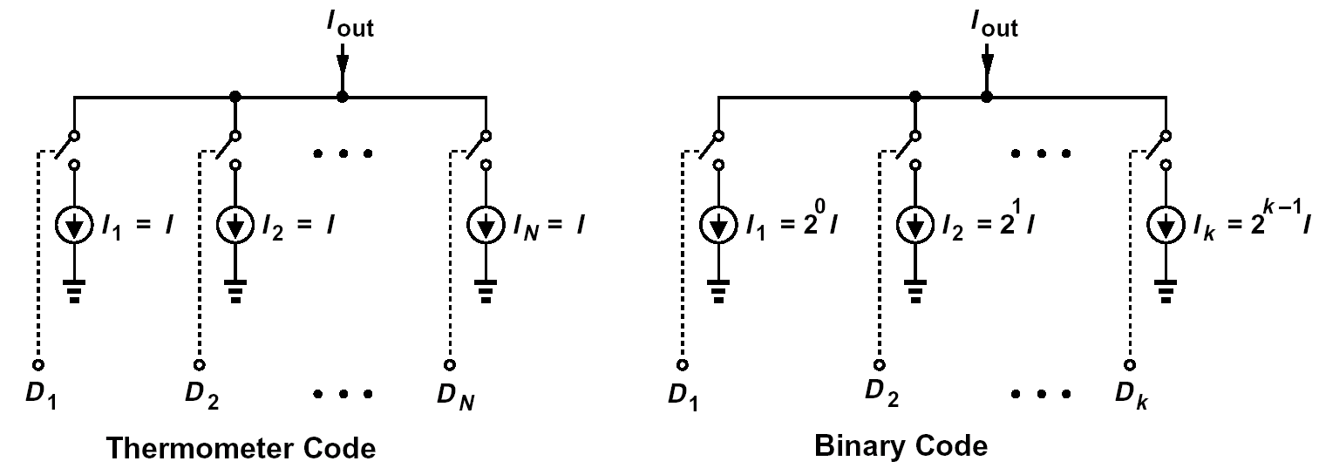

- Segmented arrays are unconditionally monotonic.
- Segmented arrays have much less glitch impulse than binary arrays.
- But, binary arrays require no decoding.

Current-to-Voltage Conversion
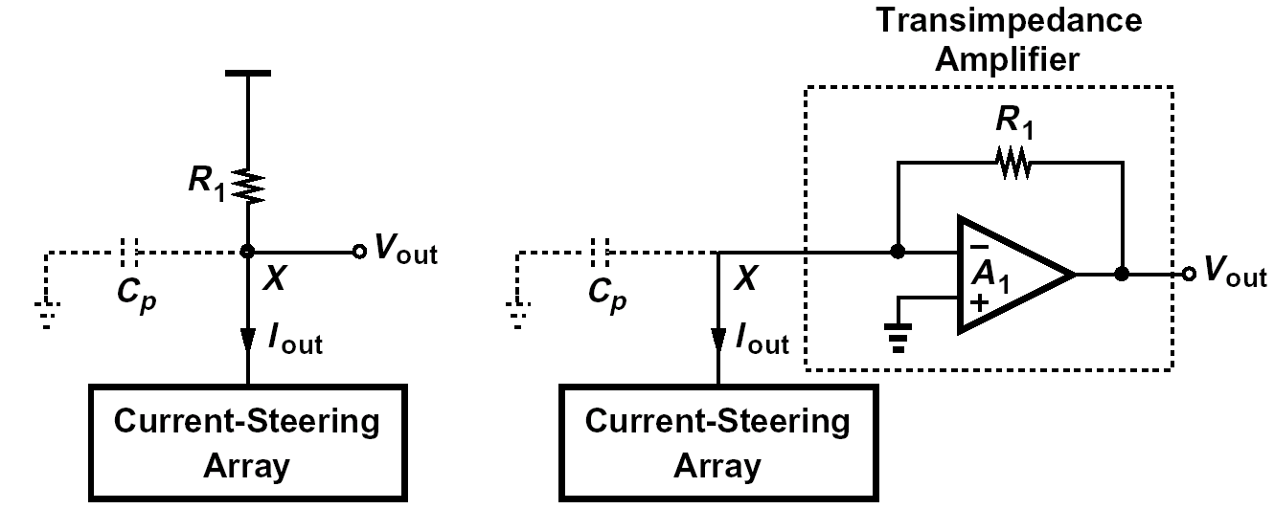

- Difficult to design a high-speed amplifier that can drive a 50 Ω load, especially at low supply voltages.
--> The simple resistive load is much more common if DAC is to drive off-chip loads.
- Often need to use PMOS implementations:

- Sources of Nonlinearity:

- Current Source Mismatch
- Finite Output Impedance of Current Cells
- Nonlinearity of Load Resistor

1. Current Source Mismatch:
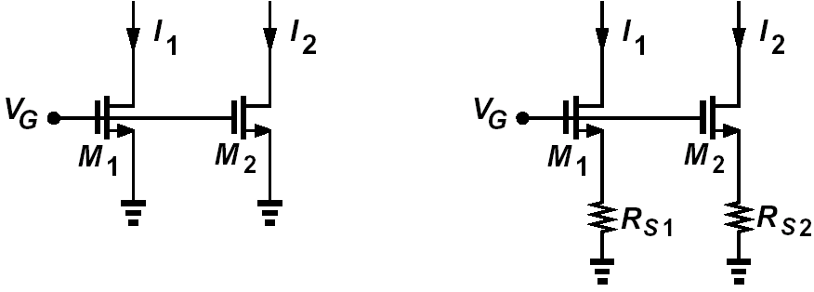
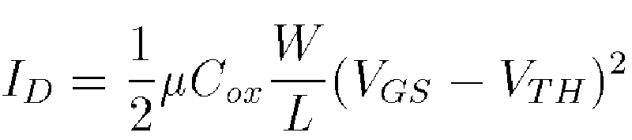
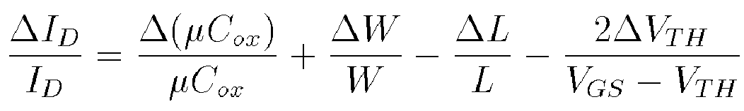
- Trade-off between headroom and mismatch

Resistive degeneration rarely used for MOS current sources (why?)

How about short-channel devices?
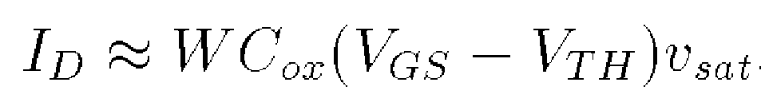
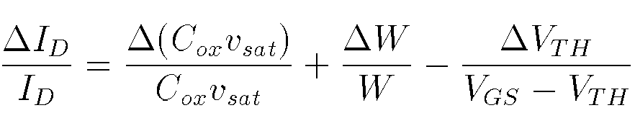

2. Finite Output Impedance of Current Cells:
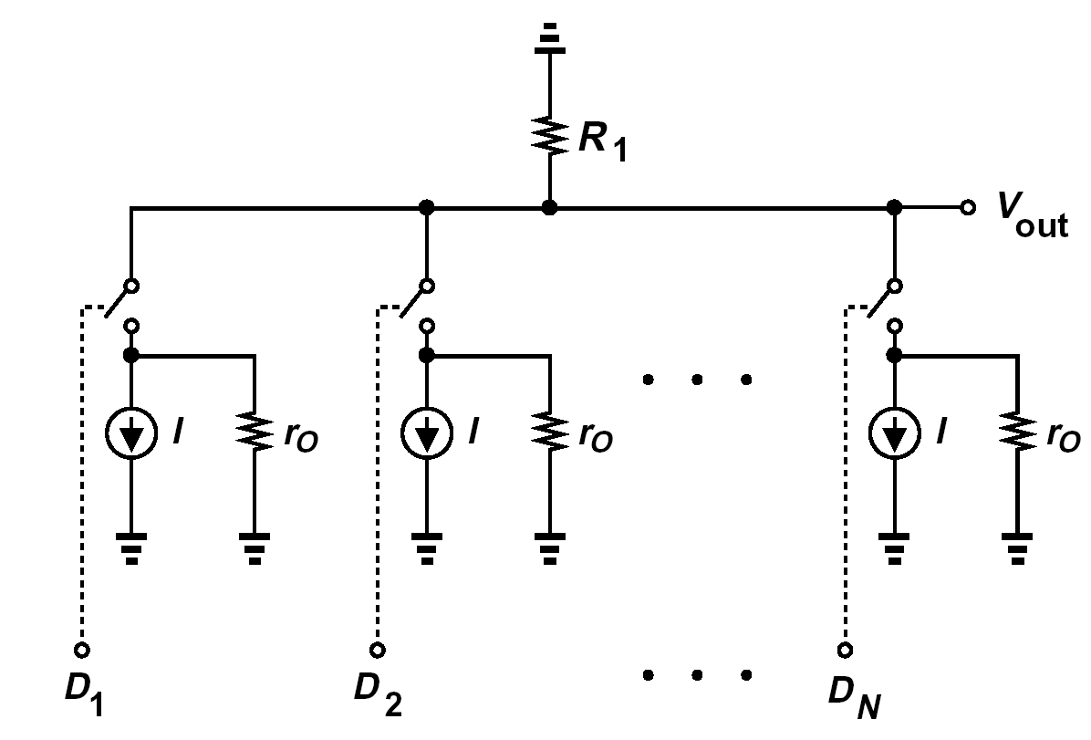
If j current sources are switched to output:

The end points are:

That is,
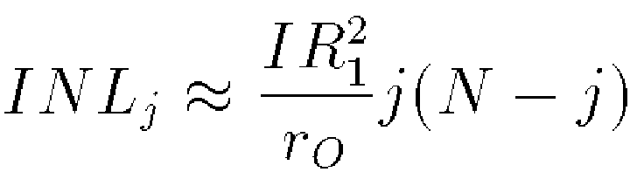
and relative INL is:

For example, for 10 bit linearity, relative INLmax < 0.1%
R₁ = 50Ω, N = 1024 --> 50 Ω*10³ / (4 r_{o}) < 10⁻³ --> r_{o} > 55 Ω*10⁶ / 4

Charge Division

Simple but Impractical:
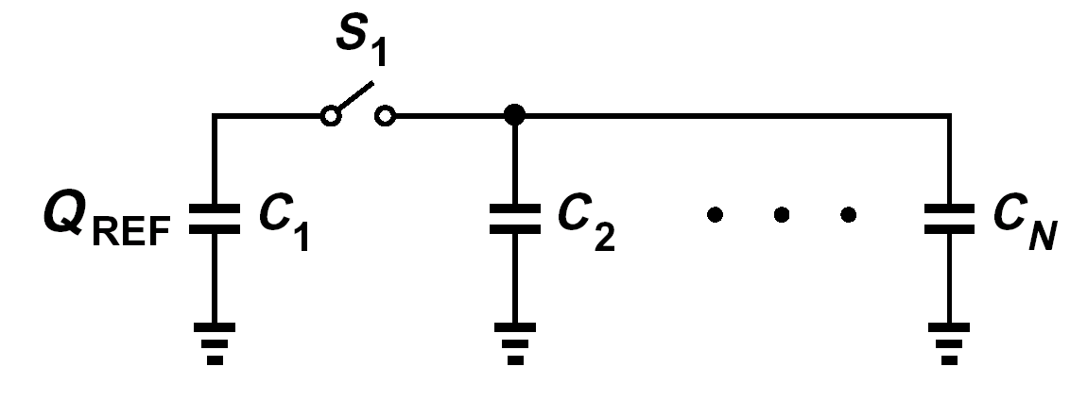

(Nonlinear relationship between Q and Vout)
Practical Implementation:
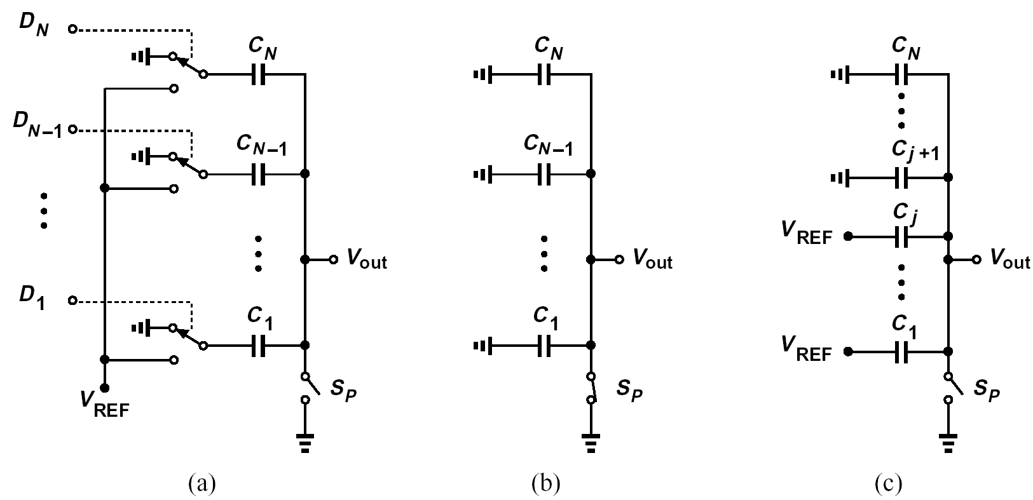
- Usually add another C from output to GND.
4C
2C
C
C
8C
Vout
Vref
0

Segmented Array:

Vref
Vref
Vref
Vref
C
C
C
C
Thermometer Code
Vout
Reset switch

- DNL is small; only one cap is added from one code to next.
- Unconditionally monotonic

Sources of Nonlinearity
- Capacitor Mismatch
- Capacitor Nonlinearity
- Nonlinearity of Junction Cap. of Reset switch

1. Capacitor Mismatch
C = W*L*ε/t_{ox}
L
W
tox

∆C/C = ∆W/W + ∆L/L - ∆t_{ox}/t_{ox}

How to choose W and L?

To calculate the INL due to cap. mismatch, we follow the procedure for resistor ladders. For segmented arrays, the results are identical. For binary arrays, it becomes complicated because of cross correlations => may have to resort to simulations.

2. Capacitor Nonlinearity

In modern technologies, capacitor nonlinearity is only due to voltage dependence of the dielectric constant. It is quite small.

Usually build the cap and measure its variation with voltage first. Then, represent as
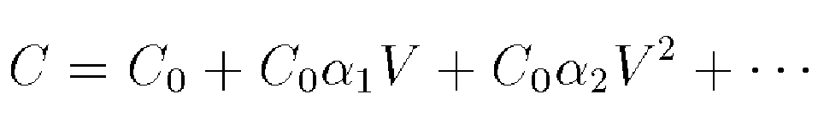

Important Note:
Q(V) ≠ C(V) V for a nonlinear cap.

Rather:
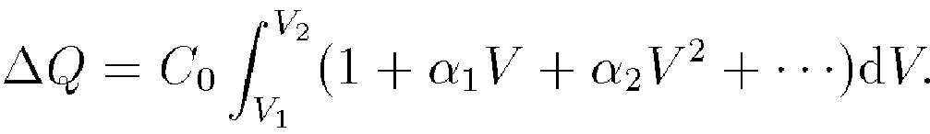
- Example: Nonlinearity in a segmented DAC:
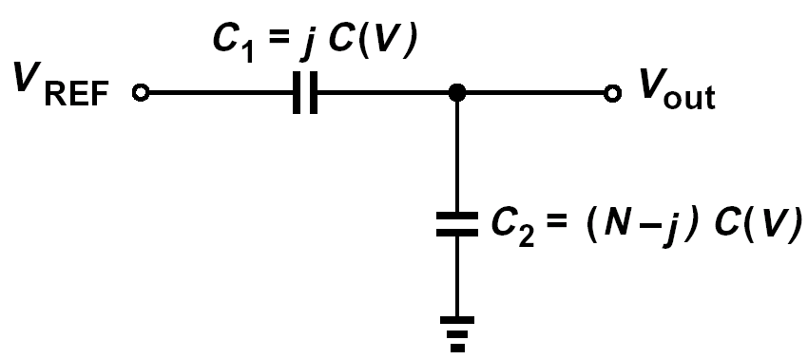

The charge on C₁ must equal that on C₂:
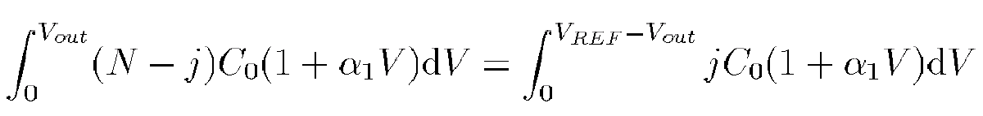

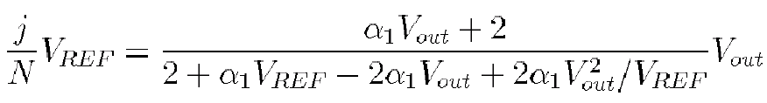

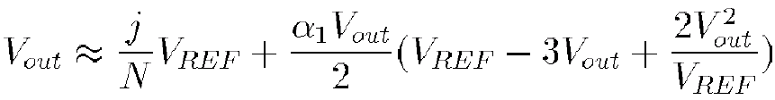
Thus, the maximum INL occurs at:

3. Switch Junction Cap. Nonlinearity
Reset
Vout

Can approximate this with a polynomial and proceed as before.

How wide should the switch be?

Problem of Top Plate Parasitic

Nonlinearity or gain error?
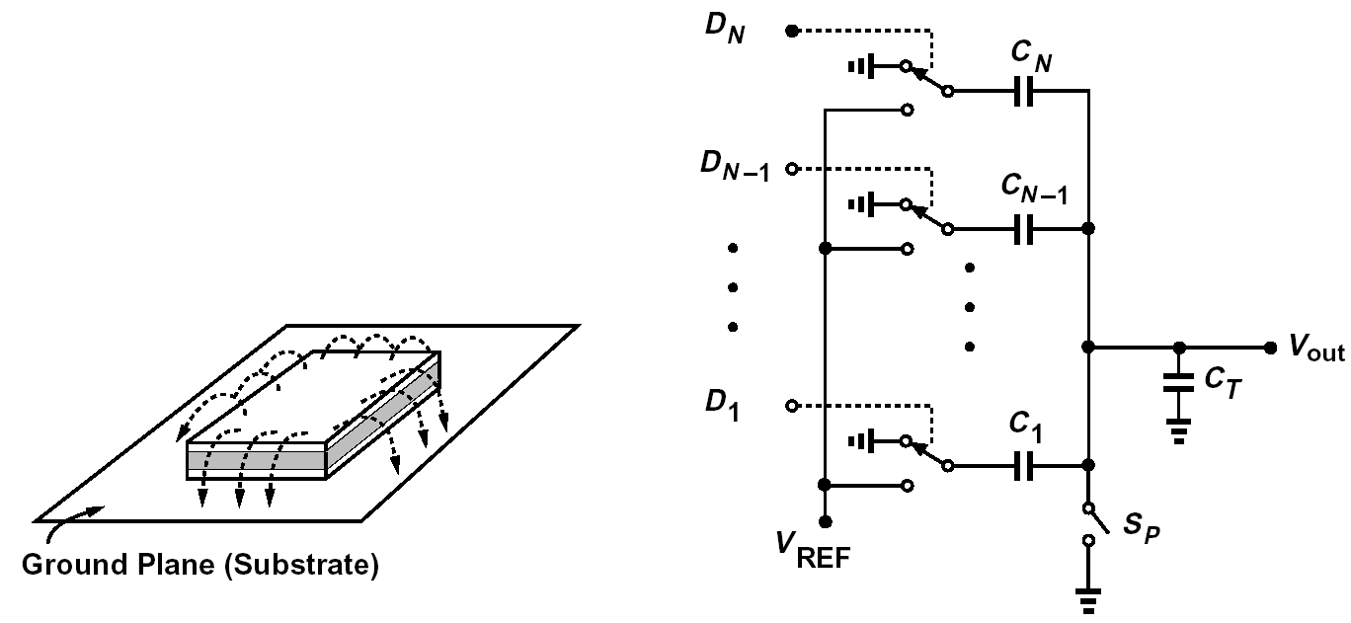

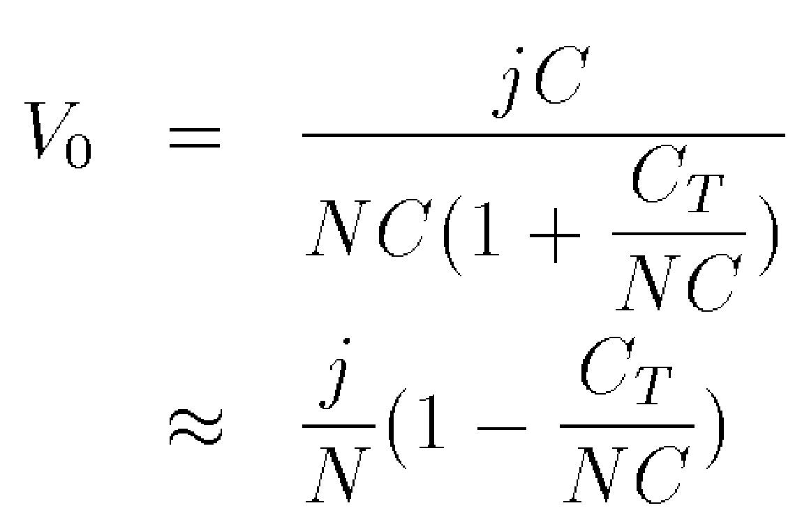

How to reduce this effect?

Switching Functions in DACs

Resistor-Ladder DACs
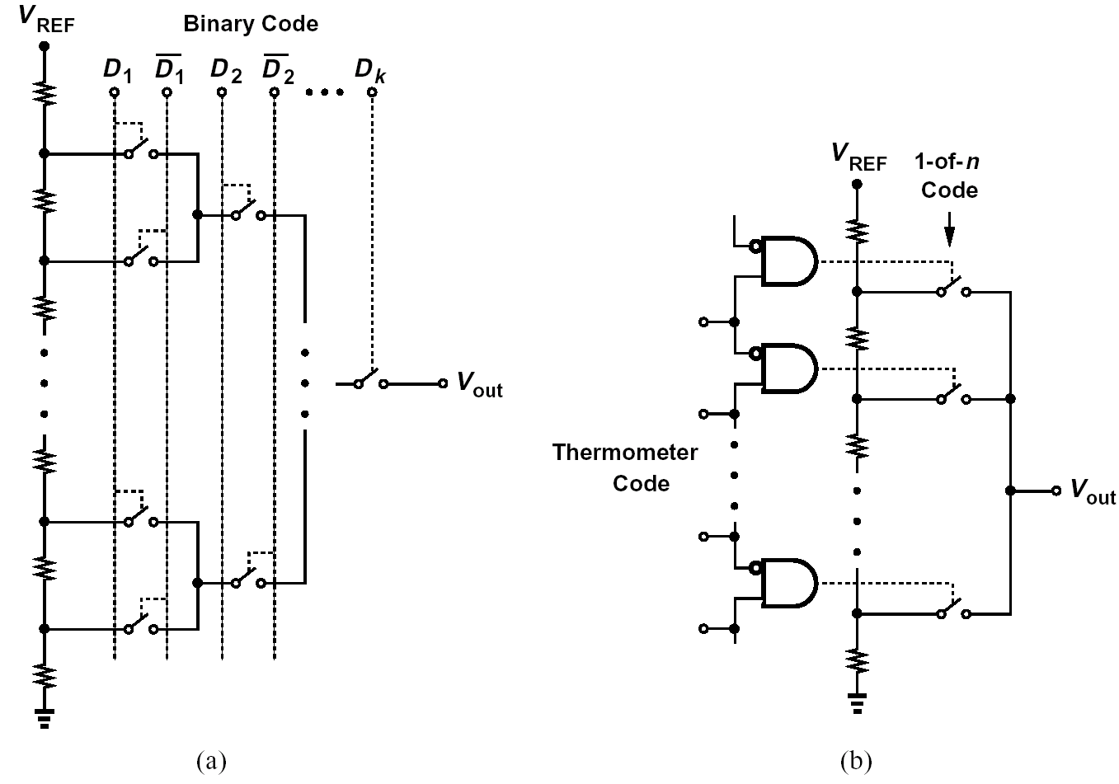

(Not capable of driving resistive load)
How do the speeds compare?

- Need to use complementary switches if the output voltage range is comparable with gate-source overdrive.

Current-Steering DACs
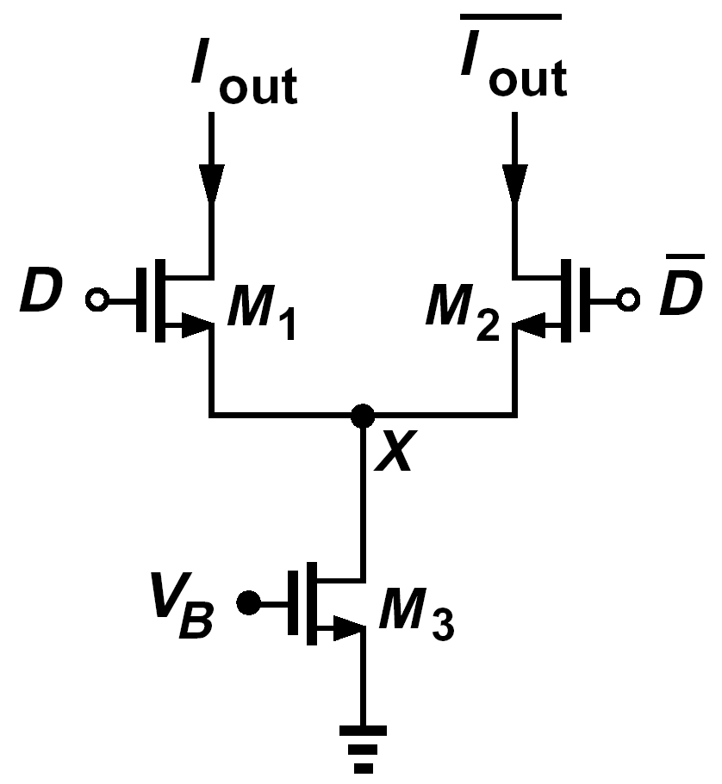
- Need relative large data swings to ensure complete switching.
- Primary Trade-offs: Need to maximize (V_{GS} - V_{TH})₃ to improve matching => headroom is limited. D & D_b cannot go all the way to positive supply if M₁ & M₂ are to remain in saturation with maximum output swing.

Conclusion: Current-steering DACs have limited output voltage swings, but they can drive resistive loads directly. In contrast, resistor or capacitor DACs can provide rail-to-rail swings, but they cannot drive resistive or capacitive loads efficiently.

Capacitor DACs
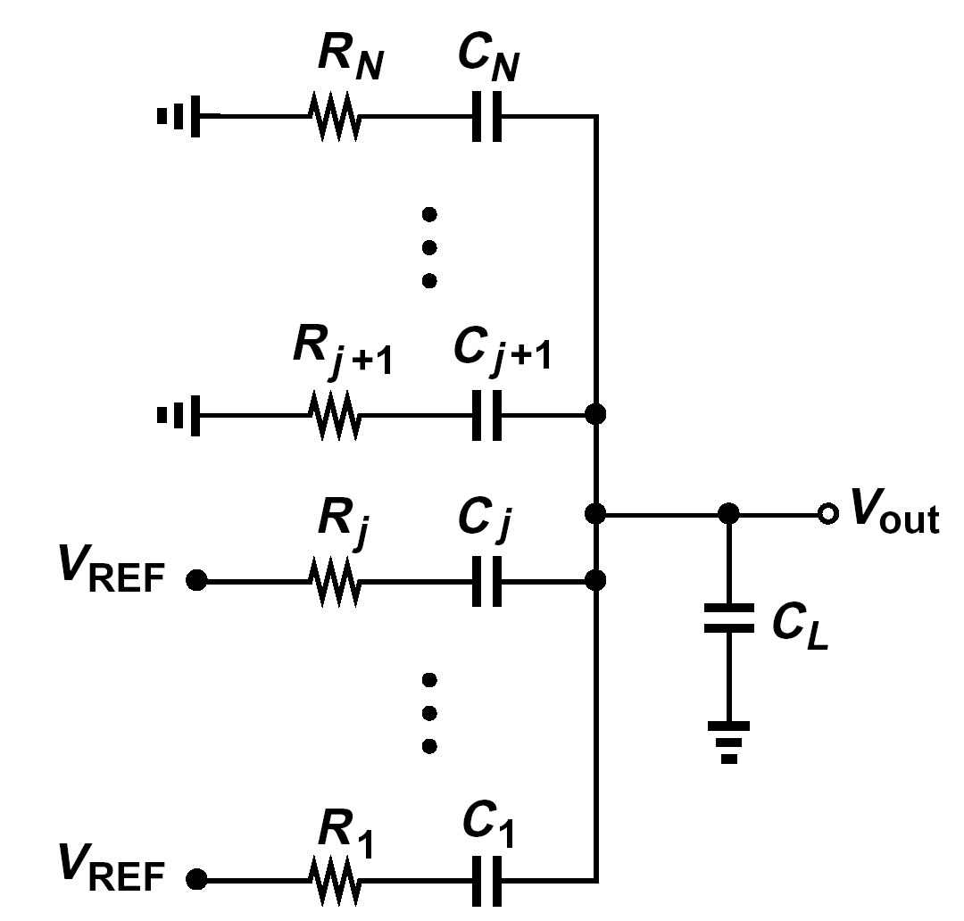

- Intrinsic speed is very high.
What limits the speed here?

Binary-Thermometer Code Conversion

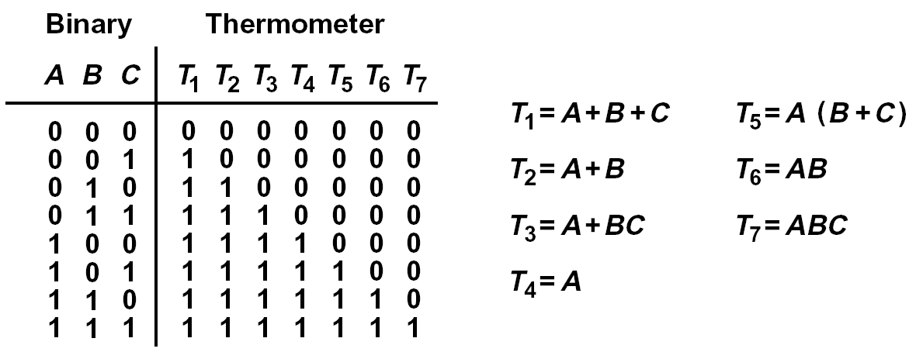

DAC Architectures

Ladder with Switched Subdivider
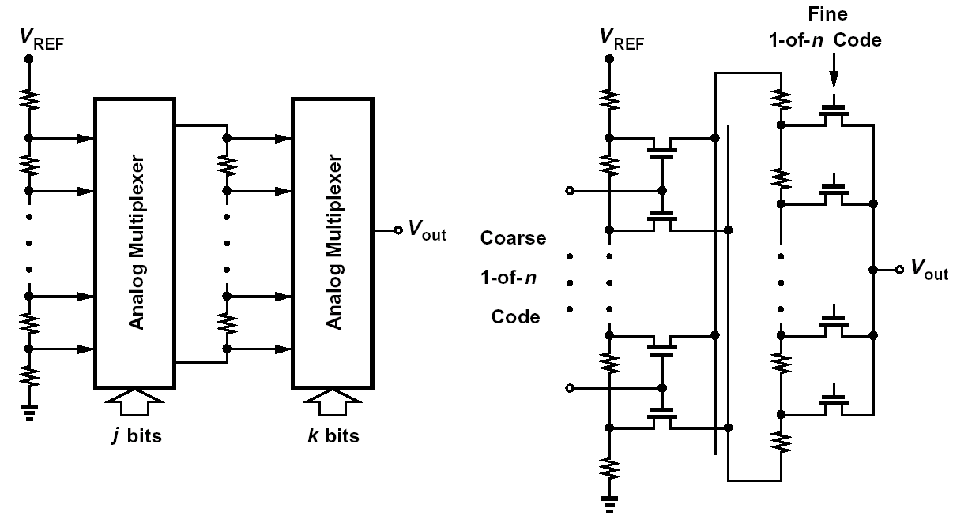

- The on-resistance of switches introduces differential nonlinearity; R_{on} must be much less than R_{U2}.
- The loading of secondary ladder upon the first causes DNL; R_{u1} must be much less than R_{U2}.
- Long settling time because the entire secondary ladder along with its capacitance moves up and down.

Intermeshed Ladders

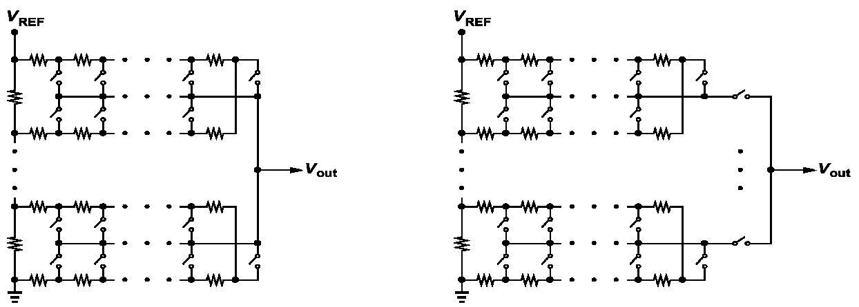
Can precharge nodes for faster settling.

Current-Steering Architectures
1. Fully-Segmented Architecture
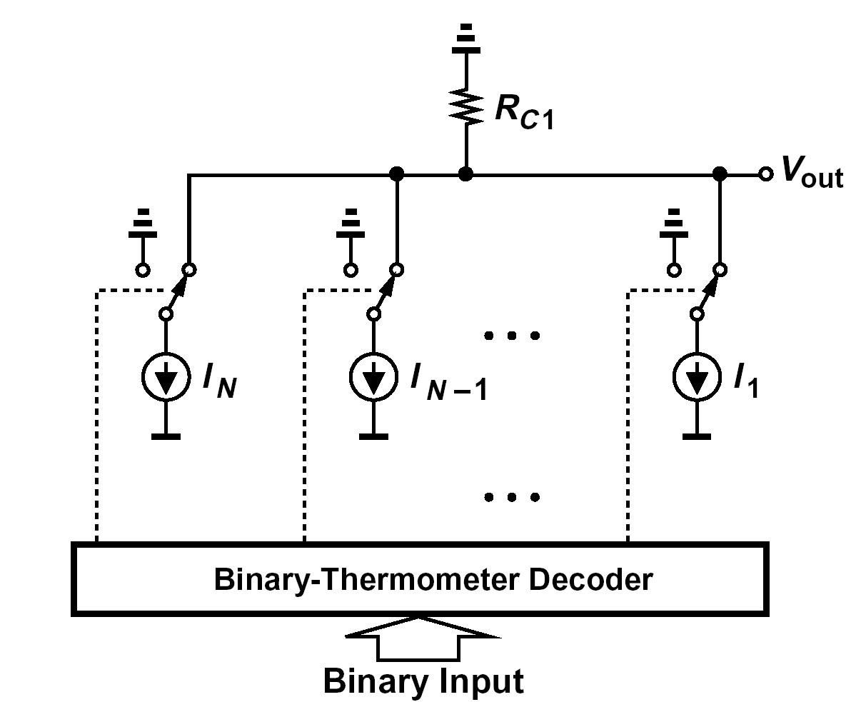

- Binary weighting using R-2R networks
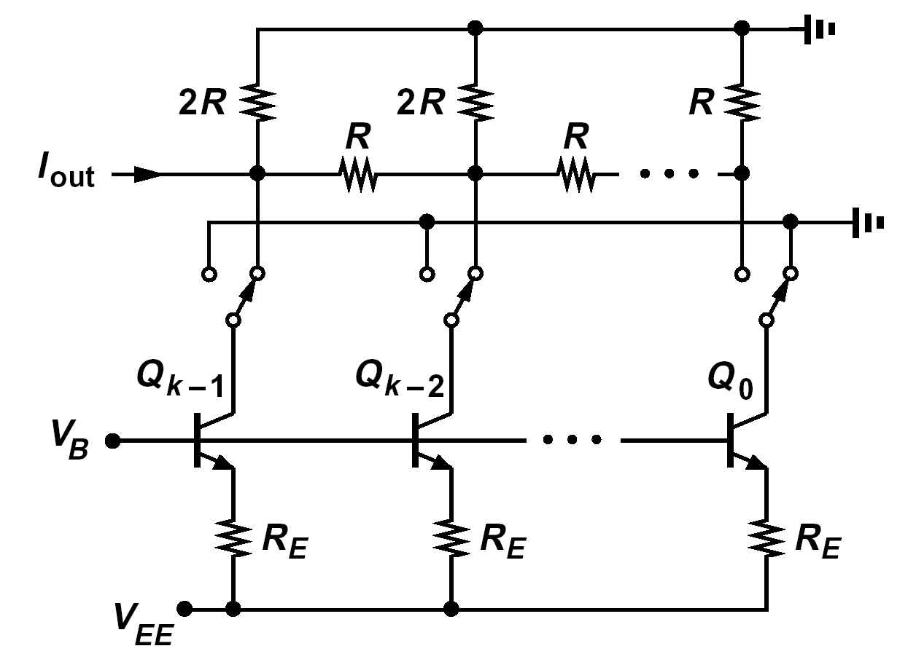

Partially-Segmented Current-Steering DACs

Recall:

- Fully-segmented arrays are very large for high resolutions; they also require substantial logic for binary-thermometer conversion. But, their glitch impulse and nonlinearity are small.
- Binary arrays using R-2R networks are small, but their glitch is large and their matching requirements very tight.

- Combine the two to get “partially-segmented” DACs:
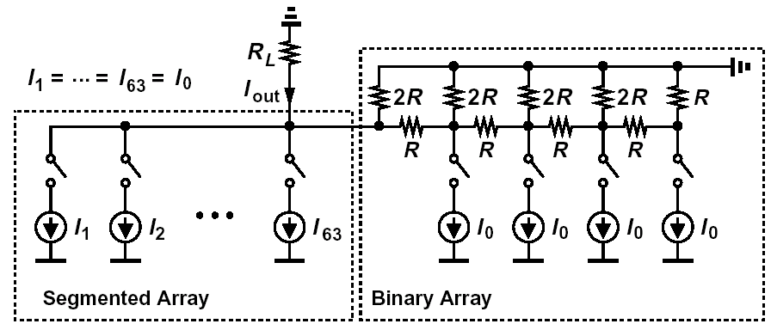

Issues:
- How to perform binary-thermometer code conversion to minimize routing and capacitance on output node?
- How to partition into segmented and binary? <= 4 bits

Matrix Architecture (Miki, JSSC, Dec. 86)

- Arrange the current sources in a matrix;
- Perform the decoding in two or three steps, with part of it inside each cell in the matrix.
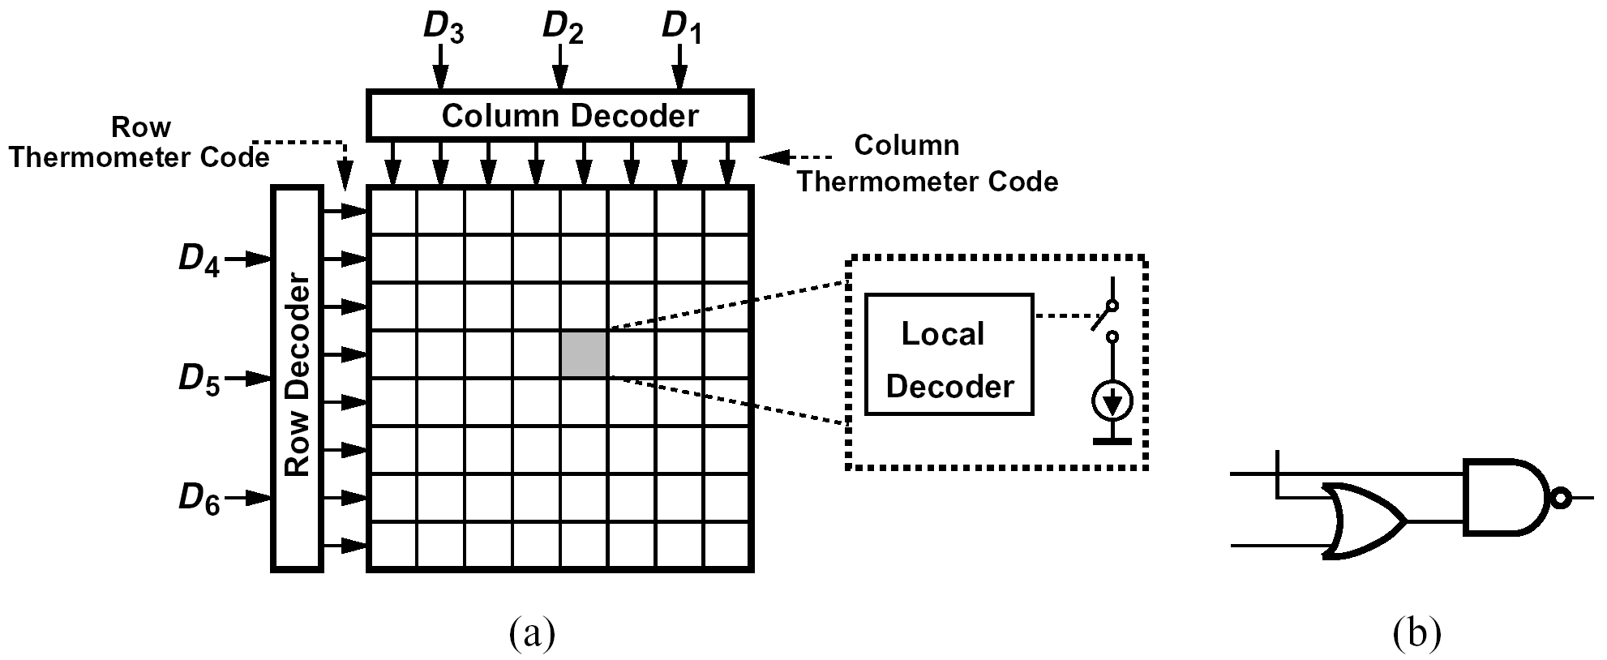
Status of each row:
  - All current sources are on;
  - All current sources are off;
  - Some current sources are on.
Local decoding takes these cases into account.

Use of Clocks in DACs

In principle, DACs do not need any clocks; the digital input simply ripples through and eventually generates an analog output.

In practice, most high-speed DACs use clocks and latches to synchronize (align) the date and also perform the logic in pipelined stages.

Matching Considerations

Required Matching for DACs: [Bastos, JSSC, Dec. 98]


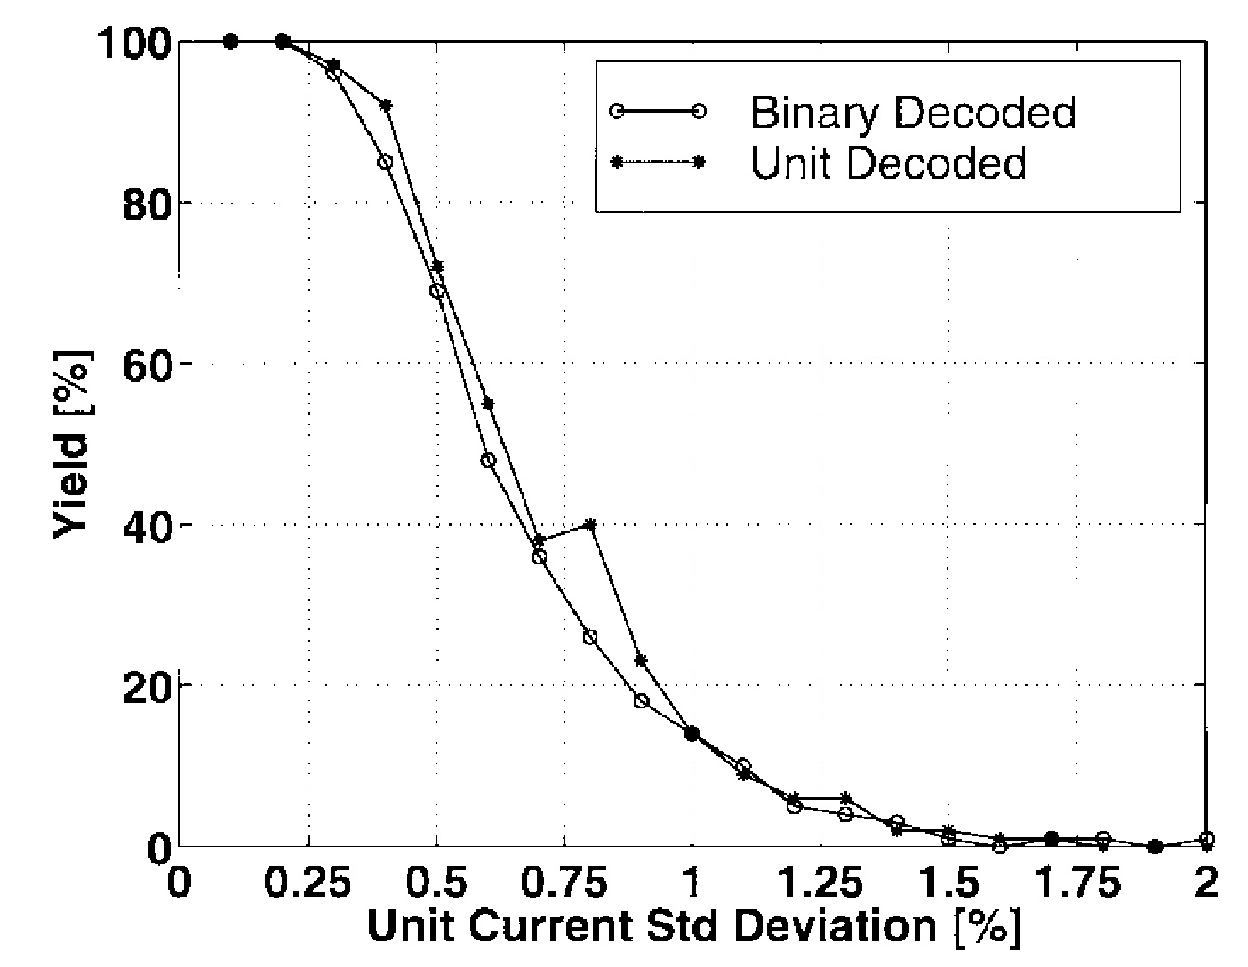
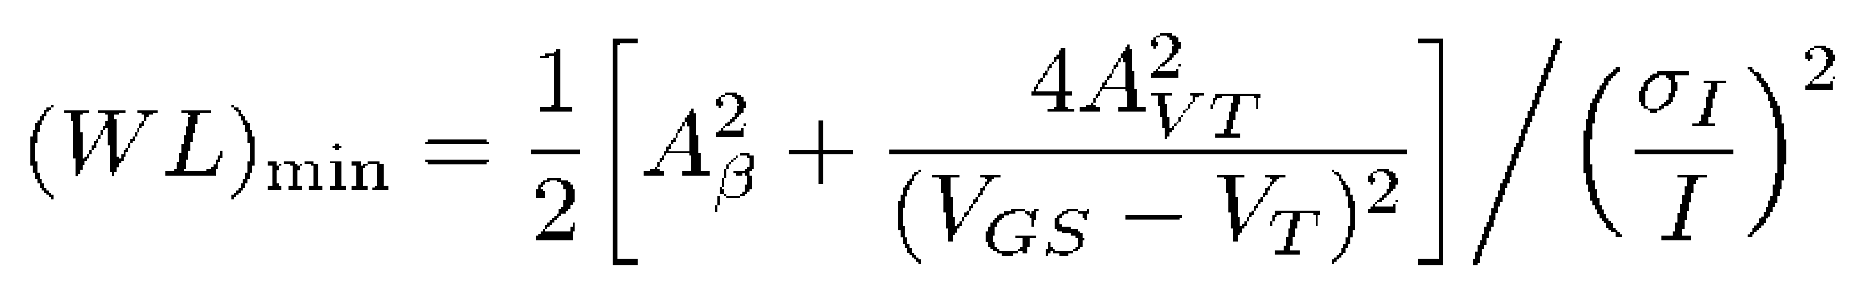

Binary vs. Segmented Arrays: [Lin, JSSC, Dec. 98]
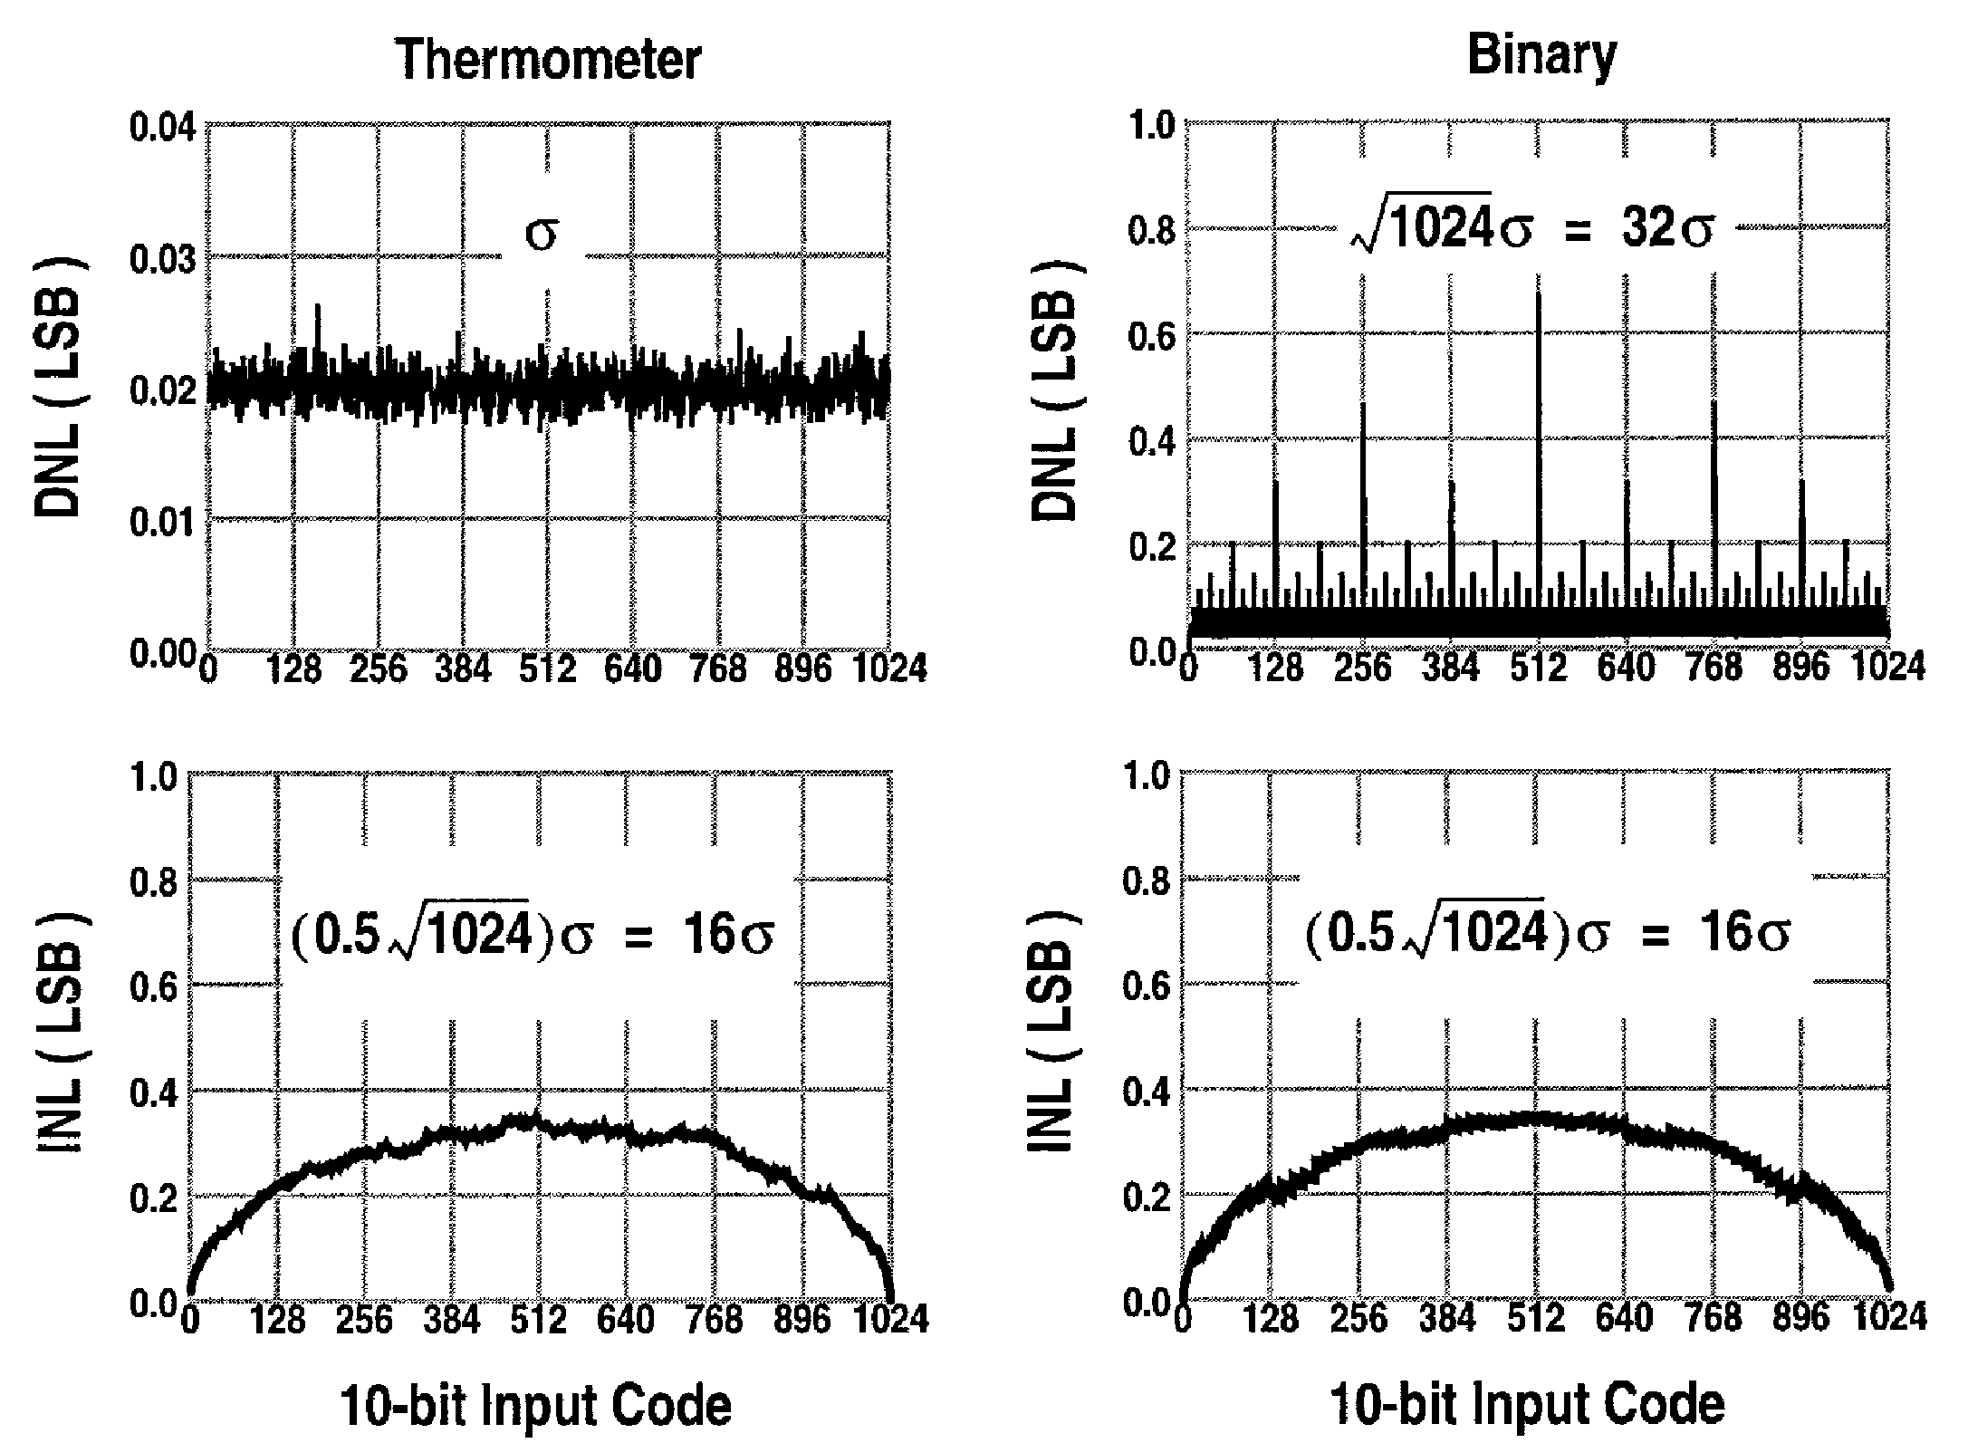
Example of Randomization in Layout

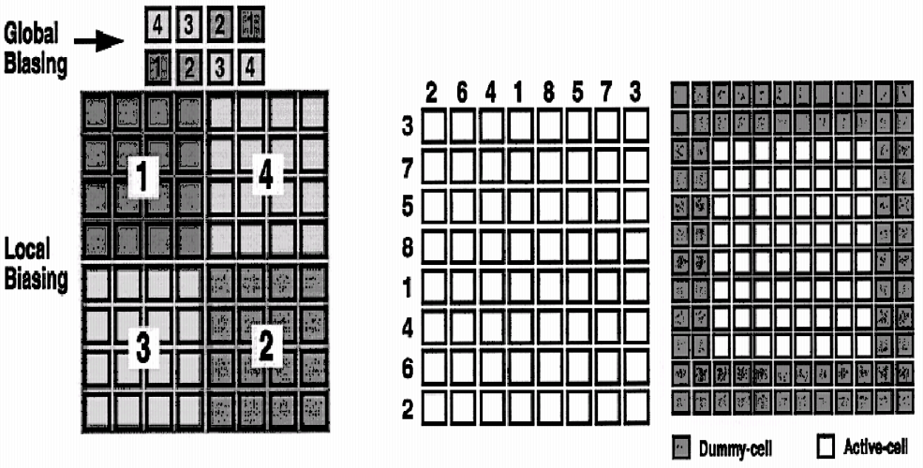
[Lin, JSSC, Dec. 98]

