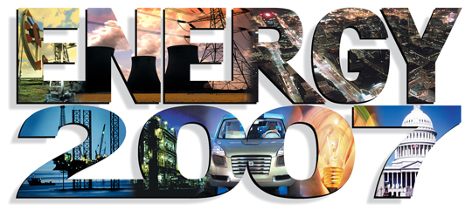

National Symposium on America’s Energy Future

December 7, 2006, 8:00 a.m. to 3:15 p.m.

United States Capitol

Cannon House Office Building, Caucus Room 345

House of Representatives

Washington, D.C.

As a newly elected United States Congress tackles a host of critical national and global issues, it is clear that 2007 will be a vital year for America’s energy situation. Confronting the challenges of adequate energy supplies, building a strong economy, and dealing with risk issues ranging from national safety to global climate change, the energy debate will be more complex than ever. Policy makers and citizens need to make smart choices based on accurate economic and scientific analyses that approach energy’s problems and opportunities realistically and objectively.

Moderators: The Symposium will be moderated by two veteran Washington journalists with deep experience covering the nation’s capitol:

- Frank Sesno, Special Correspondent and former Washington Bureau Chief, CNN; Professor, George Washington University. Sesno is an Emmy-award winning journalist who reported on global oil production and consumption for CNN Presents: "We Were Warned – Tomorrow’s Oil Crisis."

- David Rapp, Editor and Senior Vice President, Congressional Quarterly. Rapp heads the company's print and online editorial operations, including CQ Weekly, CQ Today, and CQ.com. A 20-year veteran of the CQ newsroom, Rapp oversees a staff of more than 110 correspondents, editors, and researchers who report and analyze the inner workings of Congress and the federal government.

Energy 2007 is sponsored by the John F. Kennedy School of Government at Harvard University, University of Southern California, RAND Corporation, Penn State: Institutes on Energy and the Environment, California Institute of Technology, Congressional Quarterly, the Lawrence Livermore National Laboratory, and The Communications Institute, with support from the Thomas R. Brown Foundations.

Who should attend? The Symposium’s goal is to provide policy makers as well as government, business, and community leaders the knowledge to make the smart decisions required for the future. The program is also designed to provide journalists with the knowledge to more accurately cover the story.

Content: The program will deal with the critical energy issues now facing the nation. The program content is based on economics, science, and engineering research conducted by many of the leading experts in the world.

