Introduction
Our ongoing research is concentrated on providing a robust communication channel for the hierarchical distributed control network. This includes dealing with various communication issues for mobile teams, which in our case are Unmanned Aerial Vehicles (UAVs). We can view the group of UAVs making coordinated maneuvers, to attain the desired goal, as the mobile wireless communication network (also called as ad-hoc wireless network), as in figure 1.1. Here, UAVs act as mobile (highly dynamic) nodes. The goal is to have robust, efficient and fault tolerant communication scheme for this mobile network.


Figure 1.1: Network formed by UAVs

The communication for any system or network performs in seven layers. This communication model is called the OSI reference model. Figure 1.2 depicts the OSI model.

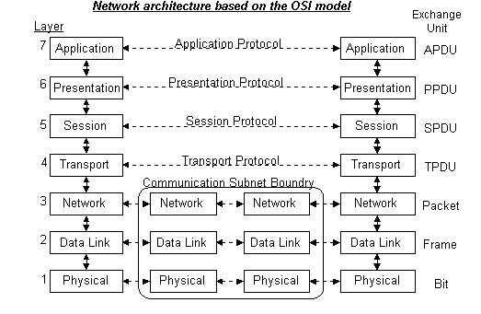
Figure 1.2 OSI Reference Model.

Each layer is governed by certain algorithms or protocols, which are designed to handle different applications. Our main focus is on the physical layer and data link layer (Medium access control, MAC, sub layer).
Current wireless systems are constrained by fixed bandwidth allocation (on a per connection basis), delay and delivery guarantee, network topology, etc. In short, it is constrained by Quality of service (QoS) requirements. QoS provisioning in a wireless network is a particularly difficult issue because physical layer problems, such as path loss, fading, and multipath, can make the communication links unreliable [1]. Because of these physical layer problems, it is essential to deal with the channel capacity issues for the mobile teams to increase the system throughput.
We shall present the channel capacity models for ideal and broadband jamming environments (individual links) in section 2. Unlike wired networks, wireless networks do not come with ready-made links. Rather, links are formed by nodes choosing power levels at which they transmit [2]. These connectivity issues will be dealt with in section 3.
Ad-hoc wireless networks promise convenient infrastructure-free communication. They function by multihopping, i.e., the ability of the radios to relay packets from one another without the use of base stations [3], [4]. The significance of a multi-hop network is it increases the transport capacity [5]. But with the mobility and delay as the constraints this may not be always true. We shall discuss the probability of achieving multi-hop connections in a random mobile network and the capacity of a mobile network considering delay in section 4 and 5 respectively.
In section 6 we shall present the distributed control problem. This deals with maintaining the highest possible QoS for the unexpected change in location of one of the UAVs. We shall discuss the issues related to MAC layer clustering in section 7. The report concludes with future work in section 8.

- Channel Capacity Model
Here, we shall consider two channel models:
  - Air-to-Air (A2A) channel, and
  - Ground-to-Ground (G2G) channel.

The assumptions made for these channel models are:
- Each node is equipped with an isotropic antenna.
- The transmitted signal is modulated by spread spectrum modulation.
- For Low probability of intercept (LPI), P_{r}/W_{s}N₀ = 0.1, where P_{r} is the received power, W_{s} is the bandwidth of spread spectrum signal and N₀ is the power spectral density (psd) of white noise.
- The jamming of a signal is performed by a broadband jammer.

The capacity model for both A2A and G2G channels come from extension of Shannon’s equation:
where, Pr is the received power, W is the channel bandwidth.

Also, for an isotropic antenna,
where P_{t} is the transmitted power. Spread factor, f, is defined as f = W_{s}/R, where, W_{s} is the bandwidth of the spread spectrum signal and R is the information rate in bps.
The interest lies in knowing the behavior of the information signal at 2Mbps. The significance of 2Mbps is, it is the data rate for the control traffic.

  - A2A channel (No Jammer)
In absence of a broadband jammer, the channel capacity is:
Figure 2.1 shows the behavior of the channel capacity (in bps) with the distance (meters).
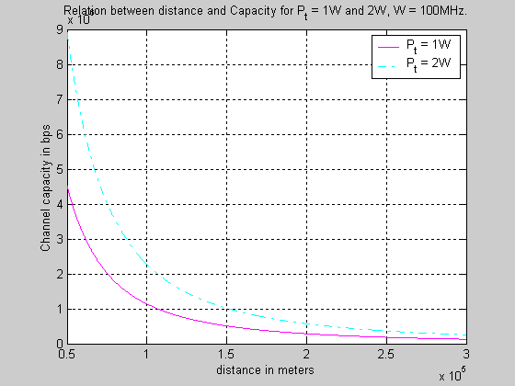

Figure 2.1: Simulation plot for A2A channel (no jammer)
Here, the transmitting power is assumed to be 1Watt & 2Watts, and available channel width is 100MHz. For 1W power, the distance achieved at 2Mbps is 75.5 km and for 2W, 106.78 km. The high values of transmitting distance are due to the fact that channel conditions are assumed to be ideal with high channel width (100MHz.).

  - G2G channel (No Jammer)
The channel capacity for this case is :
where α is the path-loss coefficient and constant K = K’F where F is the fading margin and K’ is the propagation constant.

Figure 2.2 shows the behavior of the channel capacity (in bps) with the distance (meters) for this case.
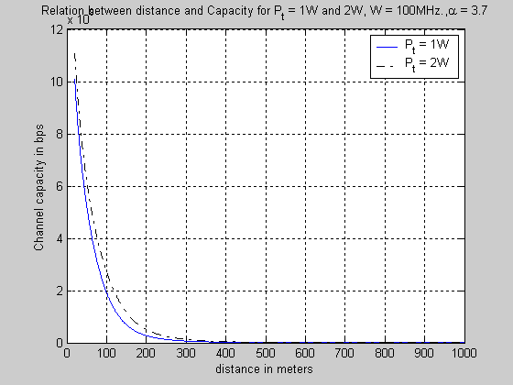

Figure 2.2: Simulation plot for G2G channel (no jammer)

The transmitting power is assumed to be 1Watt & 2Watts, available channel width is 100MHz and α=3.7. For 1W power, distance achieved at 2Mbps is 98 m and for 2W, 118.22 m.

  - A2A channel (Presence of Broadband Jammer)
The channel capacity for this case is:

where, J’av is the average jamming power at distance ‘r’ from the receiver, f is the spread factor. For CDMA, with jamming and N_{u} simultaneous users, channel capacity is given by (assuming identical signal power):

Figure 2.3 depicts the relation between channel capacity and distance for this case.
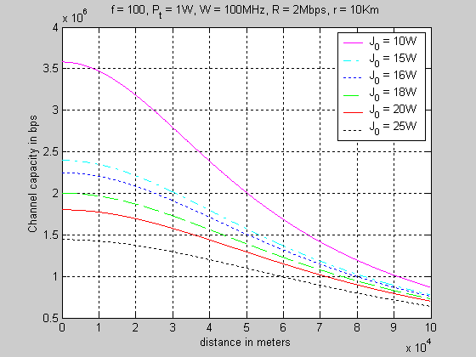

Figure 2.3: Simulation plot for A2A channel (presence of jammer)
The above simulation plot shows the behavior at different jamming powers. For jamming power of 10 W, the transmission distance achieved is 50.3 km.

  - G2G channel (presence of broadband jammer)
The channel capacity for this case is:
where, is the average jamming power at distance r from the receiver, K₁ is the propagation constant for jammer. For CDMA with jamming and N_{u} simultaneous users, capacity is given by (assuming identical signal power):
Figure 2.4 shows the behavior of channel capacity with the distance. The simulation is carried out for various jamming power and α = 4.5.
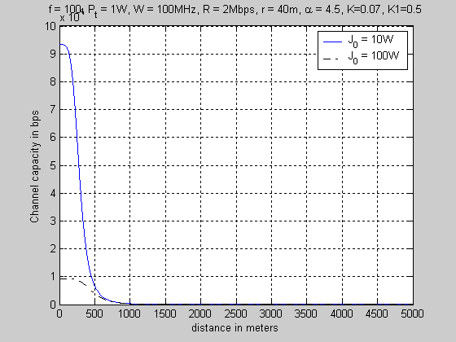

Figure 2.3: Simulation plot for G2G channel (presence of jammer)

Connectivity Issue
  - Problem Definition:
Consider a closed surface, say square, of unit area. Randomly place ‘n’ nodes within the area with some distribution other than uniform (Poisson, for e.g.). The solution to uniformly paced nodes could be found by continuum percolation. How large should ‘n’ be to have 99% probability of connectivity?

  - Motivation:
    - Deals with the issue of sensor coverage.
    - Provides guidance on minimum node density to achieve communications connectivity.

  - Approach:
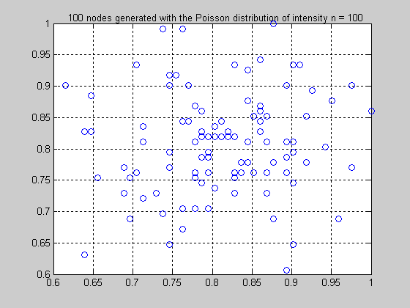
Consider a square of unit area with nodes placed with the Poisson distribution, as in figure 3.1.

Figure 3.1: Generation of 100 nodes having a Poisson distribution with intensity = 100.

The Poisson distribution here is a 2-dimensional Poisson, i.e. X ~ Poisson (n), and Y ~ Poisson (n), where n is the number of nodes. Also, X and Y are iid random variables. The simulation was carried out to know the number of nodes required to have 99% connectivity, figure 3.2 and 3.3.
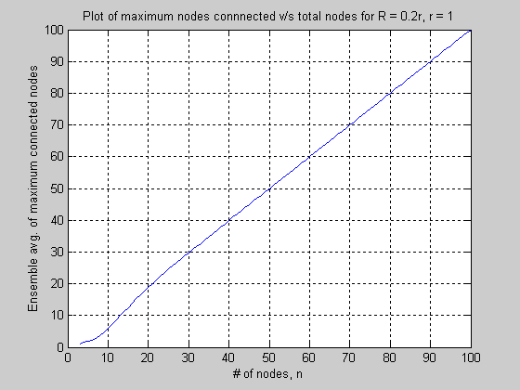
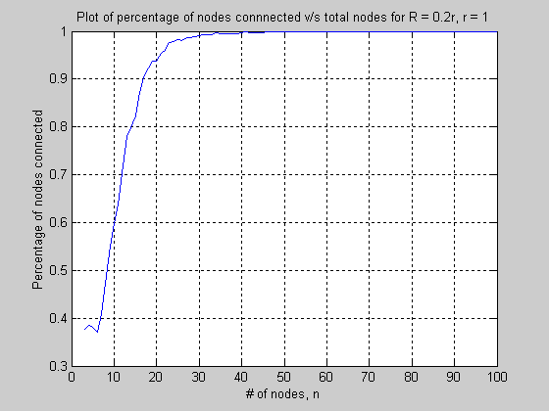

Figure 3.3: Max. nodes connected v/s total Figure 3.4: Percentage of connected v/s total # of nodes nodes

The maximum connected nodes are obtained by the ensemble average over 100 iterations. The above simulation is for the radio range of 20%. Figure 3.5 shows the behavior of the nodes require for 99% connectivity with the transmission range. The best fitting polynomial plot for figure 3.5 is depicted in figure 3.6.

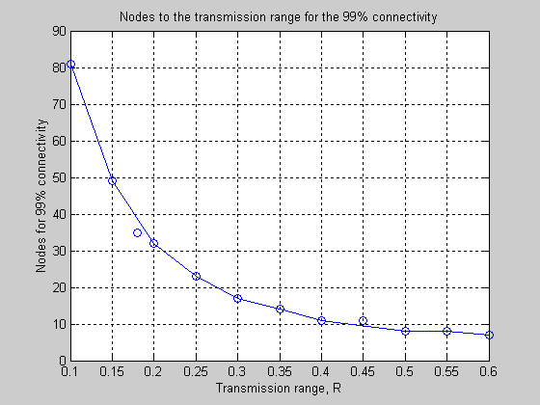
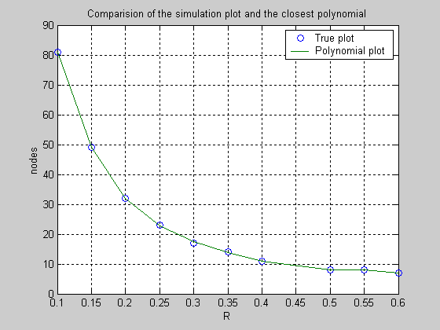

Figure 3.5: Simulation plot of the nodes for Figure 3.6: Best polynomial fit for fig. 3.5
the 99% connectivity with the
transmission range.

The number of nodes required for the 99% connectivity, N, as a function of radio range, R for the Poisson distributed nodes is: N ~ O(e^{-R}). The simulation shows that the nodes requirement for 99% connectivity decay exponentially with the radio range. The same simulations were carried out for various other distributions – exponential, beta, etc. and the similar results were obtained.
The interesting observation that could be inferred from simulation results is all the distribution result in exponential inter-node distances for the tails. This suggests that algorithms designed to deal with exponential tails should be robust across a wide range of distributions. If we can prove this for, say, Poisson then, we can extend this to all the other distributions which are unimodal with exponential tail.
Let us consider the clustering algorithm on Poisson distributed nodes. The objective of the clustering algorithm is to partition the network into several clusters. Optimum cluster size is dictated by the tradeoff between spatial reuse of the channel and delay minimization. Other constraints also apply, such as power consumption and geographical layout. Cluster size is controlled through the radio transmission power [4]. Here we assume fixed transmission power for all the radio nodes. The clustering algorithm implemented here is the distributed clustering algorithm discussed in [4]. Figure 3.6 shows the network connectivity for 20 Poisson-distributed nodes. Figure 3.7 depicts the clustering algorithm executed on the network layout of figure 3.6. The notation (nid, ch) means (respective node id, it’s cluster head).

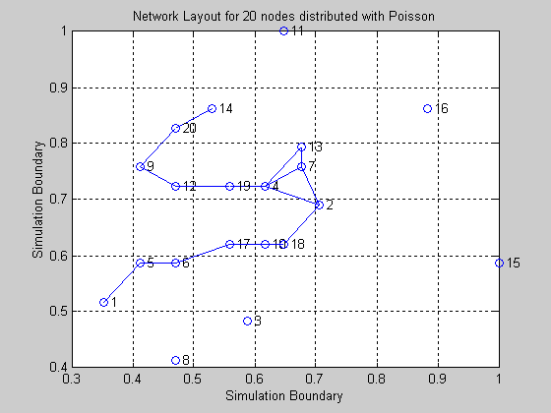
Figure 3.6: Network Connectivity for 20 nodes
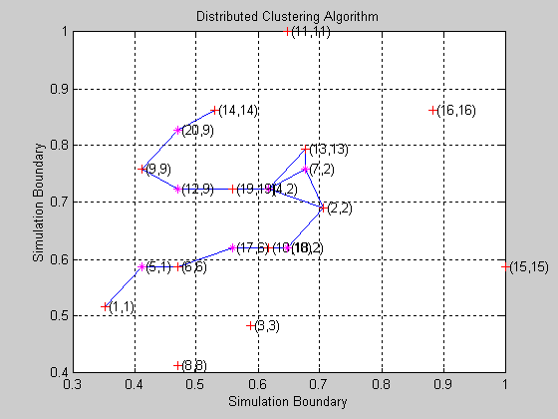

Figure 3.7: Distributed Clustering algorithm on figure 3.6

As observed from figure 3.7, the tail of the distribution does not take part in the clustering process. They themselves act as the cluster head. So we need to come up with a robust power control strategy so that the tail participates in the network formation without creating interference. Hence, the network formation problem should have minimum connectivity time and minimum energy expenditure without creating interference. The problem might be solved analytically, if we can formulate it as an optimization problem. One approach is to exploit the properties of two-dimensional Poisson distribution. Another approach is to consider the pdf of Euclidean distance between any two poisson-distributed nodes.
(Skipping the derivation).

The hindrance that lies here is in mapping g(r,θ) → g(r).

From p_{r}(r) we can find the step size for increasing the transmitting power to form the network. Let d be the original transmission range, then
. From this, we can calculate the step size, σ. Once step size is calculated, the algorithm can be generalized for all the nodes in the network and the robustness could be checked from the simulation.

Probability of Multi-hop connection
The probability is found for the event that, in an N-node randomly distributed (Gaussian) deployment of mobile radio terminals (nodes), any two nodes are connected by a two-hop path and are not directly connected. The probability that a link between two nodes has sufficient signal-to-noise ratio for acceptable transmission quality of reliability is, other factors being equal, the probability that the link distance r is less than some value R, where R is termed the transmission range [7]:
Pr{Link is good} = Pr{r ≤ R} = F_{r}(R)

Mathematically,
(x,y) coordinates of the mobile locations ~ N(0,σ²)
pdf of the link distance r is:
Pr{2-hop connection}=P₂ [7]
Asymptotically m – hop connection probability: [7]
Upper bound on average number of hops between node pairs:
[7] gave the upper bound on two-hop probability. To find the closest value P₂ approaches, it is essential to know the lower bound too.
The lower bound for two-hop probability is calculated from:
, where , and
g(γ) = ∫_{ν}
The limits of the integration are (1/4γ², 1/γ²).
Since g(γ) is a continuous function it can be integrated numerically. The continuous integration is very complicated. Figure 4.1 shows the simulation results for the bounds.

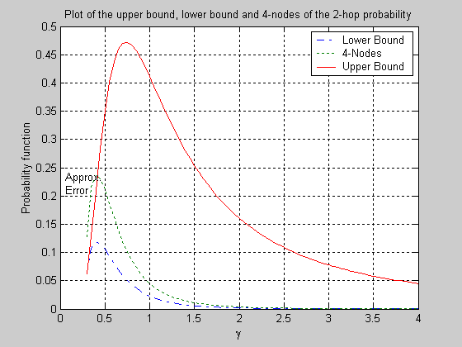

Figure 4.1: Simulation plot of the bounds on 2-hop probability.
Due to the employment of numerical integration, there is a minor approximation error at low values of γ.

Capacity of a Mobile Wireless (Ad Hoc) Network
In case of ad hoc wireless networks, we expect the total capacity to grow with the area they cover, due to spatial re-use of the spectrum: nodes sufficiently far apart can transmit concurrently. However, ad hoc routing requires that nodes cooperate to forward each others’ packets through the network. This means that the throughput available to each single node’s application is limited not only by the raw channel capacity, but also by the forwarding load imposed by distant nodes. This effect could seriously limit the usefulness of ad hoc routing [3]. The capacity of ad-hoc wireless networks is constrained by the mutual interference of concurrent transmissions between nodes.
Gupta and Kumar [5] derive the transport capacity of a static ad hoc network. Revisiting their results and approach:
Radios that are sufficiently distant can transmit concurrently; the total amount of data that can be simultaneously transmitted for one hop increases linearly with the total area of the ad-hoc network. If node density is constant, this means that the total one hop capacity is O(n), where n is the total number of nodes. However, as the network grows larger the number of hops between each source and destination may also grow larger depending on the communication patterns. One might expect the average path length to grow with the spatial diameter of the network, or equivalently the square root of the area, or . With this assumption the total end to end capacity is roughly , and the end-to-end throughput available to each node is .
In case of a mobile network, the transport capacity depends largely on the tolerance of delay. If the delay could be afforded then, mobility increases the transport capacity [8]. The end result for this particular case could be infinite delay. The model for the loose delay constraint is the source transmits a packet to a relay node and relay node in turn transmits to a destination whenever it comes near to the destination node.
To get the real picture of QoS provisioning, the actual capacity with no loose delay constraint becomes essential. Also, the delay in many applications is not acceptable (for example, in the on-going MURI project), and this will reduce the capacity for mobile networks compared to static networks.
The major difference in the capacity for the fixed wireless network and mobile Ad-hoc network is the energy used for updating the routing table for the latter case. There are many algorithms for updating he routing table. The simplest way of doing is flooding. Capacity may tend to zero if the energy usage for updating routing table goes very high. Hence, the throughput for the case of Ad-hoc wireless network with no loose delay constraint is of – signaling for updating routing table.

Distributed Network Control Problem
  - Problem Definition:

Y

N1

Figure 6.1: Network Connected in a Multi-hop fashion.
Consider the network connected in a multi-hop fashion as shown in the figure 6.1. Suppose a request comes from ground station to node N1 to move from its current location to location Y, to accomplish some specific functions / mission. This can cause a change in the QoS assurance for the network. So, the objective is to minimize the Euclidean distance between N1 and Y subject to QoS constraints.
  - Approach:
We shall formulate this as an optimization problem. Let the current position of Node N_{i} (node in consideration) be defined as Q_{i}(t) = {X_{i}(t), Y_{i}(t)}. Let the requested position of Node N_{i} be Q_{j} = {X_{j}, Y_{j}}. The objective function is min || Q_{i}(t) - Q_{j} ||. The cost function is minimized subject to QoS constraints.

  - Network Model:
Power received from transmitter j, at receiver i is given by G_{ij}F_{ij}P_{j}. The nonnegative number G_{ij} is the path gain in absence of fading from the j^{th} transmitter to the i^{th} receiver. F_{ij} is the Rayleigh fading between each transmitter j and receiver i. Signal to Interference ratio for user i is given by .
Outage Probability: O_{i} = Pr (SIR_{i} ≤ SIR_{th}) where SIR_{th} is the given threshold. The outage probability, thus, can be expressed as .
Over a path S, outage probability is .
Constellation Size M used by a hop can be closely approximated for M-QAM modulation as . In this expression for M, K is given by .
The data rate of the i^{th} hop is. Link Capacity is denoted by Cj packets/sec. (for each individual link), assuming J links [1].
We are assuming K classes of traffic in our model, and for each QoS of class k, the bandwidth required is b_{k} Hz. Delay guarantee in a service level agreement (SLA) is d_{k,UB} sec. Minimum probability of delivering the packet across the unreliable network required in SLA is p_{k,LB}. Number of packets dynamically admitted in the k^{th} class of traffic is n_{k}. Probability that link will be maintained during transmission is p_{j} [1].
Capacity Model:
Let the link distance be r_{j}. From Shannon’s equation, we have the link capacity as:
where B_{j} is the link bandwidth.
Therefore, where, r_{j} is defined as . Capacity of the system is, .
Also, . The bandwidth and hence the capacity requirement for each traffic class is different. Let us categorize the link capacity into and the respective bandwidth requirement is b_{i} , i = {1,2,3,…,K}. Thus, to transmit k classes of traffic on a link we should have, .

  - Problem Formulation:
This problem could be solved in three steps:
Step 1: Optimize power for throughput maximization [1]

The objective function is the overall system throughput. The following problem is a convex optimization problem.
A change in location of a node N_{i} is admissible if the QoS requirements can be supported by the system without disturbing the existing QoS requirements of the current nodes position. A request for the change in position is immediately entertained if feasible solution of the problem in Step 1 exists after the new position’s QoS constraints have been added. An infeasible solution is a definitive statement that this request may not be entertained without a change in required QoS.

Step 2: SLA feasibility under network constraints.

No objective function is necessary, since in this formulation only the feasibility of the SLA terms p_{j}, d_{k,UB} and p_{k,LB} is being tested. The constraint sets description:
CS1) Link Capacity Constraint.
CS2) Delay Guarantee constraint.
CS3) Delivery probability constraint.
CS4) Guaranteed data rate to each class of traffic.
CS5) Service Level Agreement (SLA) constraint that give a class of traffic the sole right to traverse a link j*.
CS6) Specifies end to end delay guarantee and a delay requirement for a particular traffic class k* on a link j*.
CS7) Upper bound constraint on p_{j}.
CS8) Positivity Constraints.
The formulation is a non-linear optimization problem. However, this could be solved as convex optimization problem as in [1].

Step 3: Link Distance Minimization.
The objective function is to minimize the Euclidean distance between the current position of node N_{i} and the new position under all network and QoS constraints. The constraints are the same as in Step 2 except for the addition of capacity model constraints.
We could even formulate couple of more optimization problems to maximize unused capacity and minimize the delay [1]. They end up as convex optimization problem.
In general, it may not be necessary to solve the whole optimization problem. We just need to consider the worst case scenarios with 2 classes of traffic. If the algorithm is robust for the worst case then, with high probability it will end up robust for any case. The other approach to minimizethe number of constraints is to develop a cost function for the QoS constraints or to prioritize it.

MAC Layer Clustering
The strongest constraint in our case is that no delay can be afforded. Because of this, we need to exploit the MAC layer protocols other then 802.11 and Bluetooth. While, 802.11 allows lot of delay, bluetooth works only for RF. Hence, we need to come up with suitable MAC layer protocal which is compatible with TCP/IP model.
A communication network, whether fixed wireline or mobile wireless, is a dynamic entity whose state may change frequently in ways that cannot be accurately predicted. To meet performance goals prescribed for user traffic, a network must be able to adapt its behavior to accommodate changes in its intrinsic properties (e.g., connectivity, capacity, and offered load). Ideally, the control functions that govern the network’s performance should meet two objectives:
      - To respond rapidly and correctly when adapting the network’s behavior to current network state.
      - To minimize consumption of the network’s transmission, processing, and storage resources both during and as a result of the adaptation process.

The distribution of nodes into clusters promotes more efficient use of resources in controlling large dynamic networks. A cluster is a subset of nodes, which can (two-way) communicate with clusterhead and (possibly) with each other [9]. A good clustering algorithm should be stable to radio motion, and should adapt quickly to change in the network topology (especially when the nodes are highly dynamic, e.g. UAVs).
There are various clustering algorithm options that can be exploited [4], [10], [11]. Figure 3.6 and 3.7 shows the implementation of algorithm described in [4]. The clustering algorithm in [4] divides each cluster in such a fashion that no nodes in a cluster is more than two-hops away. This could be ideal for us as delay is minimized. The possibility of having backbone node in each cluster could also help in minimizing the delay. We also want to avoid lot of communications, as it makes susceptible to jamming. Hence, the robust, fault-tolerant and efficient algorithm needs to be formulated for MAC layer.

Future Work
      - Designing robust distribution control algorithm for the nodes to acknowledge the special requested activities.
      - Getting the bound on the capacity of mobile wireless network with no loose delay constraint or knowing the achievable region.
      - Confirming the domination of tail-behavior for the given distribution (almost solved).
      - Solving analytically the network formation problem i.e. minimizing the connectivity time.
      - (Probably the toughest of all) Critical probability for network connectivity.
      - Designing MAC layer clustering algorithm, which adapts with minimum delay to the change in the network configuration. Also, making it sure that its robust and fault tolerant.
      - Extending UAV-UAV clustering algorithms to UAV-UGV (channel condition changes).
      - Implementing and testing the communication algorithm for mobile teams for the control scenarios.

References

[1] Mung Chiang, et. al., "Resource Allocation for QoS Pro-visioning in Wireless Ad Hoc Network", GLOBECOM 2001.
[2] Feng Xue, P.R. Kumar, "The number of neighbors needed for connectivity of wireless networks", Submitted to Wireless Networks, April 2002.
[3] Jinyang Li, et. al., "Capacity of Ad Hoc Wireless Networks", Proceedings of the 7th ACM International Conference on Mobile Computing and Networking (MobiCom '01), July 2001.
[4] Chunhung Richard Lin, Mario Gerla, "Adaptive Clustering for Mobile Wireless Networks", IEEE Journal on Selected Areas in Communications, 15(7): 1265-1275, September 1997.
[5] Piyush Gupta and P. R. Kumar, "The Capacity of Wireless Networks", IEEE Transactions on Information Theory, 46(2):388-404, March 2000.
[6] J.O. Irwin, "The Frquency Distribution of the Difference between Two Independent Variates following the same Poisson distribution", Journal of the Royal Statistical Society, 100(3):415-416, 1937.
[7] Leonard E. Miller, "Probability of a Two-Hop Connection in a Random Mobile Network", Conference on Information Sciences and Systems, The John Hopkins University, 2001.
[8] Matthias Grossglauser and David Tse, "Mobility Increases the Capacity of Ad-hoc Wireless Networks", IEEE INFOCOM, 2001.
[9] Mario Gerla, Jack Tzu-Chieh Tsai, "Multicluster, mobile, multimedia radio network", ACM-Baltzer J. Wireless Networks, 1(3):255-265, 1995.
[10] I. Stojmenovic, et. al., "Dominating Sets and Neighbor Elimination-Based Broadcasting Algorithms in Wireless Networks", IEEE Trans. on Parallel and Distributed Systems, 13(1):14-25, January 2002.
[11] M. Chatterjee, et. al., "An On-Demand Weighted Clustering Algorithm (WCA) for Ad Hoc Networks", IEEE GLOBECOM 2000, pp. 1697-1701.
[12] Jan De Mot, et. al., “Coordinated Path Planning for a UAV Cluster”, Presented at The First AINS Symposium, UCLA, May 2002.

