UNIVERSITY OF CALIFORNIA
Los Angeles

Shear Wave Velocity as Function of SPT Penetration Resistance and Vertical Effective Stress at California Bridge Sites

A thesis submitted in partial satisfaction
of the requirements for the degree Master of Science
in Civil and Environmental Engineering

by

Naresh Bellana

2009

The thesis of Naresh Bellana is approved

_________________________________
Jonathan P. Stewart

_________________________________
Mladen Vucetic

_________________________________
Scott J. Brandenberg, Committee Chair

University of California, Los Angeles
2009

DEDICATION

To
my parents,
family
and friends

Table of Contents

Table of Contents iv
List of Figures v
List of Tables vii
Acknowledgments viii
ABSTRACT OF THE THESIS ix
1. Introduction 1
2. Literature Review 4
2.1. Influence of Overburden Stress 7
3. Development of Data Set 10
4. Statistical Regression 18
4.1. Regression Analysis 18
4.2. Residuals 22
4.3. Influence of Surface Geology 24
4.4. Effect of Omitting σ_{v}’ Term 26
4.5. Comparison with Published Relations 28
5. Conclusions 30
6. Appendix 33
7. References 62

List of Figures

Figure 1. Modulus reduction curves for (a) sand (Seed and Idriss 1970) and (b) clay (Vucetic and Dobry 1991). 2
Figure 2. Influence of overburden on V_{s} values associated with constant N₆₀ but different (N₁)₆₀ 8
Figure 3. Map of sites where boring logs and suspension logs were measured for this study. 11
Figure 4. Distribution of data points by soil type. 13
Figure 5. Example of data processing methodology to obtain weighted average value for statistical regression. 16
Figure 6. V_{s} versus N₆₀ and P_{a}/σ_{v}’ for (a) sand, (b) silt, and (c) clay, and lines showing results of regression equations for various N₆₀ and P_{a}/σ_{v}’ values. 21
Figure 7. Residuals, defined as natural log of measured V_{s} values minus natural log of predicted V_{s} values, versus N₆₀ and P_{a}/σ_{v}’ for (a) sand, (b) silt, and (c) clay. 23
Figure 8. Quantile-quantile plots indicating the extent to which the error term is normally distributed for (a) sand, (b) silt, and (c) clay. 24
Figure 9. V_{s} versus N₆₀ with different symbols indicating different surface geologic epoch for (a) sand, (b) silt, and (c) clay. 25
Figure 10: Residuals versus N₆₀ and P_{a}/σ_{v}' for regression for all soils without overburden term. 27
Figure 11: Existing correlations from literature over the current data set 29
Figure 12. (a) Bridge no. 10-0298, boring no. 98-4 (abut.4), (b) Bridge no. 10-0298, boring no. 96-2, (c) Bridge no. 10-0298, boring no. 96-3. 34
Figure 13. (a) Bridge no. 10-0298, boring no. 98-10 (abut 1) (b) Bridge no. 28-0253R, boring no. 94B1R (Pier 9) (c) Bridge no. 28-0153R, boring no. 96-5 (Pier 8) 35
Figure 14. (a) Bridge no. 28-1053R, boring no. 95B13R (Pier 7) (b) Bridge no. 28-1053R, boring no. 96-4 (Pier 7) (c) Bridge no. 28-1053R, boring no. 95-12 (Pier 5) 36
Figure 15. (a) Bridge no. 28-0352L, boring no. 96B-29 (b) Bridge no. 28-0352L, boring no. 95-2 (Pier 3) (c) Bridge no. 28-0352L, boring no. 95-1 (Pier 4) 37
Figure 16. (a) Bridge no. 28-0352L, boring no. 96B-37 (b) Bridge no. 28-0100, boring no. 96-2 (Piers 10 and 11) (c) Bridge no. 28-0100, boring no. 96-5 (Piers 31/32) 38
Figure 17. (a) Bridge no. 28-0100, boring no. 96-7 (Pier 8) (b) Bridge no. 28-0100, 95-7 (Pier 21) (c) Bridge no. 28-0100, boring no. 95B4R (Pier 25) 39
Figure 18. (a) Bridge no. 28-0100, boring no. 95B5R (Pier 35) (b) Bridge no. 28-0100, boring no. 95B2R (Pier 32/33) (c) Bridge no. 28-0100, boring no. 95B3R/95B9R (Pier 34) 40
Figure 19. (a) Bridge no. 28-0100, boring no. 95-10 (Pier 47) (b) Bridge no. 28-0100, boring no. 95-11 (Pier 48) (c) Bridge no. 28-0100, boring no. 95B1R (Pier 58) 41
Figure 20. (a) Bridge no. 33-0025, boring no. B6 (Pier E19) (b) Bridge no. 33-0025, boring no. B-7 (Pier E10) (c) Bridge no. 34-0003, boring no. 95-14 (Pier W6) 42
Figure 21. (a) Bridge no. 34-0003, boring no. 95-12 (Pier W4) (b) Bridge no. 34-0003, boring no. 95-11 (Pier W3) (c) Bridge no. 34-0003, boring no. 95-10 (Pier W2) 43
Figure 22. (a) Bridge no. 34-0003, boring no. 95-5 (Pier A) (b) Bridge no. 34-0003, boring no. 95-4 (c) Bridge no. 34-0003, boring no. 95-6 44
Figure 23. (a) Bridge no. 34-0004, boring no. B95-2 (b) Bridge no. 34-0004, boring no. B95-3 (c) Bridge no. 34-0077, boring no. 01-B2 45
Figure 24. (a) Bridge no. 34-0077, boring no. 01-05 (b) Bridge no. 34-0077, boring no. 01-08 (c) Bridge no. 34-0077, boring no. 01-11 46
Figure 25. (a) Bridge no. 37-0853, boring no.98-1 (Pier 4) (b) Bridge no. 38-0583, boring no. 98-4 (Bent 7) (c) Bridge no. 49-0014L, boring no.98-1 (Abut 1) 47
Figure 26. (a) Bridge no. 51-0139, boring no. 98-1 (Abut 1) (b) Bridge no. 52-0443, boring no. 99-1 (c) Bridge no. 53-1471, boring no. 95B5R 48
Figure 27. (a) Bridge no. 53-1471, boring no. 95B4R (b) Bridge no. 53-1471, boring no. 95B1R (c) Bridge no. 53-1471, boring no. 95B2R 49
Figure 28. (a) Bridge no. 53-1471, boring no. 95B3R (b) Bridge no. 53-2272, boring no. B-1 (c) Bridge no. 53-2790R, boring no. B-6 50
Figure 29. (a) Bridge no. 53-2794R, boring no. B-1 (b) Bridge no. 53-2795F, boring no. 94-21 (c) Bridge no. 53-2796F, boring no. 94-30 51
Figure 30. (a) Bridge no. 54-1110R, boring no. 98-1 (Abut 1) (b) Bridge no. 54-1110R, boring no. 98-6 (Abut 8) (c) Bridge no. 57-0857, boring no. 96-52 (Bents R48 and 49) 52
Figure 31. (a) Bridge no. 57-0857, boring no. 96-17 (Abut S48) (b) Bridge no. 57-0857, boring no. 95-2 (Pier 33) (c) Bridge no. 57-0857, boring no. 96-16 (Bent 41F,R) 53
Figure 32. (a) Bridge no. 57-0857, boring no. 96-29 (b) Bridge no. 57-0857, boring no. 96-53R (c) Bridge no. 57-0857, boring no. 96-66 54
Figure 33. (a) Bridge no. 57-0857, boring no. 96-65 (b) Bridge no. 57-0857, boring no. 96-35 (Toll Plaza North West) (c) Bridge no. 57-0857, boring no. 96-34 (Toll Plaza South East) 55
Figure 34. (a) Bridge no. 57-0857, boring no. 96-21 (b) Bridge no. 57-0857, boring no. 96-28 (c) Bridge no. 57-0857, boring no. 96-60 56
Figure 35. (a) Bridge no. 57-0857, boring no. 96-68R (b) Bridge no. 57-0857, boring no. 96-56 (c) Bridge no. 57-0857, boring no. 96-67 57
Figure 36. (a) Bridge no. 57-0857, boring no. 96-54 (b) Bridge no. 57-0857, boring no. 96-55 (c) Bridge no. 57-0857, boring no. 96-59 58
Figure 37. (a) Bridge no. 57-0857, boring no. 96-58 (b) Bridge no. 57-0857, boring no. 96-57 (c) Bridge no. 57-0857, boring no. 96-64 59
Figure 38. (a) Bridge no. 58-0335RL, boring no. B5-01 60

List of Tables

Table 1. Some existing correlations between V_{s} and SPT-N 6
Table 2. Bridge name, number, location, number of borings, and surface geology epoch for sites included in this study. 10
Table 3. Rod length correction factors (Source: Youd et al., 2001). 14
Table 4. Unit weights. 15
Table 5. Regression constants and standard deviation of error term. 19

Acknowledgments

This research was funded by the Pacific Earthquake Engineering Research Center under contract number 65A0215. I would like to thank Tom Shantz for providing technical guidance on this work and for providing the boring logs and suspension log data. I would like to thank Barr Levy for helping me extract the electronic database from the boring log tif image files.

ABSTRACT OF THE THESIS

Shear Wave Velocity as Function of SPT Penetration Resistance and Vertical Effective Stress at California Bridge Sites
by
Naresh Bellana
Master of Science in Civil and Environmental Engineering
University of California, Los Angeles, 2009
Assistant Professor Scott J. Brandenberg, Chair

Equations representing shear wave velocity (V_{s}) as a function of energy-corrected SPT blow count (N₆₀) and vertical effective stress (σ_{v}’) are generated by statistical regression of site investigation data at bridge sites owned by the California Department of Transportation. The N₆₀ values and V_{s} values were obtained from the same boreholes between 1993 and 2001. The V_{s} values were obtained by the suspension logging method. A total of 21 bridges and 79 borings provided 918 pairs of N₆₀ and V_{s} values for regression. Surface geology at each site was obtained from a yet-unpublished Caltrans study. The influence of σ_{v}’ has not been considered by the vast majority of published relations between V_{s} and N₆₀, yet it was shown in this thesis to be a significant factor. Significant bias may exist in previous relations that neglected the influence of σ_{v}’. Residuals, defined as the natural log of measured minus the natural log of predicted values of V_{s}, were found to be normally distributed and the standard deviations were quantified as part of the statistical equations. Uncertainty in the relations is substantial, and the correlations should only be used as a rough estimate of V_{s} to prioritize site investigation resources by identifying whether directly measuring V_{s} would be worthwhile. Geophysical measurements should be made when uncertainty in the estimated values significantly affects design or retrofit decisions.

Introduction

A key property required to evaluate dynamic response of soil is small-strain shear modulus, G_{max}. Values of G_{max} are typically determined indirectly by measuring the shear wave velocity, V_{s}, and the mass density of the soil, ρ, and computing G_{max} = ρV_{s}². Small-strain shear modulus, G_{max} may be determined using “undisturbed” soil samples provided that accurate stress-strain behavior can be measured at very small shear strains (i.e. less than 0.001 percent), and sample disturbance is negligible. Disturbance is known to affect small-strain stiffness more than shear strength because weak inter-particle bonds broken during sampling contribute significantly to small-strain stiffness, hence V_{s} is most often measured in-situ rather than in the laboratory.
G_{max} is often used in combination with modulus reduction (G/G_{max}-γ) and damping (D-γ) curves to solve dynamic problems when shear strains drive the soil beyond its elastic range. Modulus-reduction curves describe the reduction of secant modulus with increase in cyclic shear strain, γ_{c}. Damping curves describe the hysteretic energy dissipated by the soil with increase in γ_{c}. These curves can be obtained through laboratory cyclic loading tests, but are typically assumed for a given soil type. The curves for obtained by Seed and Idriss (1970) for sand and by Vucetic and Dobry (1991) for clay are shown in Fig 1.

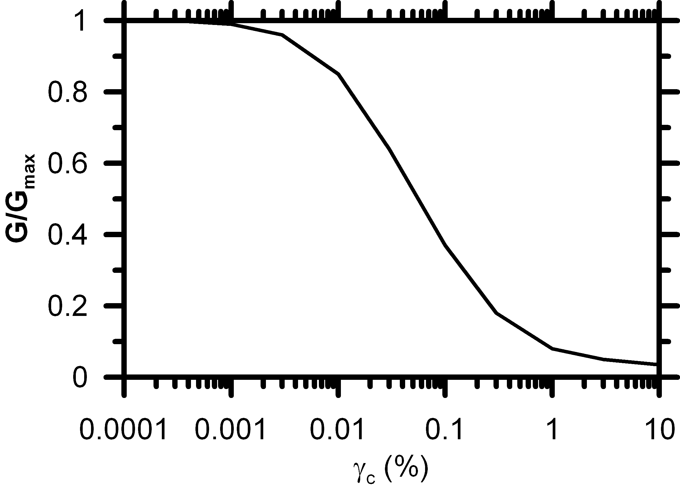
(a)
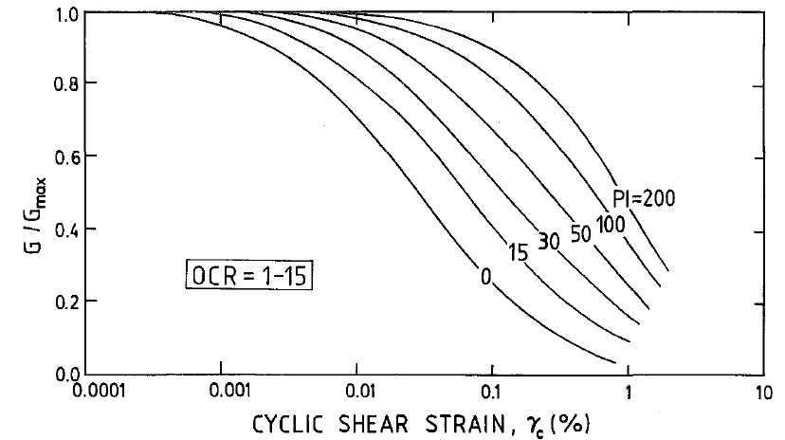
(b)
Figure 1. Modulus reduction curves for (a) sand (Seed and Idriss 1970) and (b) clay (Vucetic and Dobry 1991).

The importance of G_{max} has been widely recognized in ground motion prediction equations by implementation of site factors that modify ground motion based on the difference between a site V_{s} parameter and a reference V_{s} parameter. For example, Choi and Stewart (2005) utilized the average V_{s} in the upper 30m, called V_{s30}, and the Next Generation Attenuation relations include V_{s30} as an input parameter.
Geophysical measurements have become very common for geotechnical projects where vibrations are expected, though this was not always the case. Many older site investigations gathered information only the geologic setting, stratigraphy, and penetration resistance (SPT blow counts, or cone penetration resistance). Lack of geophysical measurements from older site investigations is particularly pertinent for bridges since many State Departments of Transportation own thousands of bridges, many of which were constructed before geophysical measurements were common. For example, Caltrans owns about 13,000 bridges, most of which were constructed before 1970. As ground motion prediction equations have advanced to include V_{s} values as inputs, there is a need to estimate V_{s} at the older bridges based on available information to guide retrofit evaluations. Correlations between shear wave velocity and blow count, geologic setting, and site stratigraphy are therefore potentially useful at least as a screening tool for identifying a subset of bridges where geophysical measurements would be the most beneficial.

Literature Review

Numerous relations between SPT blow count, N, and shear wave velocity, V_{s}, exist in the literature. Early efforts utilized laboratory results to develop correlations, and the correlations were subsequently refined as field measurement of V_{s} became more common and data became available. The early correlations based on field data often involved blow counts that were not corrected for energy, rod length, or sampler inside diameter. Hence, it is impossible to know whether bias is introduced by hammer efficiency, non-standard samplers, etc. Furthermore, various methods of measuring V_{s} were utilized in the correlations, including cross-hole, seismic CPT, spectral analysis of surface waves (SASW), and suspension logging. These different methods provide very different resolutions for V_{s} measurements at different depths. For example, SASW uses low frequencies to measure deep shear wave velocities, and the resulting measurement is averaged over a large mass of soil, but provides fairly high-resolution measurements near the surface whether other methods are often less accurate. Spatial resolution with depth suffers as a result, and it is unclear how a point estimate of N should correlate with a vertically averaged estimate of V_{s}. Cross-hole methods and suspension logging methods use higher frequency waves that average the properties of a much smaller mass of soil, and therefore provide a higher resolution point estimate similar in spatial scale to an SPT blow count.
The most common functional form for the relations proposed in the literature is V_{s}=A∙N^{B}, where the constants A and B are determined by statistical regression of a data set. The N-values are typically not corrected for overburden, but sometimes are corrected for hammer energy, rod length, and sampler inside diameter, in which case N would be replaced by N₆₀. The V_{s}-values are typically not corrected for overburden.
A significant number of correlations have been published on various soil types (Table 1). Imai and Yoshimura (1975) studied the relationship between seismic velocities and some index properties over 192 samples and developed empirical relationships for all soils. Sykora and Stokoe (1983) pointed out that geological age and type of soil are not predictive of V_{s} while the uncorrected SPT-N value is most important. Sykora and Koester (1988) found strong statistical correlations between dynamic shear resistance and standard penetration resistance in soils. Iyisan (1996) examined the influence of the soil type on SPT-N versus V_{s} correlation using data collected from an earthquake-prone area in the eastern part of Turkey. The results showed that, except for gravels, the correlation equations developed for all soils, sand and clay yield approximately similar V_{s} values. Jafari et al (2002) presented a detailed historical review on the statistical correlation between SPT-N versus V_{s}. Hasancebi and Ulusay (2006) studied similar statistical correlations using 97 data pairs collected from an area in the north-western part of Turkey and developed empirical relationships for sands, clays, and for all soils irrespective of soil type. Ulugergerli and Uyanık (2007) investigated statistical correlations using 327 samples collected from different areas of Turkey and defined the empirical relationship as upper and lower bounds instead of a single average curve for estimating seismic velocities and relative density.
Table 1. Some existing correlations between V_{s} and SPT-N
Significant differences exist among the various published relations, which is likely partially caused by differences in geology, but also by errors in measurements of N and V_{s}. Resolving the differences among published relationships is beyond the scope of this thesis.
In this thesis, particular attention is given to the functional form used to relate V_{s} to N₆₀. Nearly every relation represents V_{s} directly as a function of N without consideration for vertical effective stress, including the very early relations and more recent ones [e.g., Dikmen (2009) and Hasancebi and Ulusay (2007)]. One exception is Andrus et al. (2004), who related V_{s1} to (N₁)₆₀ (i.e. overburden corrections are applied to V_{s} and N₆₀ before regression). Sykora and Stokoe (1983) evaluated V_{s} as a function of (N₁)₆₀ and found poor correlation and suggested correlating with N₆₀ instead. Hence, of the 26 relations summarized in Table 1, 25 of them utilize the same functional form and neglect the influence of overburden.

Influence of Overburden Stress

V_{s} and N are known to normalize differently with overburden stress, so it is surprising that most correlations relate V_{s} to N instead of V_{s1} to (N₁)₆₀. Equations 1 and 2 are common overburden correction equations for N₆₀ and V_{s}.
(1)
(2)
Differences in the manner in which V_{s} and N₆₀ normalize with σ_{v}’ would be expected to introduce bias into relations directly between V_{s} and N₆₀. For example, consider three different profiles of uniform clean sand with γ = 20 kN/m³, (N₁)₆₀= 20 and a deep water table as shown in Fig. 2. Based on the relation by Andrus et al. (2004), V_{s1} = 87.8(N₁)₆₀^{0.253} = 187 m/s. Assuming n=0.5 and m=0.25, profiles of N₆₀ and V_{s}

are plotted in Fig. 2. To demonstrate bias introduced in the Vs-N relation, the V_{s} values are also plotted by assuming the Andrus et al. relation directly relates V_{s} with N₆₀ [rather than V_{s1} with (N₁)₆₀]. The two methods produce identical estimates of V_{s} at when σ_{v}’ = P_{a} (about 5m depth), but diverge significantly shallower and deeper in the profile. The only rational method for eliminating the bias is to correlate V_{s1} with (N₁)₆₀ while utilizing the correct overburden correction factors.

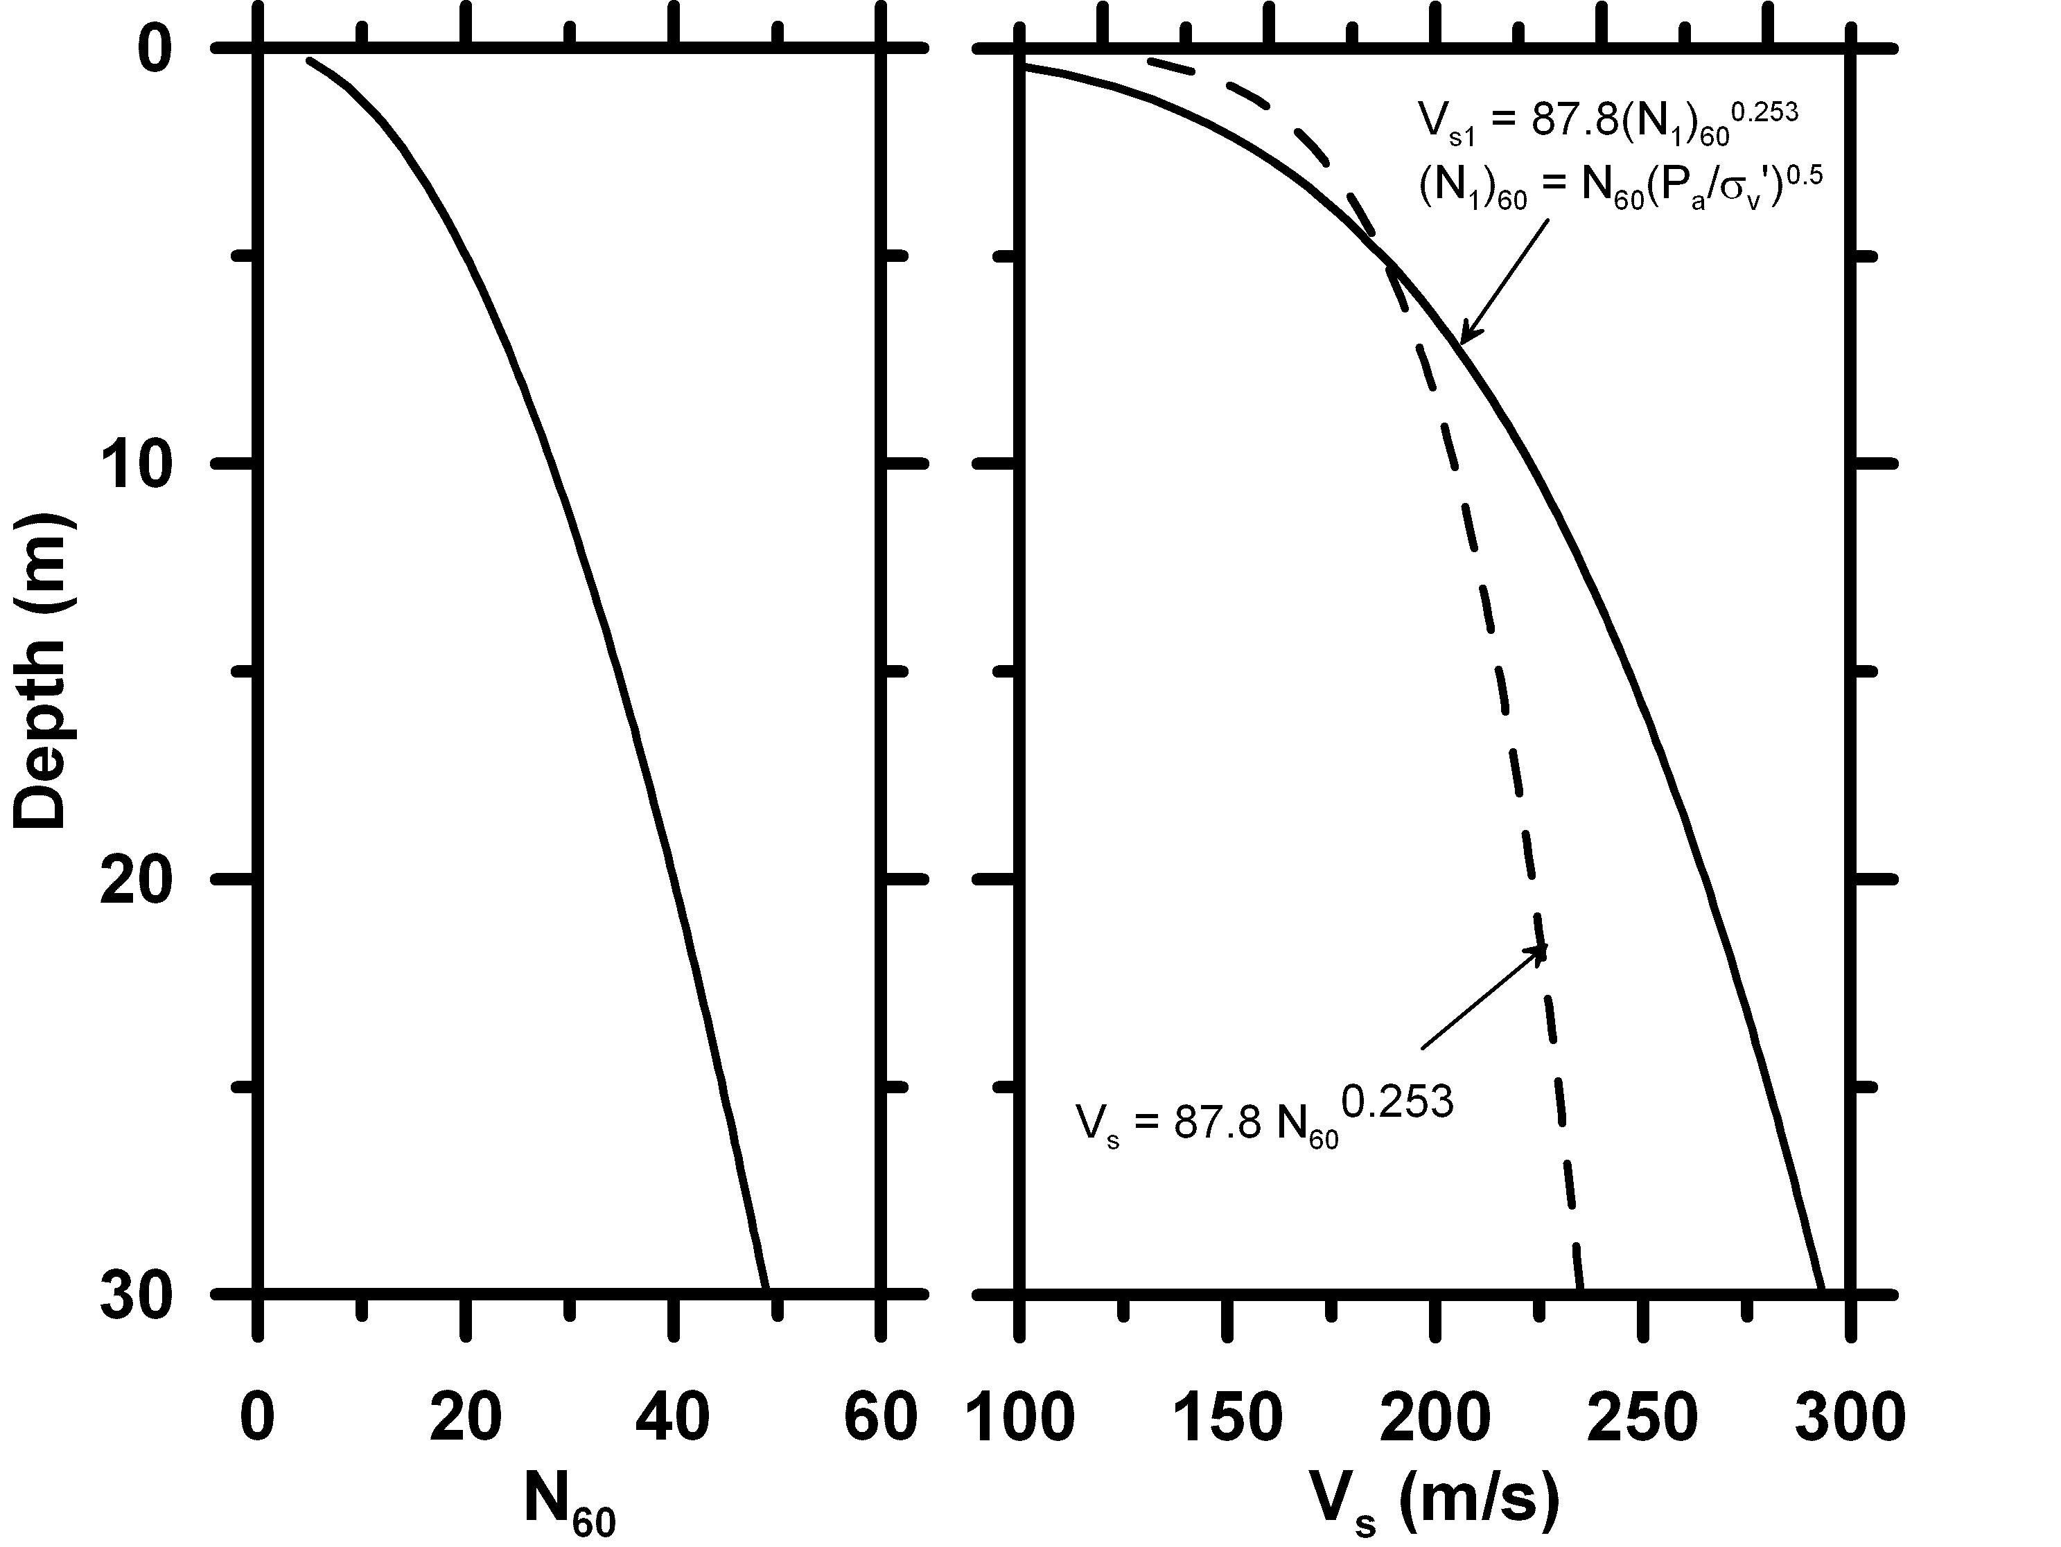
Figure 2. Influence of overburden on V_{s} values associated with constant N₆₀ but different (N₁)₆₀

The exponents n and m in Eqs. 1 and 2 are often taken as 0.5 and 0.25, respectively, but these are empirical constants that exhibit variation. For example, the exponent m is known from laboratory studies to depend on plasticity index and varies between 0.25 for clean sands and 0.5 for cohesive soil (Yamada et al. 2008). Furthermore, the cementation that naturally occurs in older sands is known to affect small-strain behavior (i.e. V_{s}) more than large-strain behavior (i.e. N₆₀). For example, DeJong et al. (2006) tested loose sand specimens cemented using gypsum and calcite precipitated by bacteria and found that V_{s} increased by as much as a factor of 4 due to cementation using bender element measurements in triaxial compression specimens. When the specimens were tested in undrained triaxial compression, the cemented specimens were stiffer initially but converged with the uncemented shear strength. The standard penetration test induces extremely large strains in the soil in the immediate vicinity of the sampler; hence it would be expected to obscure the influence of age-induced cementation. Therefore, it is reasonable to anticipate that the exponent m may increase with age, and age increases with depth and σ_{v}’. Recent studies have explored the influence of age on SPT-based liquefaction resistance since cementation increases liquefaction resistance more than N₆₀ (e.g., Hayati and Andrus 2009). Since n and m depend on soil type, cementation, age, and other factors, it is difficult to accurately correct N₆₀ and V_{s} to obtain (N₁)₆₀ and V_{s1} to produce a relation that is unbiased with respect to overburden. On the other hand, a σ_{v}’ term could be included in the regression of V_{s} with N₆₀ to inherently define the relative scaling of n and m for a particular data set. This is the approach adopted in this paper, as explained in chapter 4.

Development of Data Set

This study utilized data from a set of boreholes at Caltrans bridge sites where SPT N-values and downhole suspension logs were obtained. A total of 21 bridges and 79 boring logs were identified where N₆₀ and V_{s} measurements were available from the same borehole (Table 2). Locations of the bridges are shown in Fig. 3.
Table 2. Bridge name, number, location, number of borings, and surface geology epoch for sites included in this study.
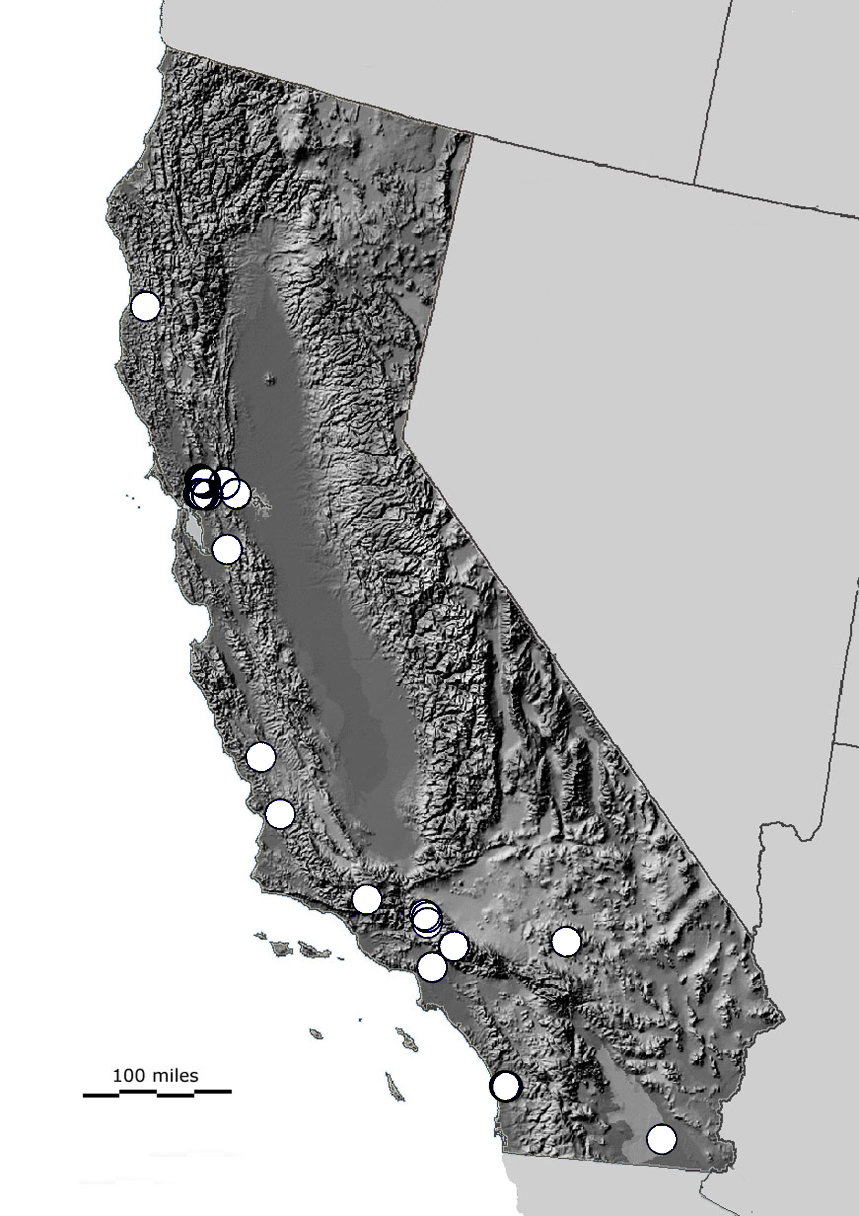

Figure 3. Map of sites where boring logs and suspension logs were measured for this study.
Boring logs were contained in as-built drawings provided by Tom Shantz of Caltrans in tif image format, and were digitized by recording blow count and soil type for each SPT measurement, and the site stratigraphy was also digitized based on the site geologist’s or engineer’s interpretation. Corrections to the stratigraphy were often made so that transitions in the V_{s} profile better corresponded to interpreted layer boundaries. Elevation of the top of the bore hole, ground water elevation, date, GPS coordinates, type of boring, size of borehole, size of sampler, hammer type and sampler type were recorded for each boring log. A few boreholes had N-values recorded as “P” or “push” when sampler sank under the weight of the rod were excluded from the data set for regression. Some blow counts were also terminated before the sampler was driven the full 18”, and were recorded, for example, as 50/4”. Such blow counts were excluded from the data set utilized in the regression.
Shear- and p-wave velocity logs were provided by Tom Shantz as Excel files, and were recorded using the downhole suspension logging method explained by Owen (1996). In this method, a probe is lowered down the open fluid-filled borehole and the source at the tip of the probe excites a wave that propagates through the boring fluid into the soil and is recorded by two receivers at 1m spacing attached to the probe above the source. The data were subsequently evaluated for quality as explained by Owen (1996), and poor quality data for which the recorded traces were difficult to evaluate were eliminated from the data set.
From the combination of boring logs and suspension logs, a total of 918 N₆₀ values were available where V_{s} values were recorded at the same depths. Fig. 4 shows the distribution of available data by soil type, which was determined by visual manual classification in the boring logs. For some boreholes V_{s} values were not recorded at shallow depths where N-values were available, and V_{s} values often were recorded deep in the profile where N₆₀ was not recorded. Only the combinations where N-values and V_{s}-values were recorded at the same depth were included in the 918 data points. All of the data were collected between 1993 and 2001.
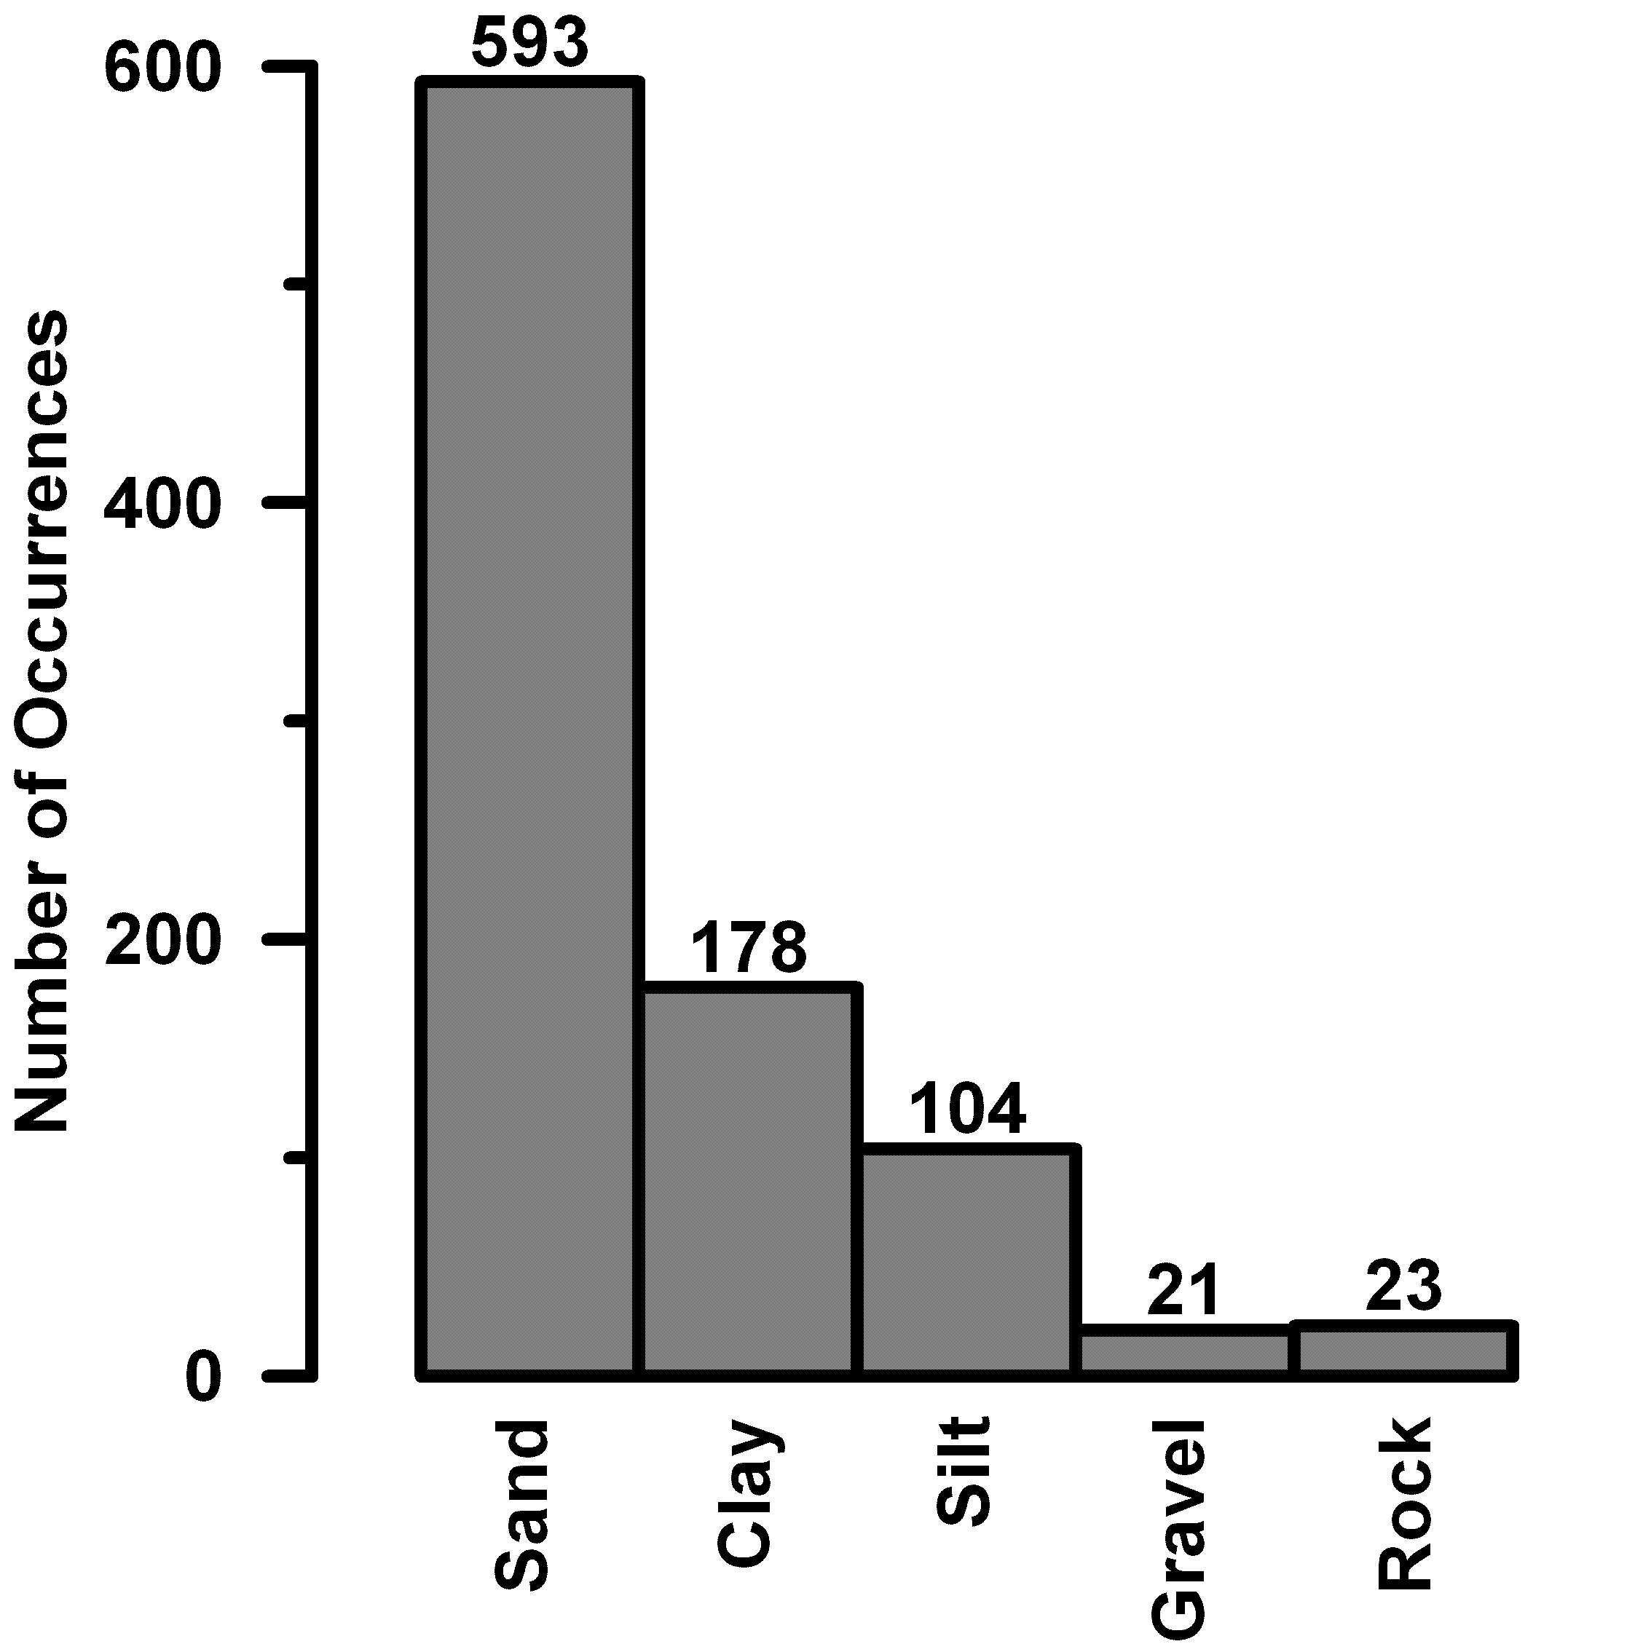
Figure 4. Distribution of data points by soil type.

The standard SPT sampler was used for all of the borings and the hammer type was either a safety hammer with an estimated efficiency of 60%, or an automatic hammer with an estimated efficiency of 82% based on previous Caltrans research (Tom Shantz, personal communication). A rod length correction factor was applied based on the information in Table 2. A liner correction factor of 1.0 was applied for samplers with liners and 1.2 for samplers without liners, which is in the middle of the range suggested by Youd et al. (2001). Some information was not included in every boring log. For example, ground water elevation was sometimes not recorded, in which case the p-wave velocity profile provided in the downhole suspension logs was used to identify the approximate elevation of the ground water table. Typically an abrupt transition from p-wave velocity lower than 500m/s to 1500m/s or higher was apparent in the boring logs and ground water elevation could be estimated with approximately 1m resolution. Whether the sampler was driven with liners was also not always available, in which case a liner correction of 1.0 was applied. Unit weights were reported only for some samples in the boring logs, and the average values for each soil type (Table 4) were assigned to samples for which unit weight was not reported.
Table 3. Rod length correction factors (Source: Youd et al., 2001).

Table 4. Unit weights.
Example data from the Noyo River Bridge is shown in Fig. 5. The first two graphs show the V_{s} profile and N₆₀ profile at the site. The V_{s} profiles were typically recorded at 0.5m intervals, whereas the N₆₀ values were recorded at much coarser sampling intervals typically 1.5m or larger. A number of possible approaches were considered for selecting an appropriate V_{s} value to associate with each N₆₀ value for statistical regression.
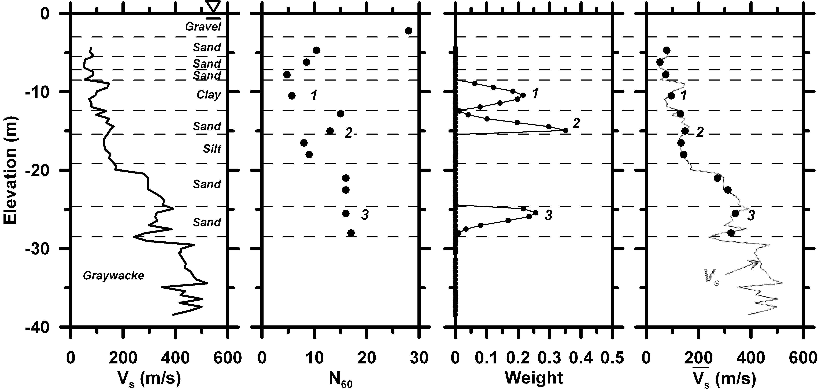
Figure 5. Example of data processing methodology to obtain weighted average value for statistical regression.

The first possibility considered was to select the V_{s} value at the elevation that is nearest to the elevation where the N₆₀ value was recorded. This approach was dismissed because high-frequency spatial variations in the V_{s} profiles could introduce errors in the regression. SPT N-values are not true point estimates, but rather average out soil properties over a finite region, and it is therefore important to obtain a V_{s} estimate that exhibits similar averaging.
The approach adopted in this study utilized a weighted average of the V_{s} profile with the weighting values inversely proportional to the difference in elevation between the N₆₀ measurement and the V_{s} measurements. The weights were computed from a truncated normal distribution centered at the N₆₀ elevation with a standard deviation of 1m. Layer corrections were not applied to the recorded blow counts. The probability density function was truncated at layer boundaries (i.e. weights were set to zero outside of the stratum containing the N₆₀ value). The weighted average shear wave velocity, , was computed using Eq. 3. Fig. 5 shows the weight functions and resulting values for three different N₆₀ values in the boring log. Point 1 shows a boring log near the center of a stratum, where the weighting function is not significantly truncated at layer boundaries. Point 2 shows an N₆₀ value near the bottom of a stratum that is truncated in the sand layer, and does not contain any influence of the underlying silt layer. Point 3 shows an N₆₀ value near the top of a dense sand layer that is truncated so that the upper looser sand layer does not provide influence. Fig. 5 also shows an N₆₀ value in the upper gravel layer, which lies above the elevation where V_{s} measurements commenced. This N₆₀ value is therefore not associated with a value and was not included in the regression. Furthermore, the N₆₀ values terminate when the underlying greywacke rock formation is reached, though V_{s} values continue into this formation. are therefore also not available in the greywacke formation and this layer is not included in the statistical regression.
(3)

Statistical Regression

Regression Analysis

The form of statistical regression utilized in this study expresses in terms of N₆₀, σ_{v}’, and regression constants, where is in m/s and σ_{v}’ is in kPa. The form of the regression equation differs from past studies by including σ_{v}’, as shown in Eq. 4.
(4)
Re-arranging and expressing in terms of natural logs, the functional form in Eq. 5 is obtained, where β₀ = lnA, β₁ = B, β₂ = n∙B-m, and ε is a random error term that is normally distributed with zero mean. Overburden correction was not directly applied to N₆₀ and [i.e. V_{s1} and (N₁)₆₀ were not computed prior to regression], but rather the β₂ parameter provides a measure of the relative overburden scaling between and N₆₀ that minimizes residuals with respect to σ_{v}’ simultaneously with N₆₀.
(5)

The β-constants were solved using ordinary least squares regression according to Eq. 6, where a single underline indicates a vector and a double underline indicates a matrix.
(6)

Regression was performed for sand, silt and clay soil types. The number of data points for gravel was deemed insufficient for regression.
Results of the regression parameters are contained in Table 5, and plotted in Fig. 6 as versus N₆₀ and versus P_{a}/σ_{v}’. Trend lines are plotted through the data points corresponding to various P_{a}/σ_{v}’ values for versus N₆₀ and for various N₆₀ values for versus P_{a}/σ_{v}’. Multiple trend lines are required since the regression includes both N₆₀ and P_{a}/σ_{v}’, and the trend lines are useful for identifying the relative influence of N₆₀ and P_{a}/σ_{v}’ for the regression of each soil type.
Table 5. Regression constants and standard deviation of error term.
For sand, P_{a}/σ_{v}’ exerts significant influence on . For example, considering sand with N₆₀=30, the regression equation returns median values of = 323, 274, and 233 m/s for P_{a}/σ_{v}’ = 0.25, 0.5, and 1.0, respectively. This trend is consistent with the example problem in Fig. 2, where for a given N₆₀ value, soil with higher σ_{v}’ (and lower P_{a}/σ_{v}’) exhibits higher V_{s}. On the other hand, for P_{a}/σ_{v}’=0.5, the regression equations return median values of = 245, 274, and 310 m/s for N₆₀ = 10, 30, and 100, respectively. This indicates that, in the range of common engineering interest, is more strongly related to overburden stress than to blow count. This finding is significant since the effect of overburden has not been directly quantified in many past studies, and may help explain the large differences among the numerous published relations.
The influence of P_{a}/σ_{v}’ decreases for silt and is the lowest for clay. For example, considering clay with N₆₀=30, the regression equation returns median values of = 322, 293, and 267 m/s for P_{a}/σ_{v}’ = 0.25, 0.5, and 1.0, respectively. On the other hand, for P_{a}/σ_{v}’=0.5, the regression equations return median values of = 223, 293, and 395 m/s for N₆₀ = 10, 30, and 100, respectively. Hence, V_{s} is more strongly related to blow count than overburden stress in the range of engineering interest for clay, which is opposite to the trend for sand. However, in all cases V_{s} was influenced by σ_{v}’, and neglecting the overburden effect would introduce bias into the results, as demonstrated later.
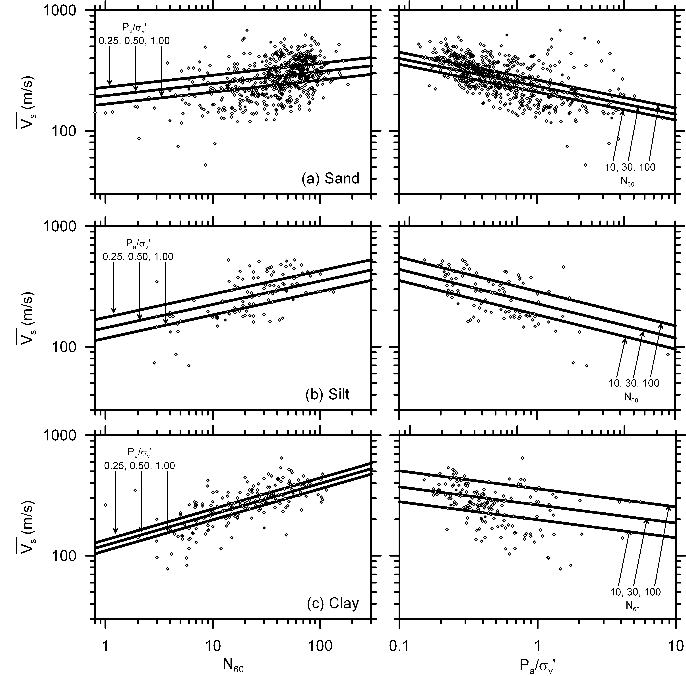
Figure 6. V_{s} versus N₆₀ and P_{a}/σ_{v}’ for (a) sand, (b) silt, and (c) clay, and lines showing results of regression equations for various N₆₀ and P_{a}/σ_{v}’ values.

The β₂ values obtained by the statistical regression provide information about the relative overburden scaling for V_{s} and N₆₀. Individual values of n and m cannot be solved from the regression, but one can be computed based on the regression parameters β₁ and β₂ since β₂ = n∙ β₁-m. For example, if n=0.5, then m=0.29, 0.38, and 0.26 for sand, silt and clay, respectively. However, n and m are known to depend on soil type (e.g., Yamada et al. 2008) and contain uncertainty. Correcting N₆₀ and V_{s} prior to regression might cause bias with respect to σ_{v}’, which is eliminated in the regression approach adopted in this study.

Residuals

Residuals defined as ln() – [β₀ + β₁ln(N₆₀) + β₂ln(P_{a}/σ_{v}’)] are plotted versus N₆₀ and (P_{a}/σ_{v}’) in Fig. 7. The mean value of the residuals is zero, and there is no trend in the residuals with either N₆₀ or (P_{a}/σ_{v}’), which indicates that the regression has removed bias with respect to these input variables. The standard deviation of the residuals is 0.286, 0.282, 0.290 and 0.306 for sand, silt, clay and all soils respectively. However, the data sample is heteroskedastic, with higher standard deviations at low confining stress. The larger uncertainty at shallow depths may be caused by measurement uncertainty, though the cause is not known. In addition to computing the standard deviation of the residuals, the distribution is required for quantifying the error term in Eq. 5. Normality of the residuals is examined using the quantile-quantile (Q-Q) plots in Fig. 8. The Q-Q plots represent the sorted residuals (i.e. the quantiles) versus the theoretical residuals that would be anticipated if the error term is normally distributed.
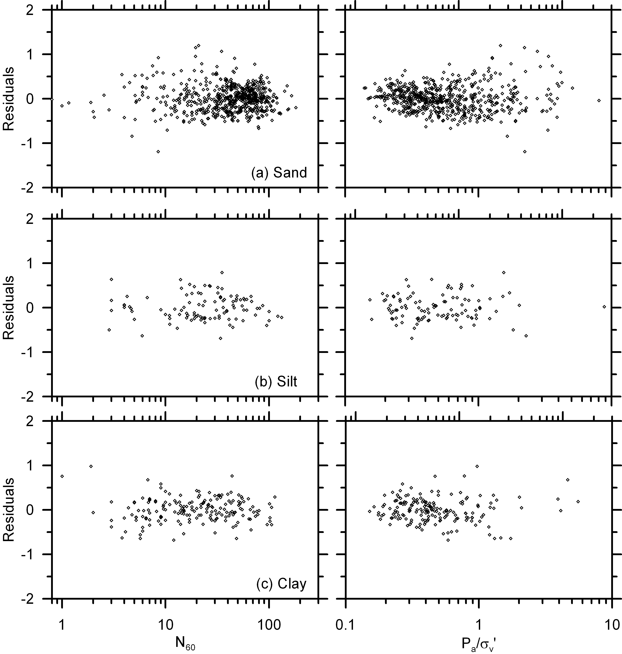
Figure 7. Residuals, defined as natural log of measured V_{s} values minus natural log of predicted V_{s} values, versus N₆₀ and P_{a}/σ_{v}’ for (a) sand, (b) silt, and (c) clay.

When measured quantiles are plotted against theoretical quantiles, a normally-distributed variable exhibits a linear Q-Q plot with a slope of unity, whereas deviation from normality is manifested by data points that do not lie along the 1:1 line. Some deviations at the ends of the Q-Q plots are anticipated based on sampling variability since the tails of distributions are often not well-sampled. The error terms in this case are reasonably approximated by a normal distribution, and deviation from normality is slightly positive at the tails of the distribution, indicating that the tails may contain slightly more probability density than implied by a normal distribution. However, this may also be due to sampling error, and the data support the conclusion that the error term is normally distributed.

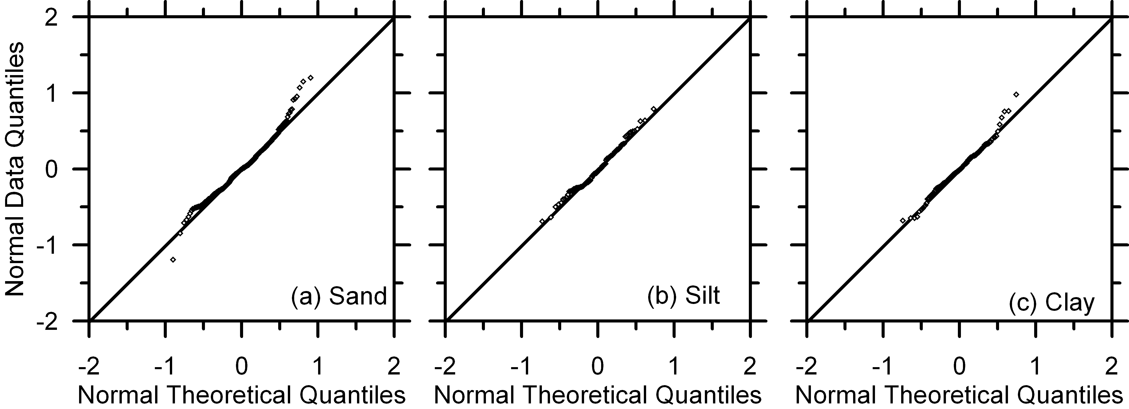
Figure 8. Quantile-quantile plots indicating the extent to which the error term is normally distributed for (a) sand, (b) silt, and (c) clay.

Influence of Surface Geology

Fig. 9 plots the same data as Fig. 6, but with different symbols corresponding to Holocene, Pleistocene, and Pre-Quaternary geologic epochs for the soil at the surface. Surface geology mapping was based on a Caltrans-funded study by Keith Knudsen (not yet published) where the surface geologic epoch at all Caltrans bridge sites was obtained. The data show no significant trend with surface geology.

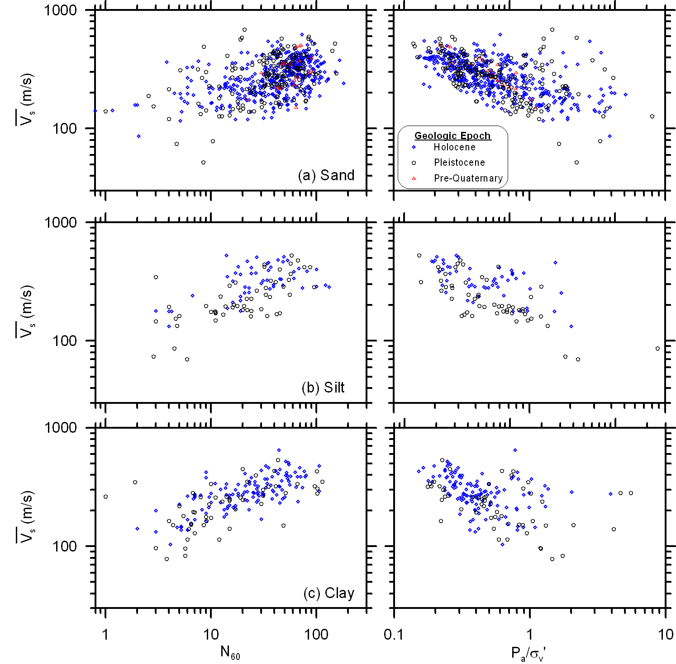
Figure 9. V_{s} versus N₆₀ with different symbols indicating different surface geologic epoch for (a) sand, (b) silt, and (c) clay.

In fact, soil with Pleistocene surface geology exhibits slightly lower average N₆₀ and V_{s} values than soil with Holocene surface geology, though the differences are not statistically significant and are likely related to the fact that the average overburden stress is also smaller for the Pleistocene data points. The observation of non-dependence on surface geology is surprising since age is known to be associated with cementation and higher strength and stiffness, but the observation is consistent with a number of previous studies (e.g., Sykora and Stokoe 1983) that also found that surface geology did not affect the correlation. One possible explanation for the non-dependence is that the V_{s}-N₆₀ pairs came from a range of depths, and sites with Holocene surface geology may be underlain by Pleistocene deposits. Hence, many of the data points in Fig. 9 associated with a Holocene symbol may have actually come from a Pleistocene or Pre-Quaternary geologic unit, particularly those with high σ_{v}’ since these samples were deeper in the profile.

Effect of Omitting σ_{v}’ Term

To demonstrate the bias caused by omitting the overburden term from regression, the regression analysis has been carried out directly between N₆₀ and for all soils, sand, silt and clay. The following formulae were obtained by using the existing dataset:
 | for all soils | (7)
 | for sands | (8)
 | for silts | (9)
 | for clays | (10)
The residuals of the data for sand are plotted versus N₆₀ and versus P_{a}/σ_{v}’ in Fig. 10. As expected, there is no bias with respect to N₆₀. However, there is significant bias with respect to the overburden term. Residuals are positive at high overburden stress (i.e. at low P_{a}/σ_{v}’), indicating V_{s} is underestimated, and negative at low overburden stress (i.e. at high P_{a}/σ_{v}’). This evidence suggests that similar bias is present in published relations that directly correlate V_{s} with N, which may help explain why the published relations differ so significantly from each other.

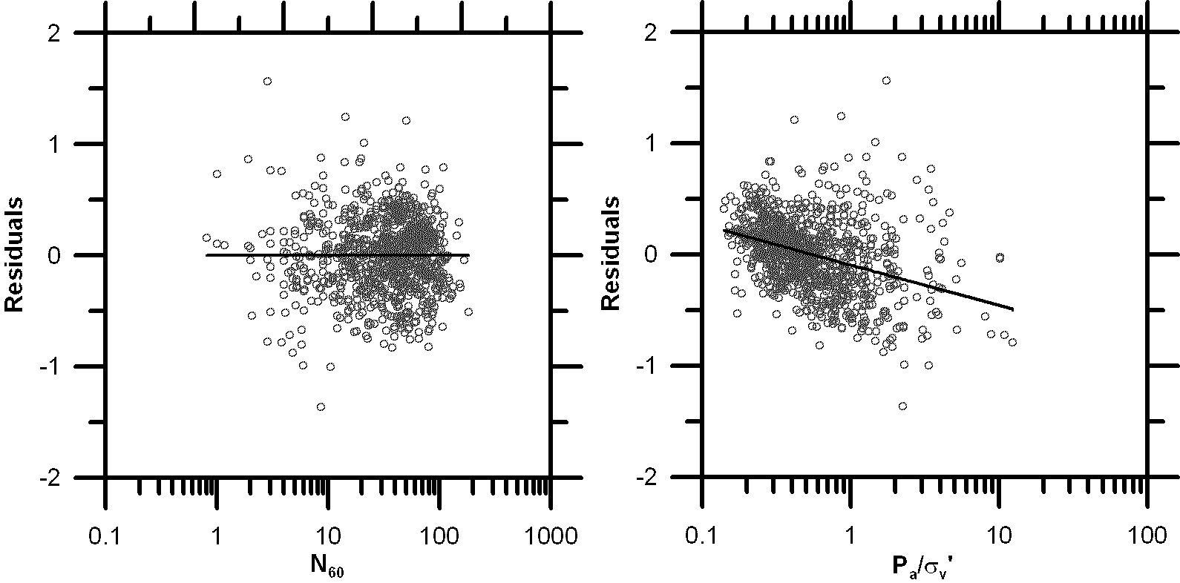

Figure 10: Residuals versus N₆₀ and P_{a}/σ_{v}' for regression for all soils without overburden term.

Comparison with Published Relations

Some of correlations from Table 1 are plotted against the data in Fig 11. Some of the correlations fit the data points reasonably well, though there is tremendous difference in the range of V_{s} values predicted for a given N value. It is unclear how much of these deviations are caused by natural variability in soil deposits, how much is caused by errors in measurements of N and V_{s}, and how much is caused by exclusion of overburden correction in the existing relations. For example Kanai (1966) may have utilized data recorded primarily at shallow depths, which could largely explain why their relation is lower than the others. Future efforts should aim to reduce the variability in these relations by utilizing only high-quality measurements of N and V_{s}, and properly incorporating the influence of overburden. This effort would involve re-interpretation of the data available in published relations, which is beyond the scope of this thesis.
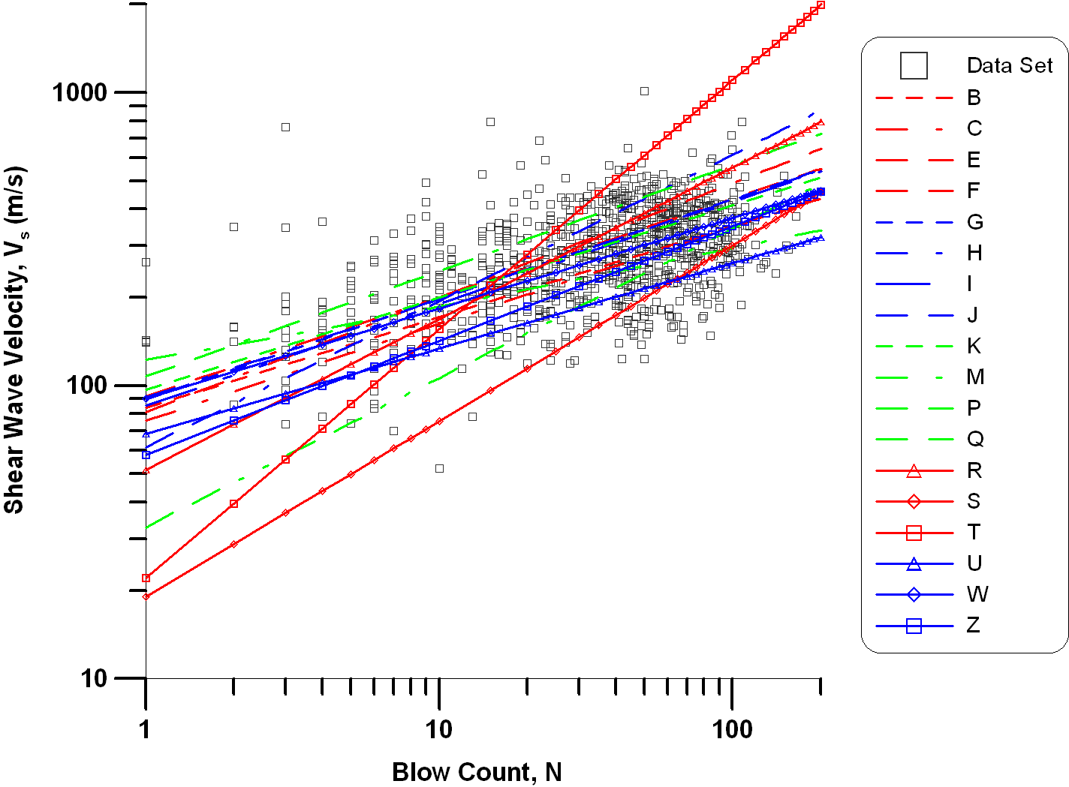
Figure 11: Existing correlations from literature over the current data set

Conclusions

In this study, shear wave velocity, V_{s}, was related to N₆₀ and P_{a}/σ_{v}’. A total of 21 bridges and 79 boring logs were identified where N₆₀ and V_{s} measurements were available from the same borehole for the study from Caltrans. Only the combinations where N-values and V_{s}-values were recorded at the same depth were included in the 918 data points for the regression analysis. Published relations typically neglect the influence of overburden, which was shown in this study to be an important contributor when predicting V_{s}. In fact, V_{s} is correlated more closely with P_{a}/σ_{v}’ than with N₆₀ for sand. This implies that if you had to predict V_{s} using either N₆₀ or P_{a}/σ_{v}’ (but not both), P_{a}/σ_{v}’ would on average provide a more accurate estimate. Of course, knowing both N₆₀ and σ_{v}’ would provide a better estimate, but this simple finding demonstrates a significant deficiency in most published relations, which neglect overburden effects. For silt and clay, V_{s} correlated more closely with N₆₀ than P_{a}/σ_{v}’, but overburden nevertheless exerted an important influence.
N₆₀ and P_{a}/σ_{v}’ are not exceptionally efficient predictors of V_{s}, and the resulting uncertainty is significant as demonstrated by the large scatter of the data in Fig. 6. The standard deviation of the residuals was about 0.3, which implies a coefficient of variation of about 30%. This large uncertainty is not surprising since V_{s} is a small-strain property, while N is a large-strain property. If the outcome of a problem depends significantly on V_{s}, correlations with blow count should not be relied upon. Rather, geophysical measurements should be made since any method for measuring V_{s} would be anticipated to provide a more accurate estimate than the proposed relations.
A likely application of the correlations presented in this work is the calculation of the thirty-meter shear wave velocity, V_{s30}, which is defined as 30m divided by the travel time of a vertically propagating shear wave in the upper 30m. V_{s30} is a required input for the Next Generation Attenuation models [Boore and Atkinson (2008), Campbell and Bozorgnia (2008), Abrahamson and Silva (2008), Chiou and Youngs (2008)] and is therefore needed to quantify seismic hazard. Geotechnical site investigations at many older sites contain boring logs, but no geophysical measurements. Obtaining a rough estimate of V_{s30} based on the recorded boring logs could therefore be useful for assessing seismic hazard at sites with that lack geophysical measurements, and for identifying whether geophysical measurements are necessary to further refine the estimate of V_{s30}. Though beyond the scope of this thesis, a useful study would compare V_{s30} values obtained directly by the suspension logs with those obtained by correlation with N60 and P_{a}/σ_{v}’. Regarding the manner in which uncertainty in the point estimate of V_{s} propagates through to calculation of V_{s30}, a particularly important concept is division of the error term into inter-boring and intra-boring components. Inter-boring error is the scatter of the data points about a trend for that particular boring, while intra-boring error identifies whether estimated V_{s} values for a given boring are systematically under- or over-estimated using the proposed relations. If intra-boring error terms are small, then the variability in point estimates of V_{s} would be canceled out since an approximately equal number of over-predictions and under-predictions would occur. In this case, V_{s30} estimates would be reasonably accurate using the proposed relations. On the other hand, if intra-boring errors are significant, then V_{s30} would be systematically under-predicted at high V_{s30} sites and systematically over-predicted at low V_{s30} sites. By inspection of the plots in the Appendix, intra-boring error terms are significant for this data set, and more work is needed to quantify uncertainty in V_{s30}.
The proposed relations are not an accurate substitute for geophysical measurements, and uncertainty in the predictions should be considered when using the relations. The primary purpose of the relations is to aid decisions regarding whether geophysical measurements are warranted for a particular problem and site.

Appendix

This appendix includes plots of vertical effective stress, SPT blow count (N₆₀), measured shear wave velocity (V_{s}) and predicted shear wave velocity versus elevation for all boring logs utilized in this study.
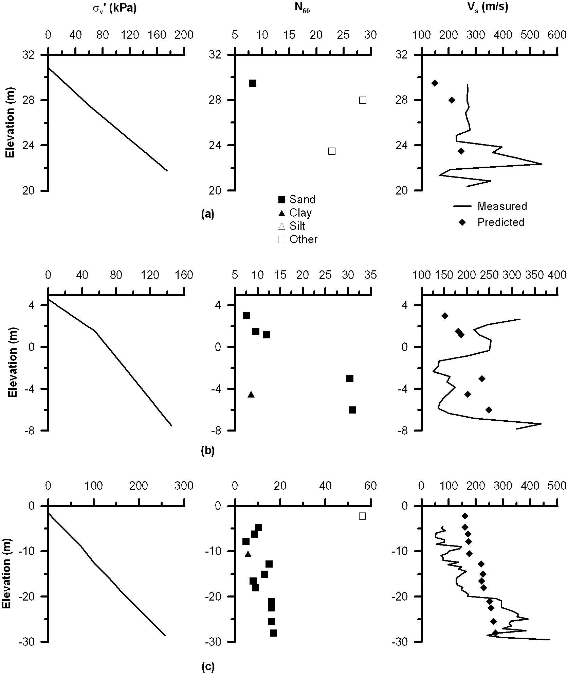
Figure 12. (a) Bridge no. 10-0298, boring no. 98-4 (abut.4), (b) Bridge no. 10-0298, boring no. 96-2, (c) Bridge no. 10-0298, boring no. 96-3.

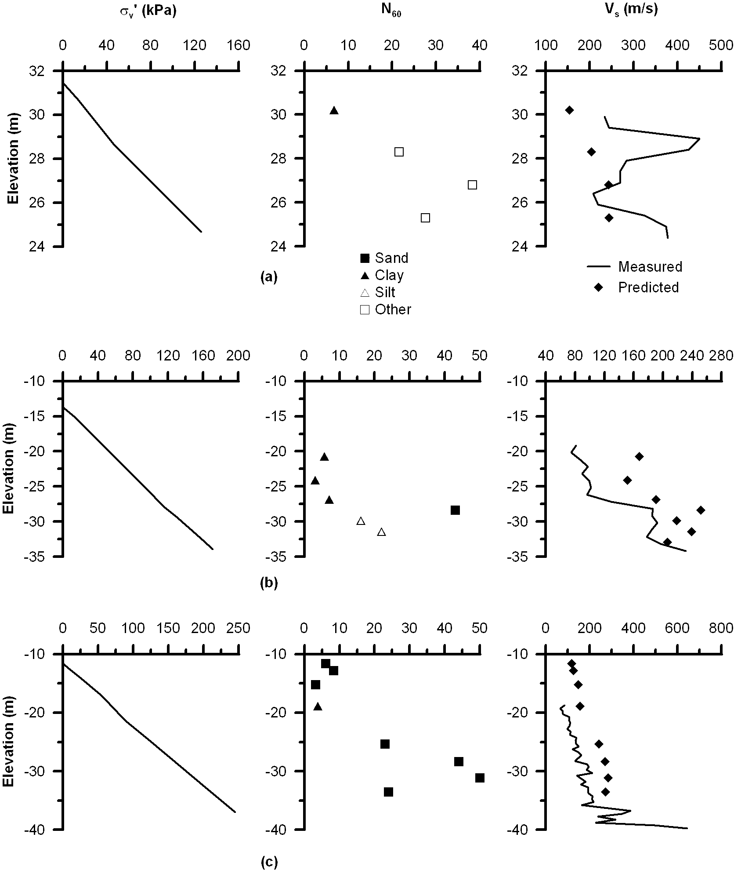
Figure 13. (a) Bridge no. 10-0298, boring no. 98-10 (abut 1) (b) Bridge no. 28-0253R, boring no. 94B1R (Pier 9) (c) Bridge no. 28-0153R, boring no. 96-5 (Pier 8)
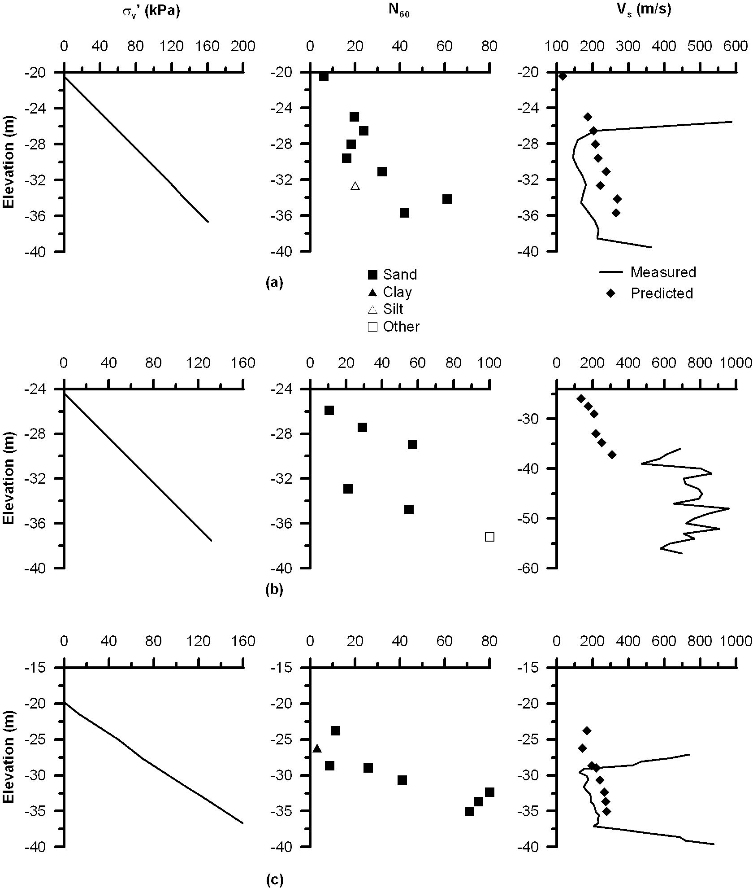
Figure 14. (a) Bridge no. 28-1053R, boring no. 95B13R (Pier 7) (b) Bridge no. 28-1053R, boring no. 96-4 (Pier 7) (c) Bridge no. 28-1053R, boring no. 95-12 (Pier 5)
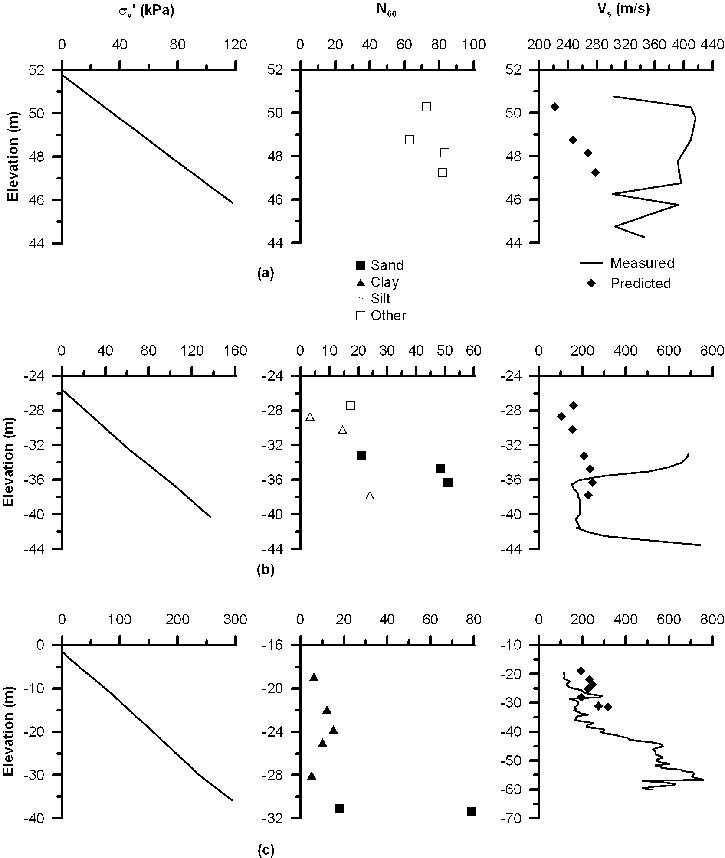
Figure 15. (a) Bridge no. 28-0352L, boring no. 96B-29 (b) Bridge no. 28-0352L, boring no. 95-2 (Pier 3) (c) Bridge no. 28-0352L, boring no. 95-1 (Pier 4)
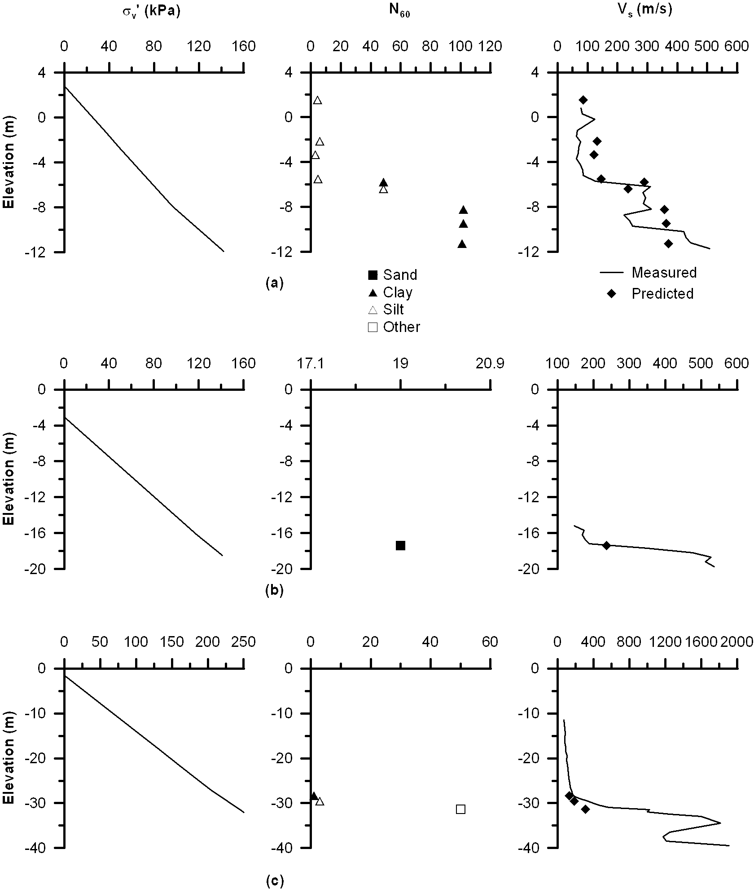
Figure 16. (a) Bridge no. 28-0352L, boring no. 96B-37 (b) Bridge no. 28-0100, boring no. 96-2 (Piers 10 and 11) (c) Bridge no. 28-0100, boring no. 96-5 (Piers 31/32)
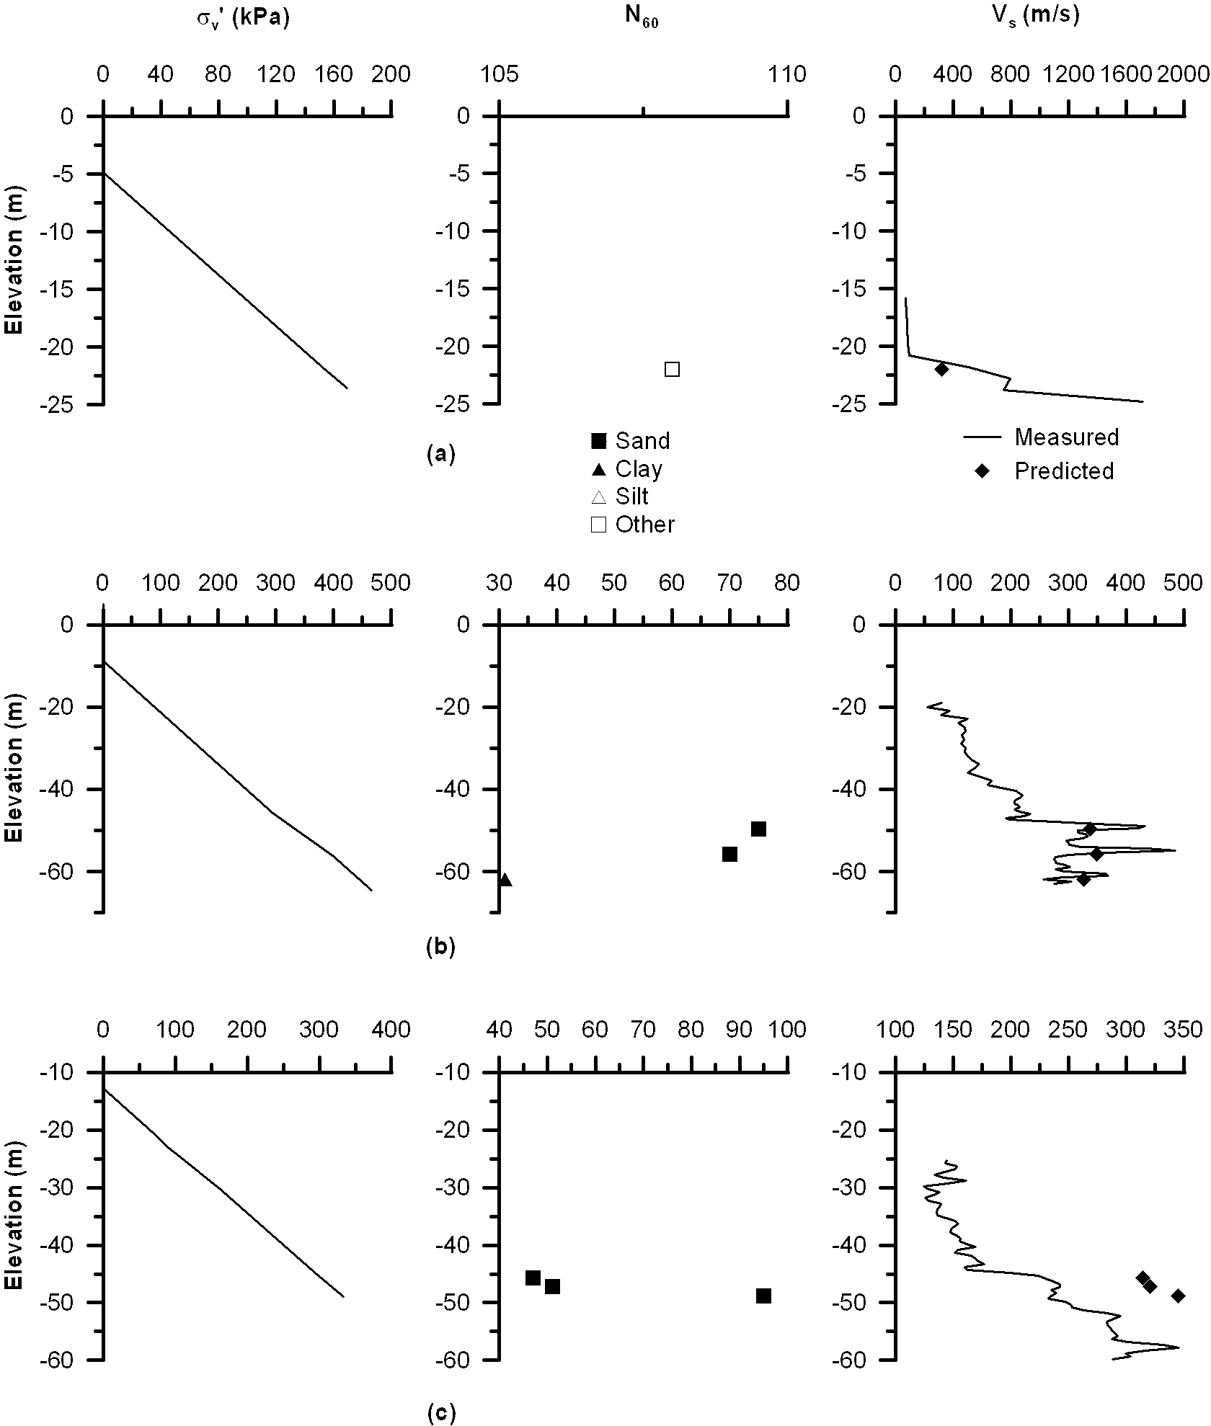
Figure 17. (a) Bridge no. 28-0100, boring no. 96-7 (Pier 8) (b) Bridge no. 28-0100, 95-7 (Pier 21) (c) Bridge no. 28-0100, boring no. 95B4R (Pier 25)
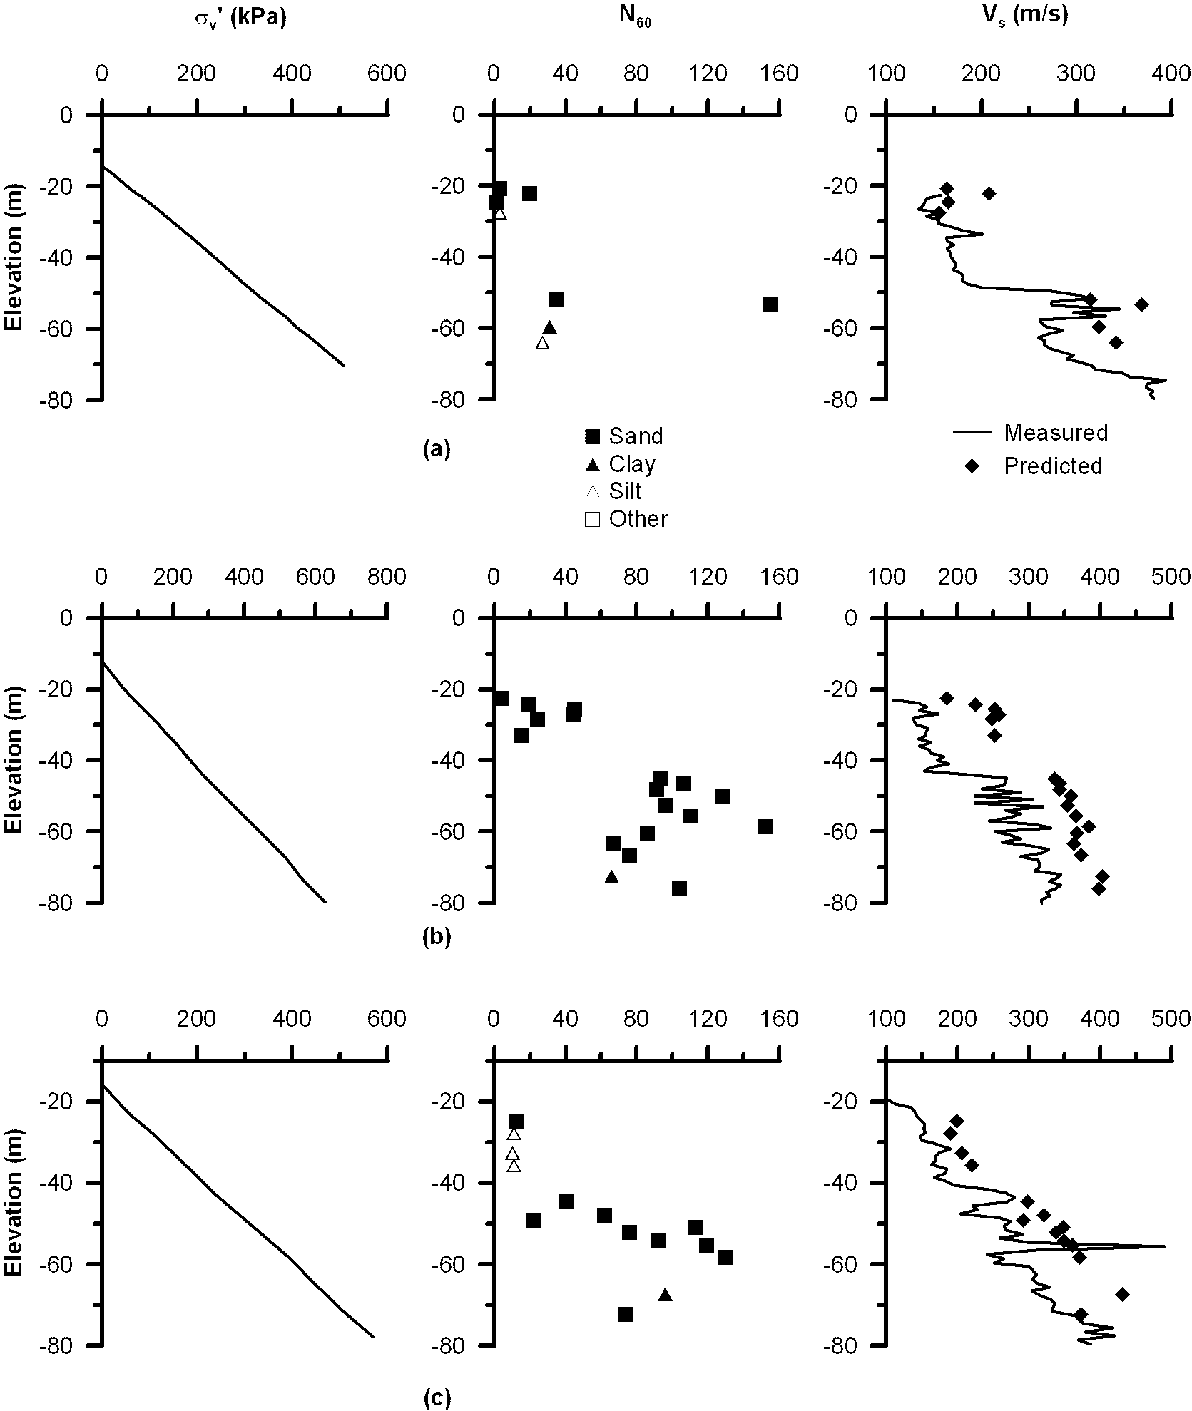
Figure 18. (a) Bridge no. 28-0100, boring no. 95B5R (Pier 35) (b) Bridge no. 28-0100, boring no. 95B2R (Pier 32/33) (c) Bridge no. 28-0100, boring no. 95B3R/95B9R (Pier 34)
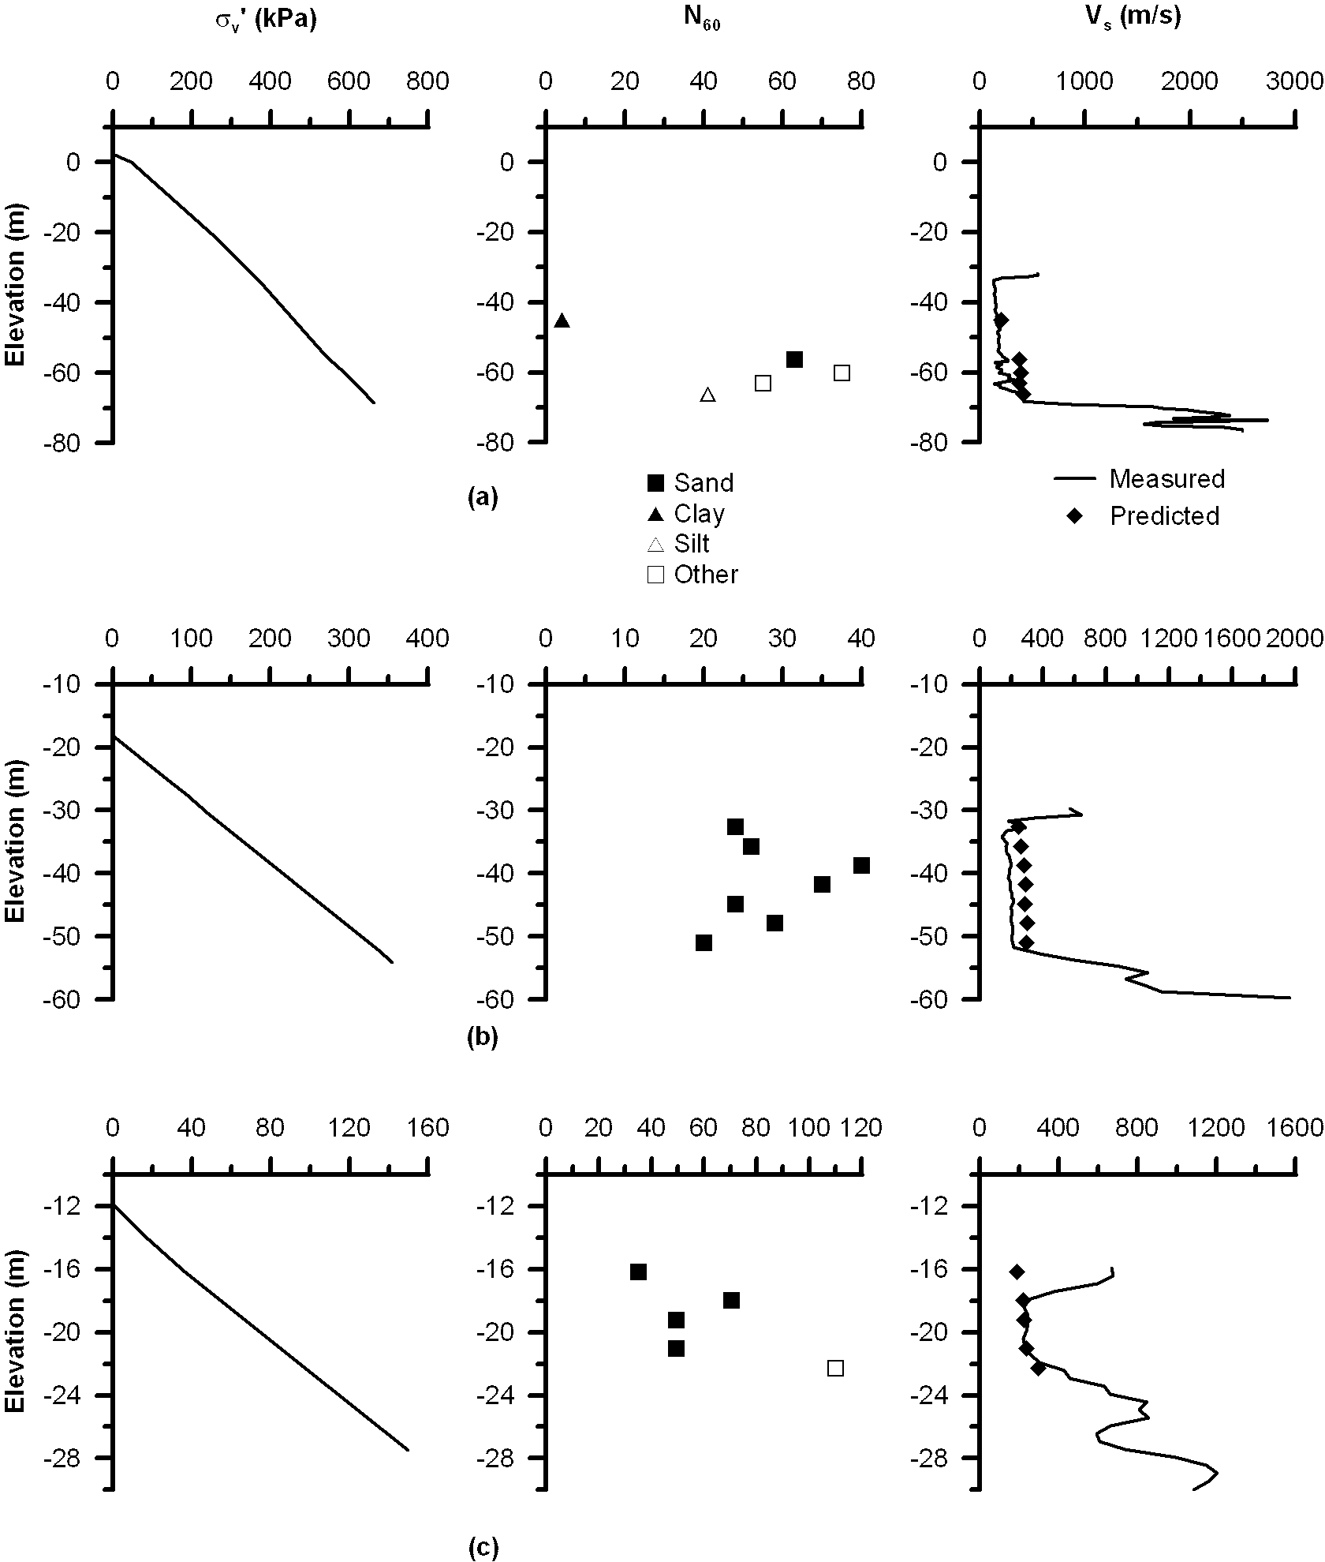
Figure 19. (a) Bridge no. 28-0100, boring no. 95-10 (Pier 47) (b) Bridge no. 28-0100, boring no. 95-11 (Pier 48) (c) Bridge no. 28-0100, boring no. 95B1R (Pier 58)
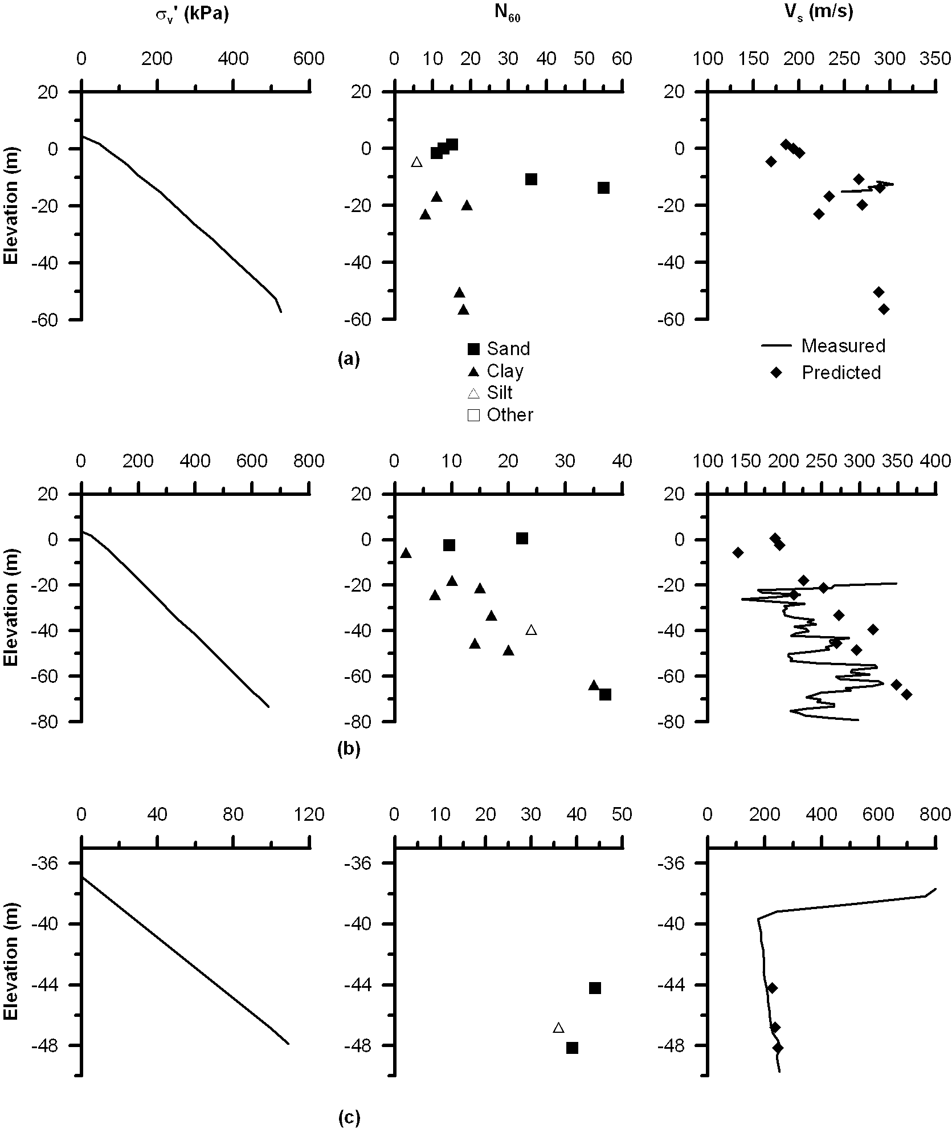
Figure 20. (a) Bridge no. 33-0025, boring no. B6 (Pier E19) (b) Bridge no. 33-0025, boring no. B-7 (Pier E10) (c) Bridge no. 34-0003, boring no. 95-14 (Pier W6)
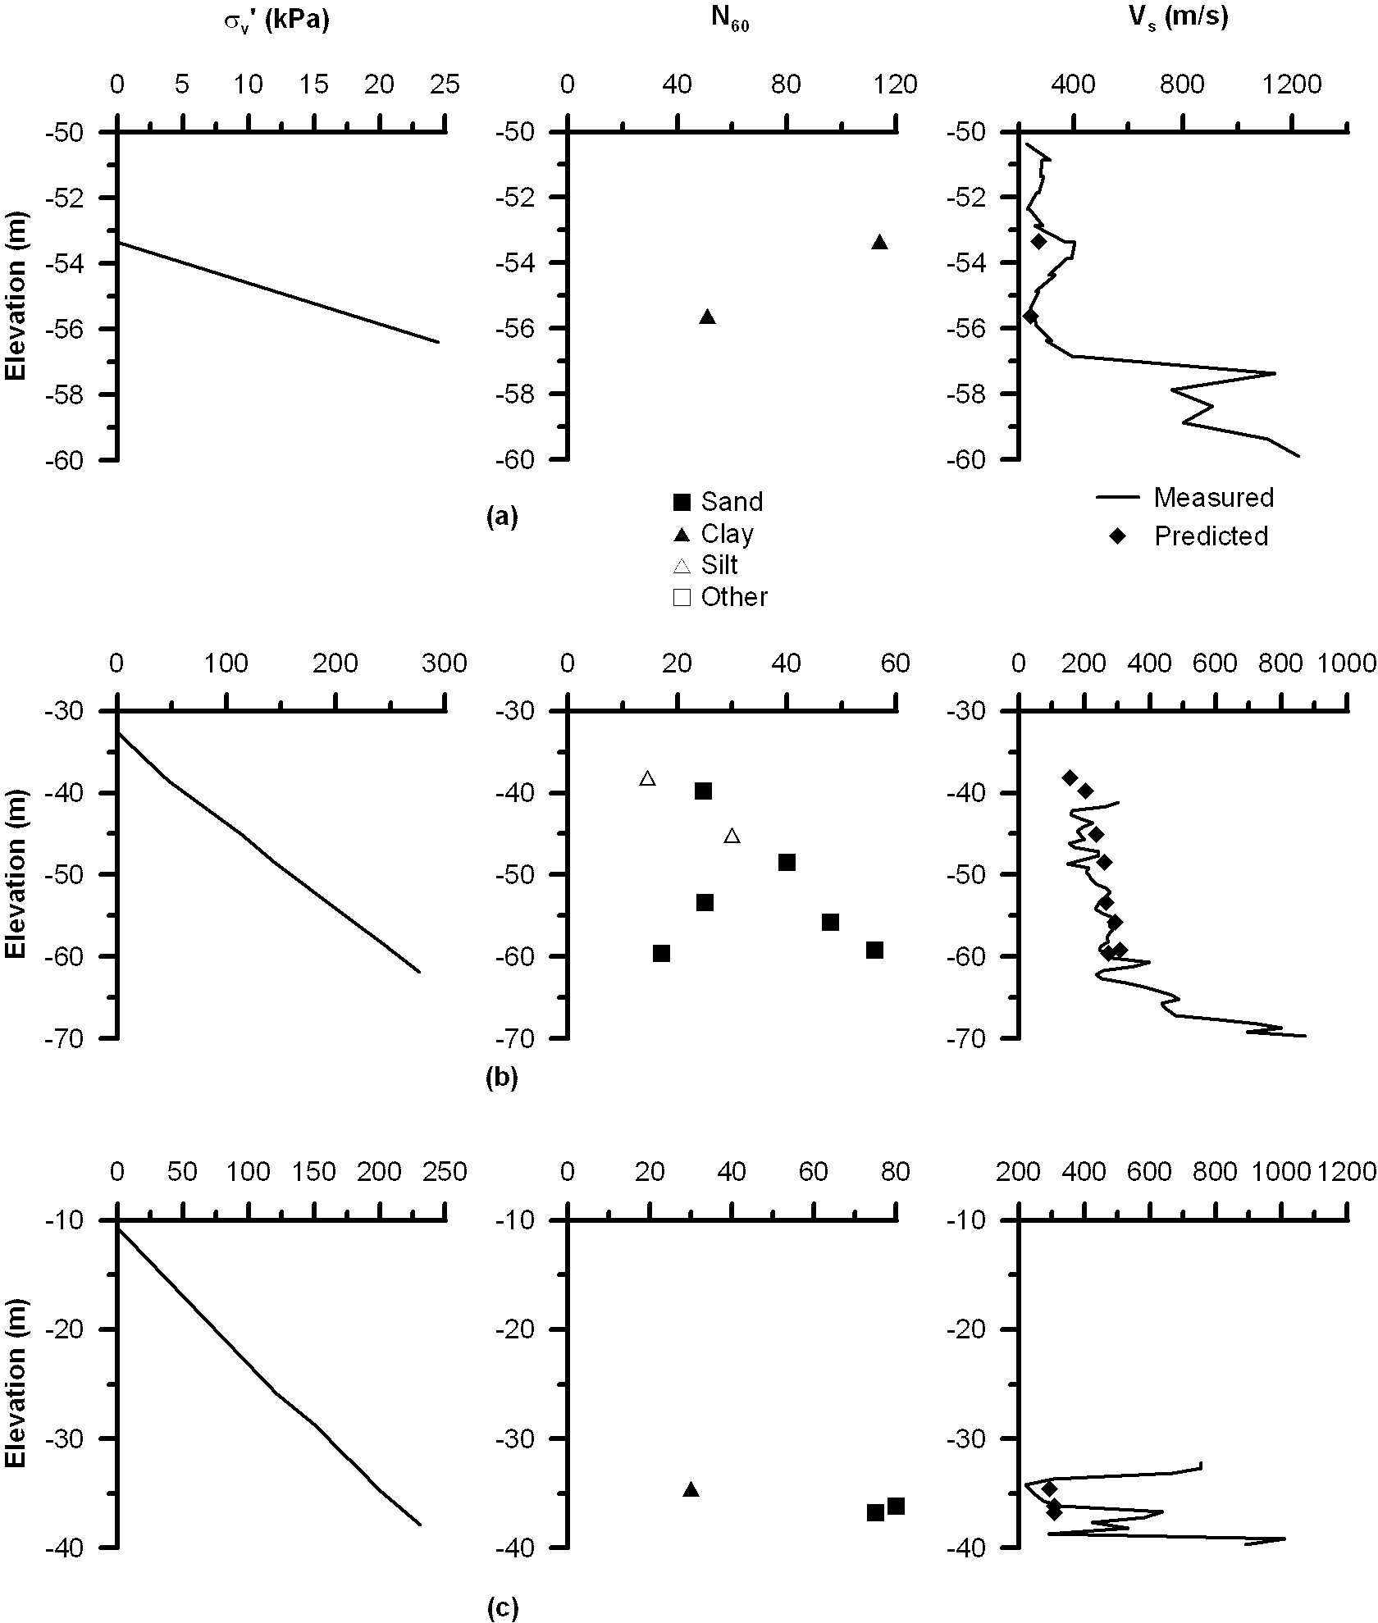
Figure 21. (a) Bridge no. 34-0003, boring no. 95-12 (Pier W4) (b) Bridge no. 34-0003, boring no. 95-11 (Pier W3) (c) Bridge no. 34-0003, boring no. 95-10 (Pier W2)

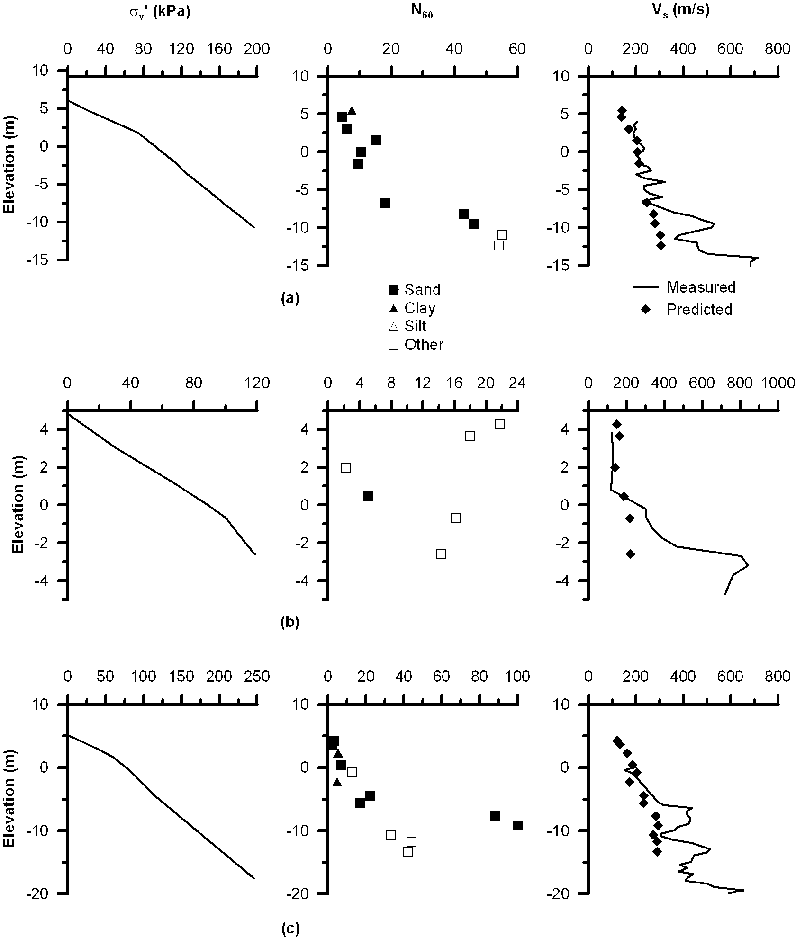
Figure 22. (a) Bridge no. 34-0003, boring no. 95-5 (Pier A) (b) Bridge no. 34-0003, boring no. 95-4 (c) Bridge no. 34-0003, boring no. 95-6
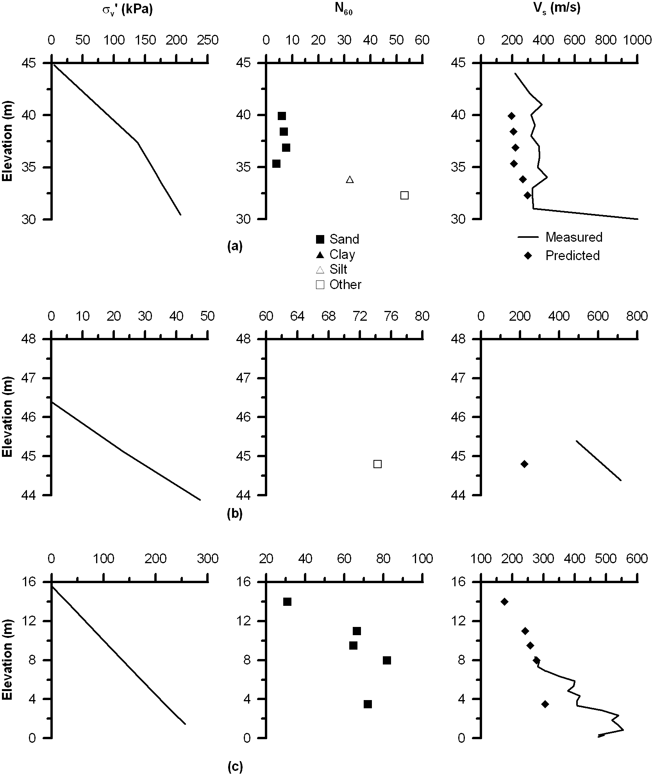
Figure 23. (a) Bridge no. 34-0004, boring no. B95-2 (b) Bridge no. 34-0004, boring no. B95-3 (c) Bridge no. 34-0077, boring no. 01-B2
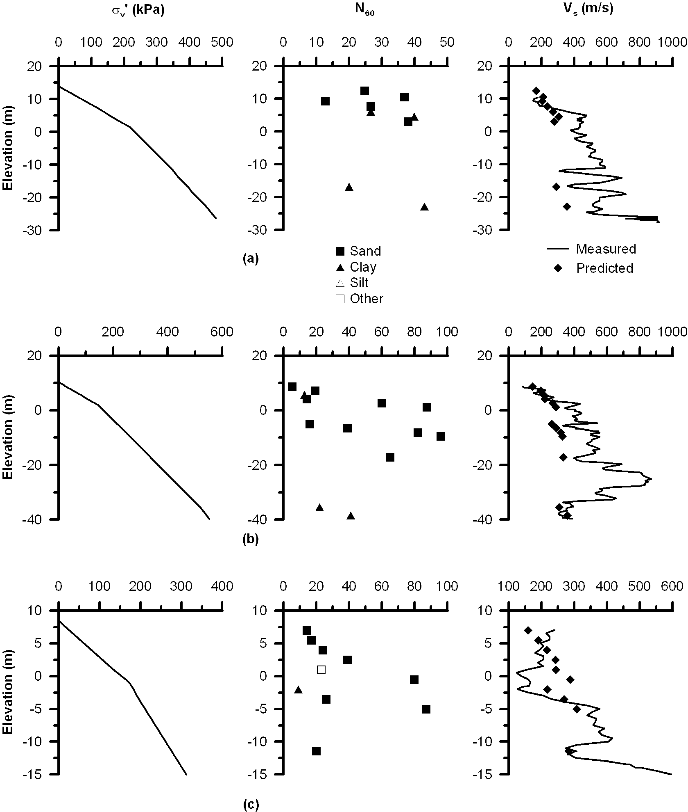
Figure 24. (a) Bridge no. 34-0077, boring no. 01-05 (b) Bridge no. 34-0077, boring no. 01-08 (c) Bridge no. 34-0077, boring no. 01-11
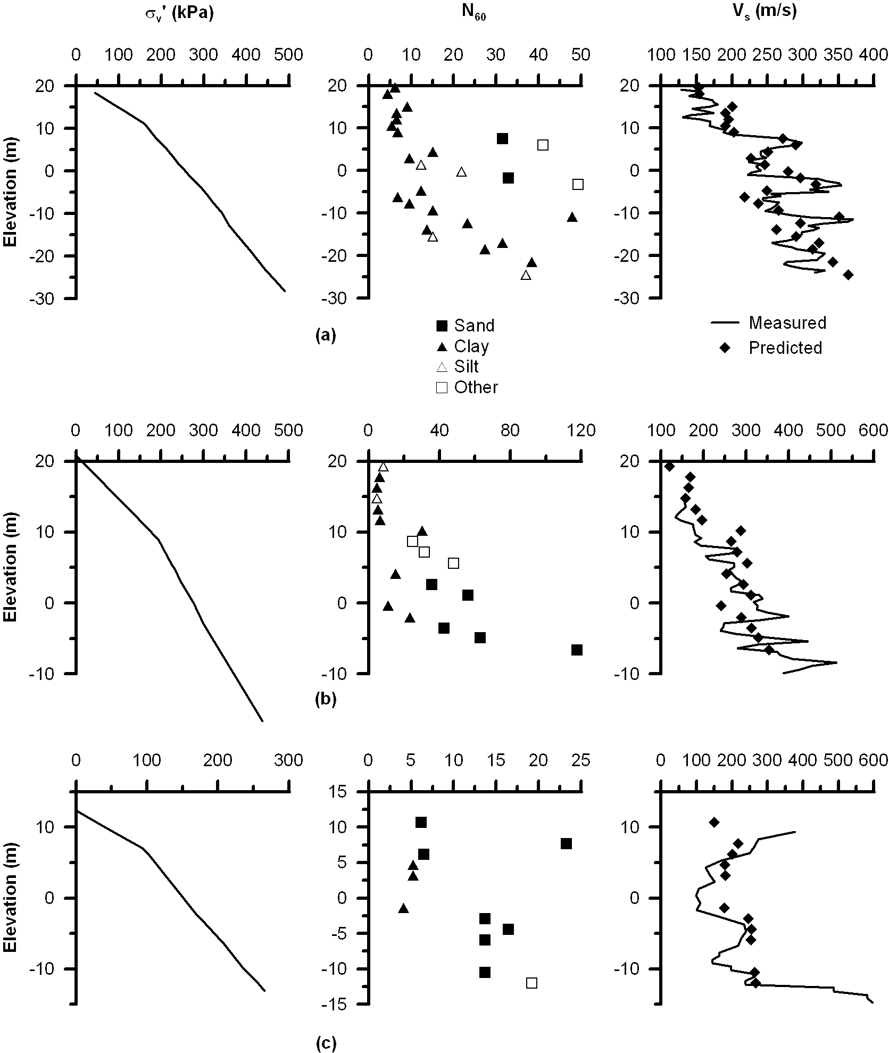
Figure 25. (a) Bridge no. 37-0853, boring no.98-1 (Pier 4) (b) Bridge no. 38-0583, boring no. 98-4 (Bent 7) (c) Bridge no. 49-0014L, boring no.98-1 (Abut 1)
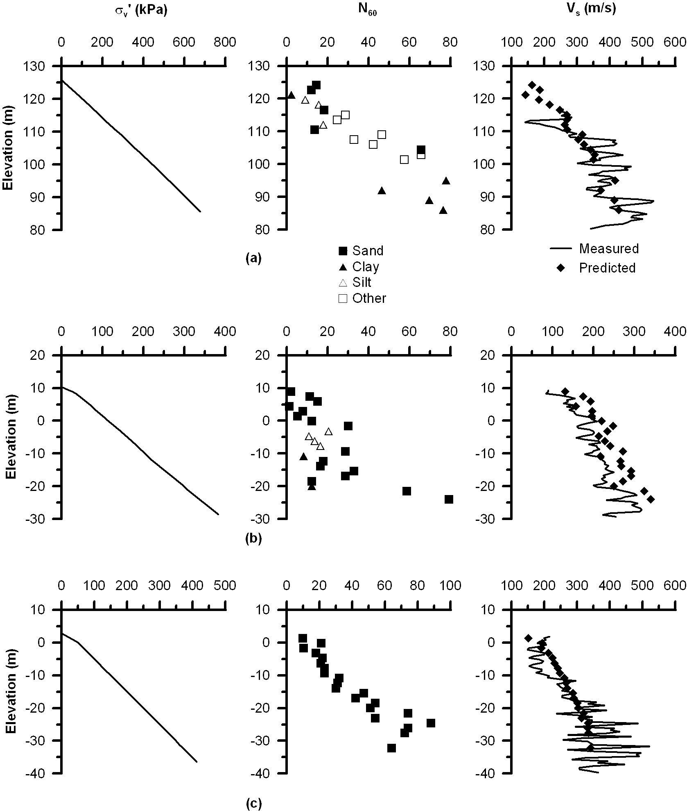
Figure 26. (a) Bridge no. 51-0139, boring no. 98-1 (Abut 1) (b) Bridge no. 52-0443, boring no. 99-1 (c) Bridge no. 53-1471, boring no. 95B5R
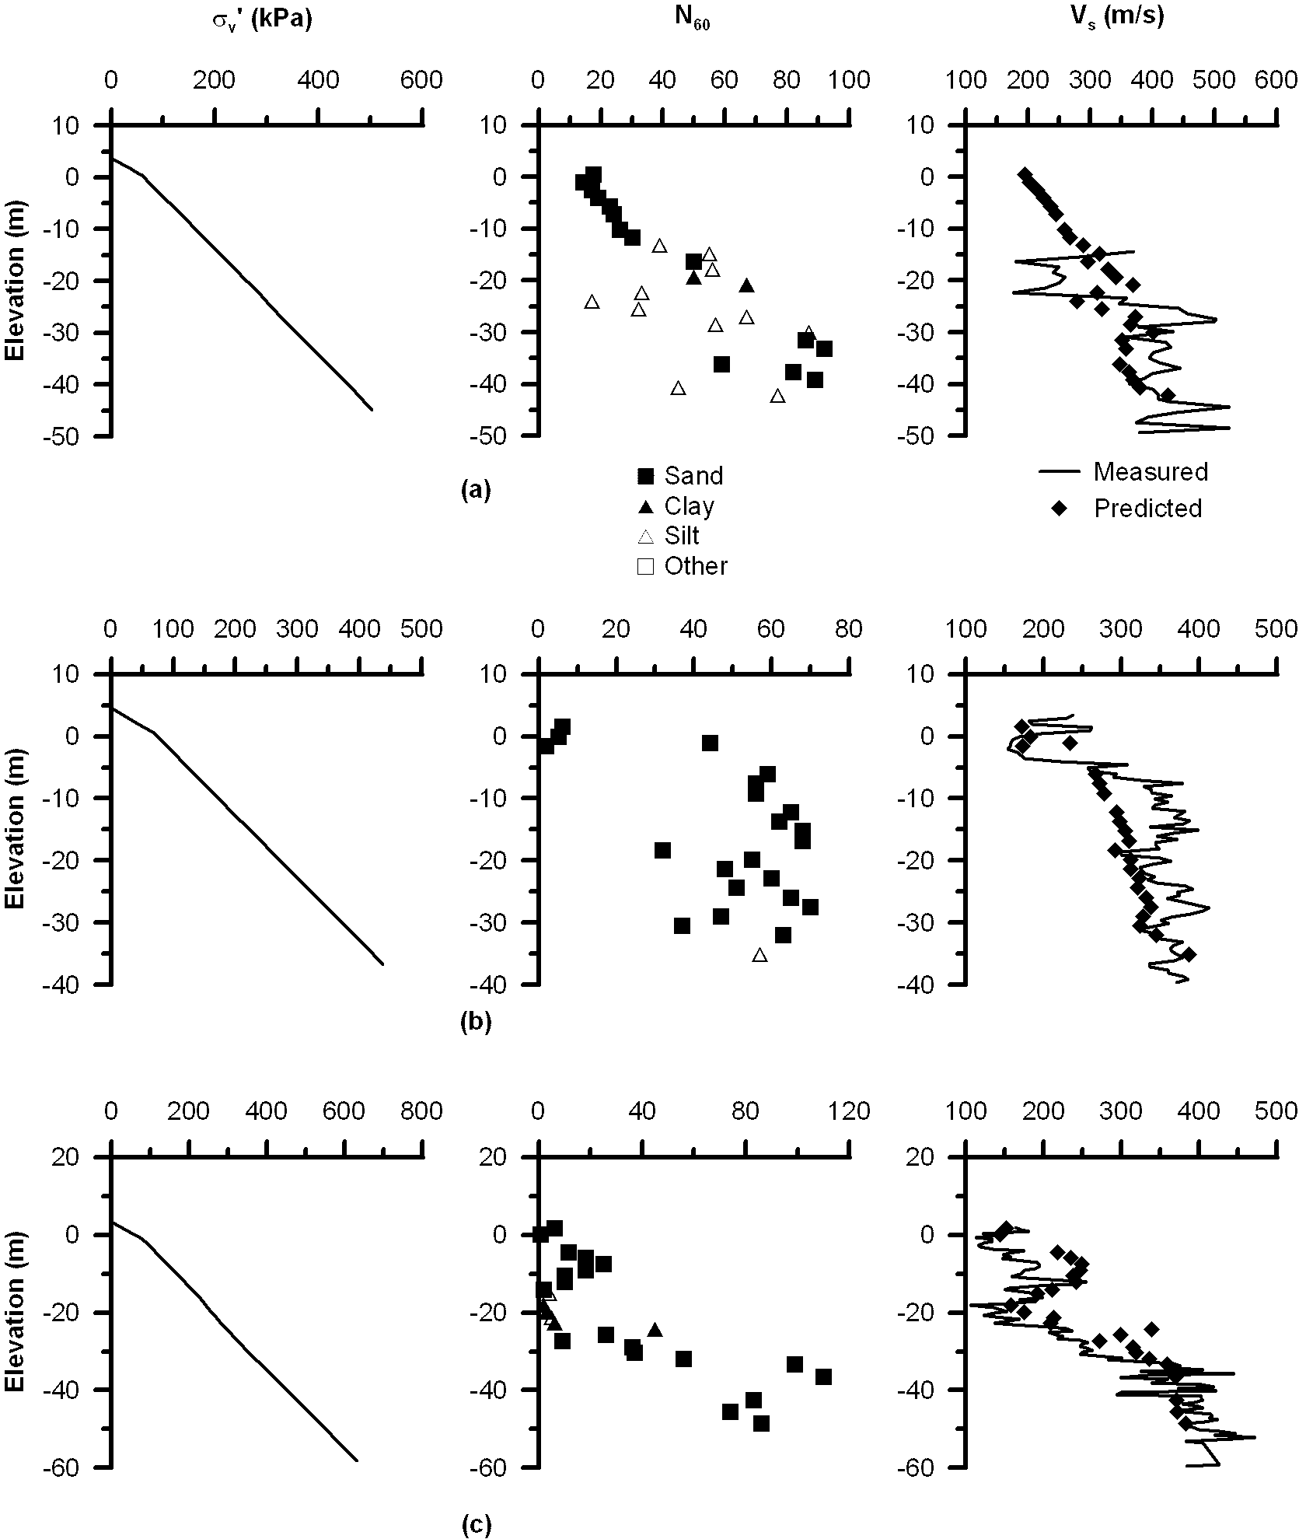
Figure 27. (a) Bridge no. 53-1471, boring no. 95B4R (b) Bridge no. 53-1471, boring no. 95B1R (c) Bridge no. 53-1471, boring no. 95B2R
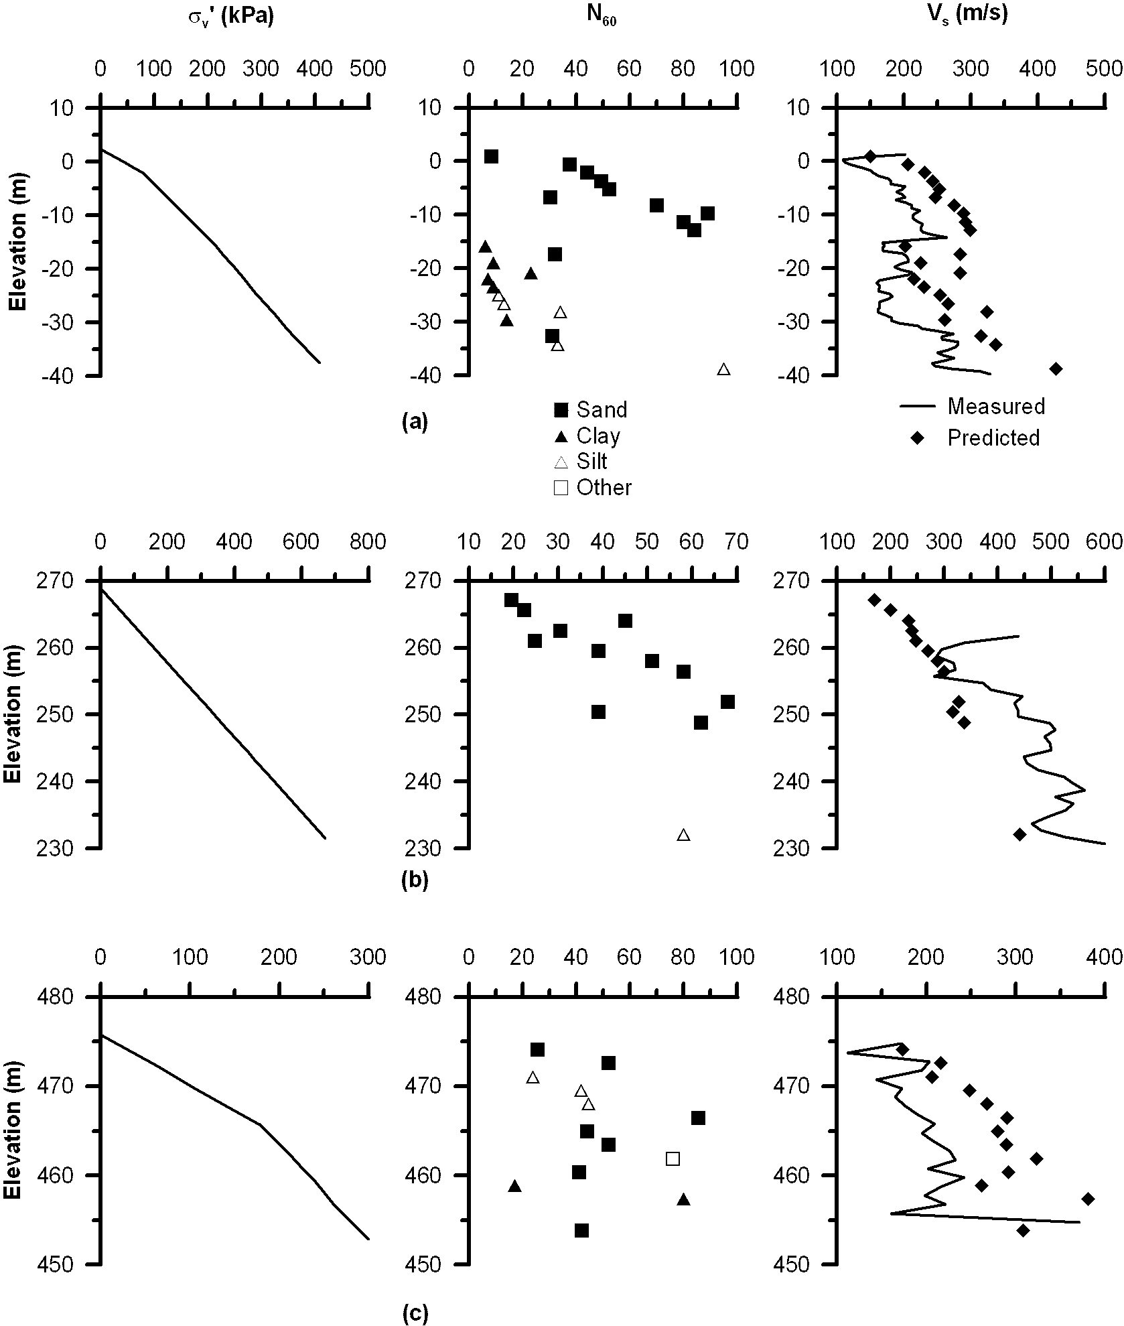
Figure 28. (a) Bridge no. 53-1471, boring no. 95B3R (b) Bridge no. 53-2272, boring no. B-1 (c) Bridge no. 53-2790R, boring no. B-6
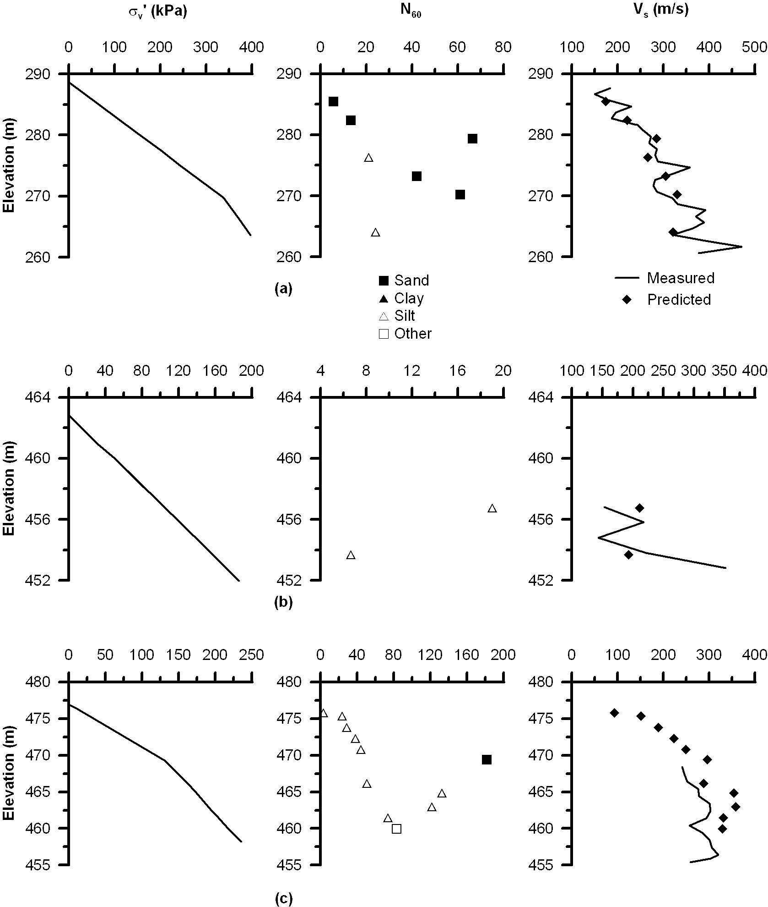
Figure 29. (a) Bridge no. 53-2794R, boring no. B-1 (b) Bridge no. 53-2795F, boring no. 94-21 (c) Bridge no. 53-2796F, boring no. 94-30

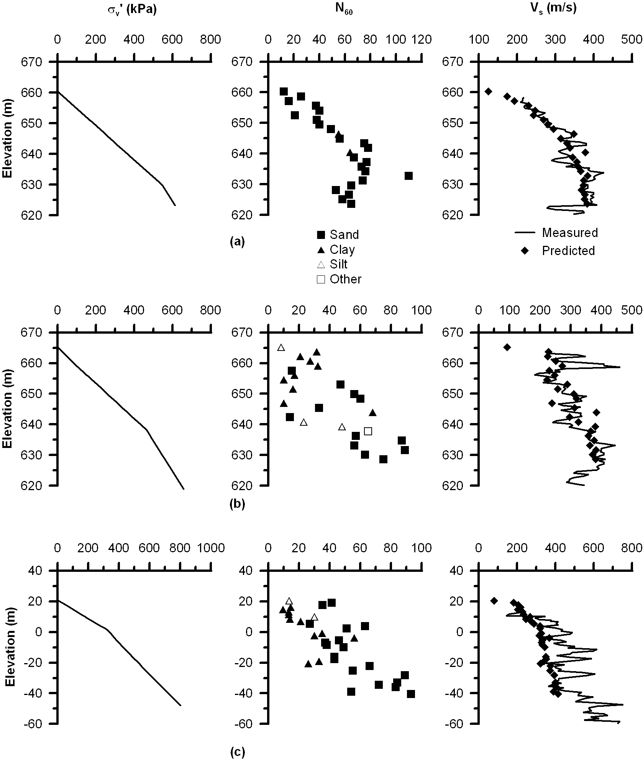
Figure 30. (a) Bridge no. 54-1110R, boring no. 98-1 (Abut 1) (b) Bridge no. 54-1110R, boring no. 98-6 (Abut 8) (c) Bridge no. 57-0857, boring no. 96-52 (Bents R48 and 49)
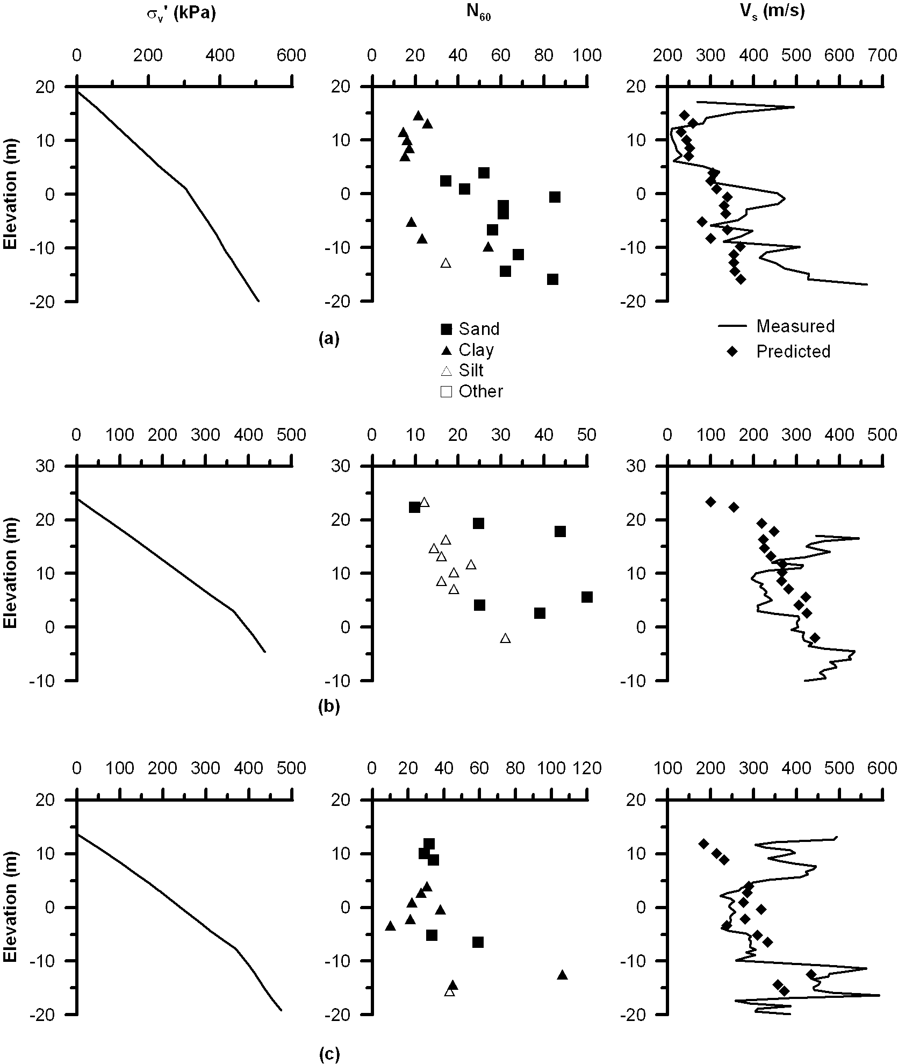
Figure 31. (a) Bridge no. 57-0857, boring no. 96-17 (Abut S48) (b) Bridge no. 57-0857, boring no. 95-2 (Pier 33) (c) Bridge no. 57-0857, boring no. 96-16 (Bent 41F,R)
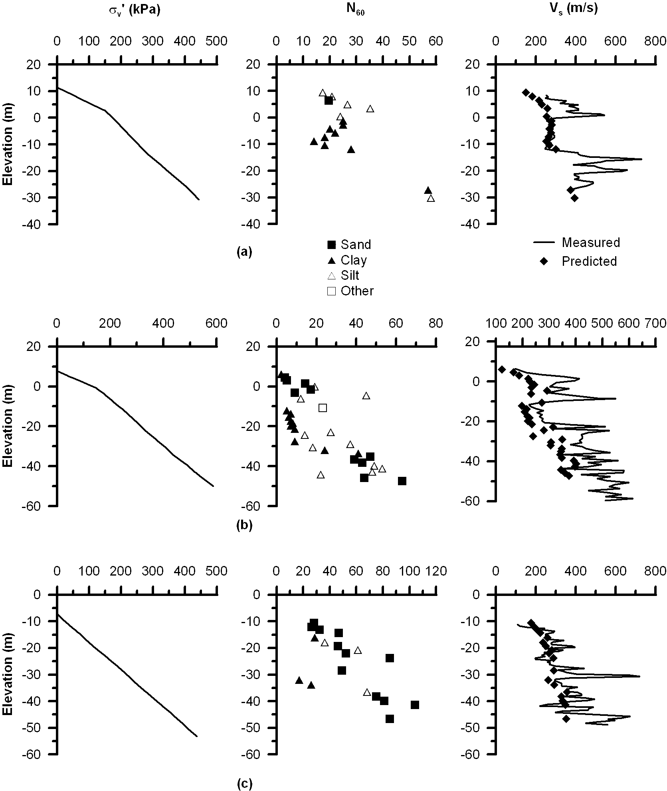
Figure 32. (a) Bridge no. 57-0857, boring no. 96-29 (b) Bridge no. 57-0857, boring no. 96-53R (c) Bridge no. 57-0857, boring no. 96-66
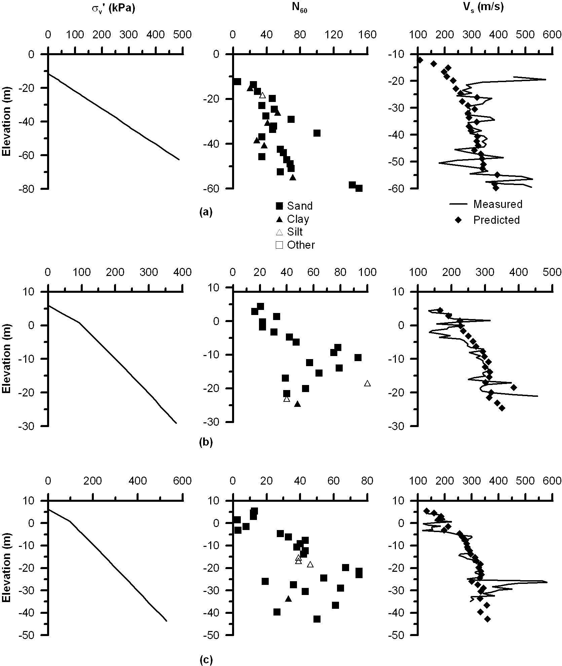
Figure 33. (a) Bridge no. 57-0857, boring no. 96-65 (b) Bridge no. 57-0857, boring no. 96-35 (Toll Plaza North West) (c) Bridge no. 57-0857, boring no. 96-34 (Toll Plaza South East)
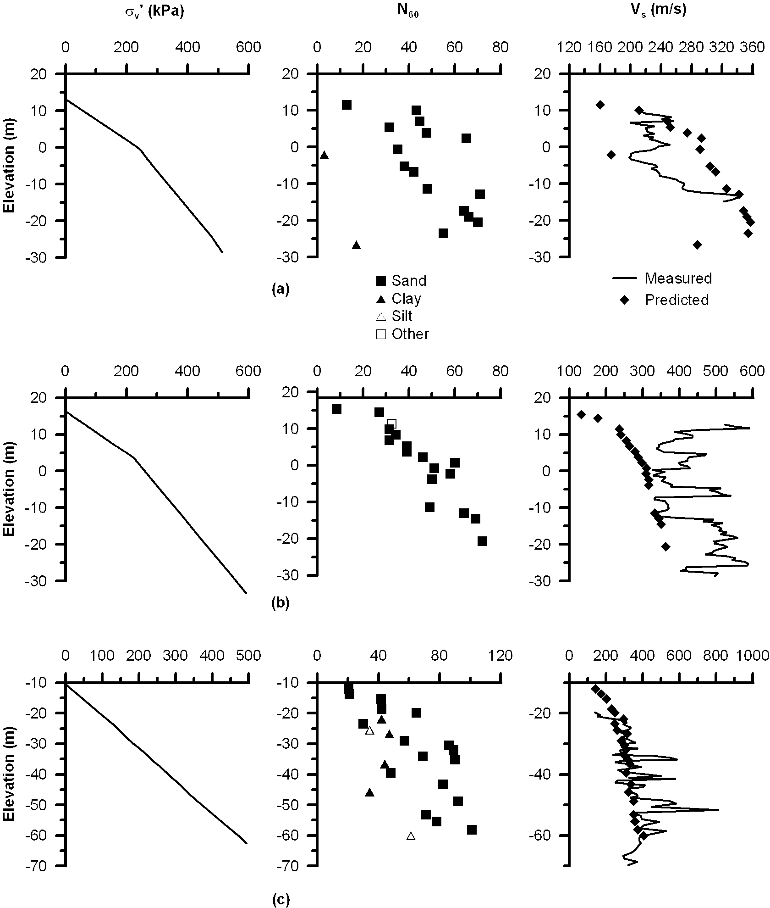
Figure 34. (a) Bridge no. 57-0857, boring no. 96-21 (b) Bridge no. 57-0857, boring no. 96-28 (c) Bridge no. 57-0857, boring no. 96-60
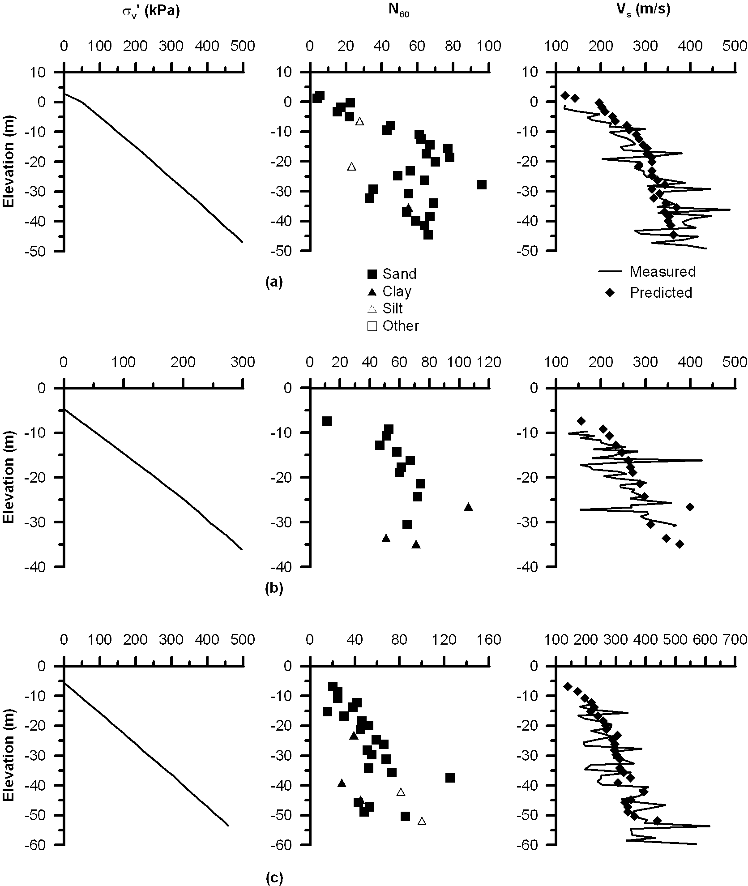
Figure 35. (a) Bridge no. 57-0857, boring no. 96-68R (b) Bridge no. 57-0857, boring no. 96-56 (c) Bridge no. 57-0857, boring no. 96-67
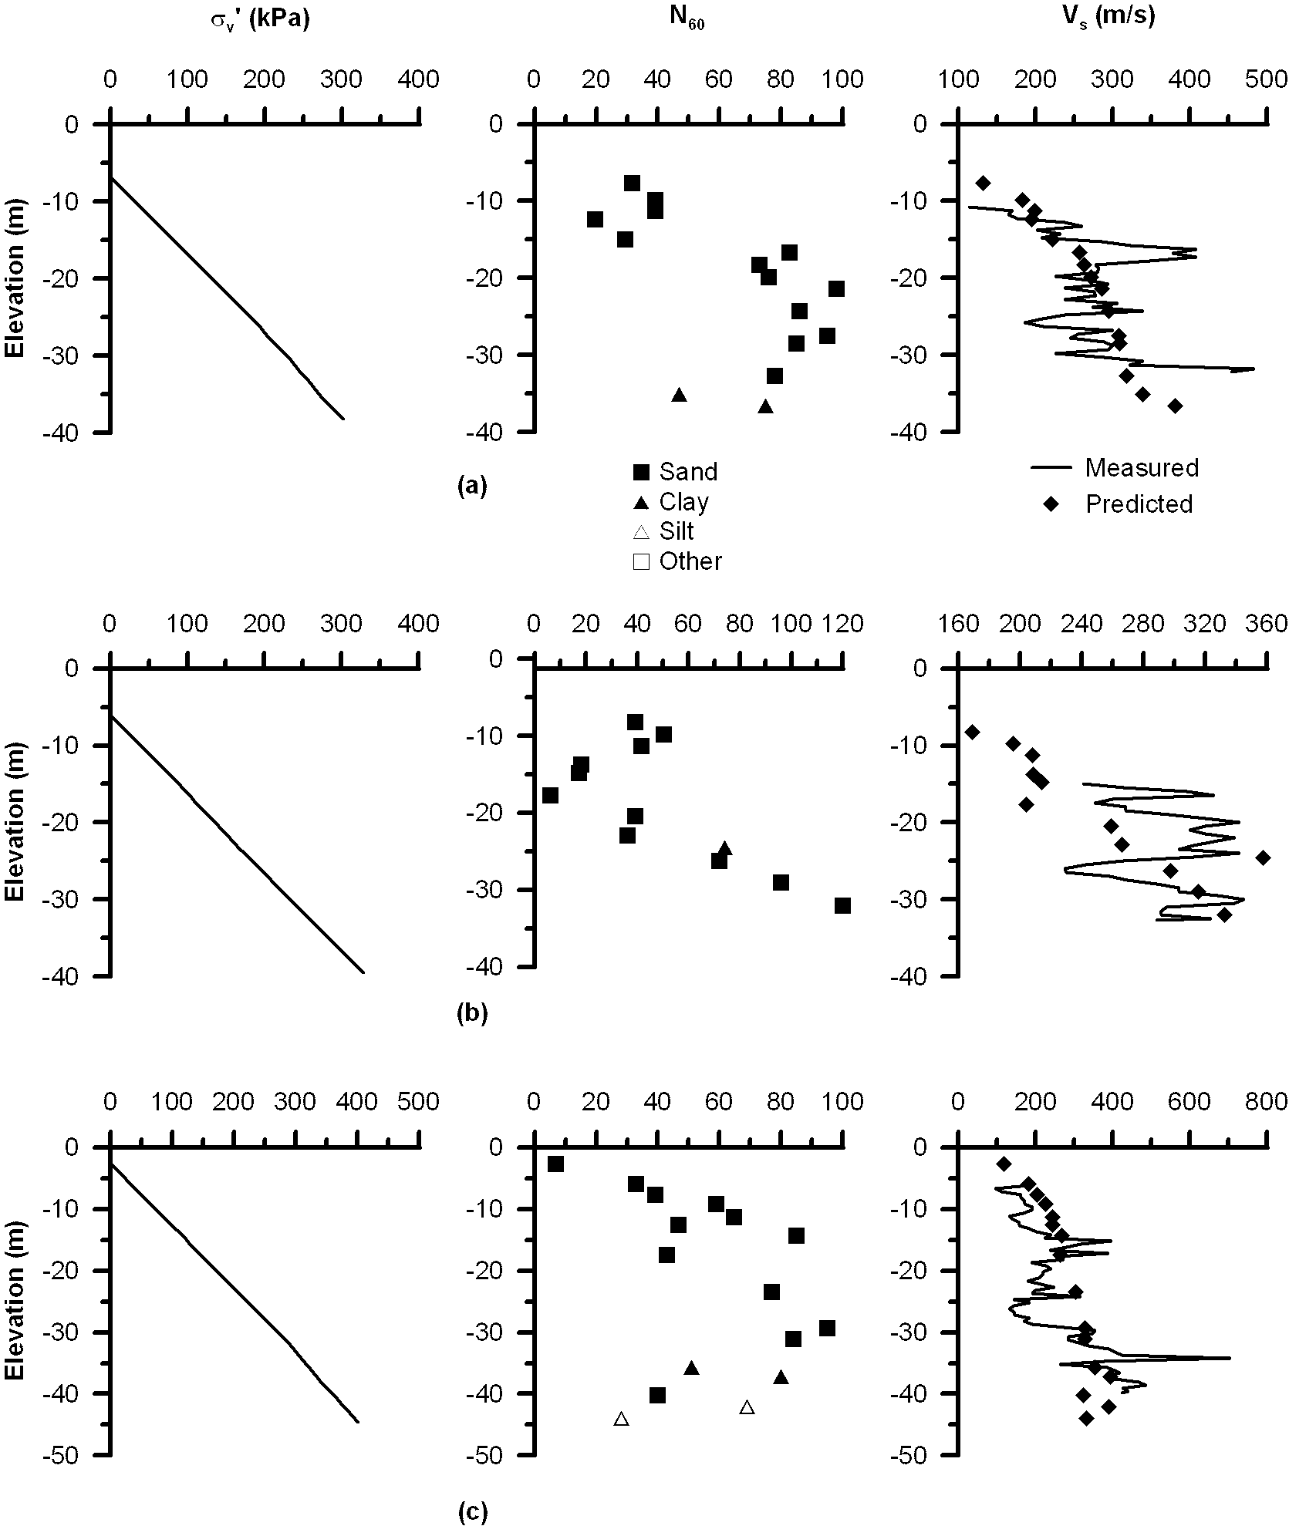
Figure 36. (a) Bridge no. 57-0857, boring no. 96-54 (b) Bridge no. 57-0857, boring no. 96-55 (c) Bridge no. 57-0857, boring no. 96-59
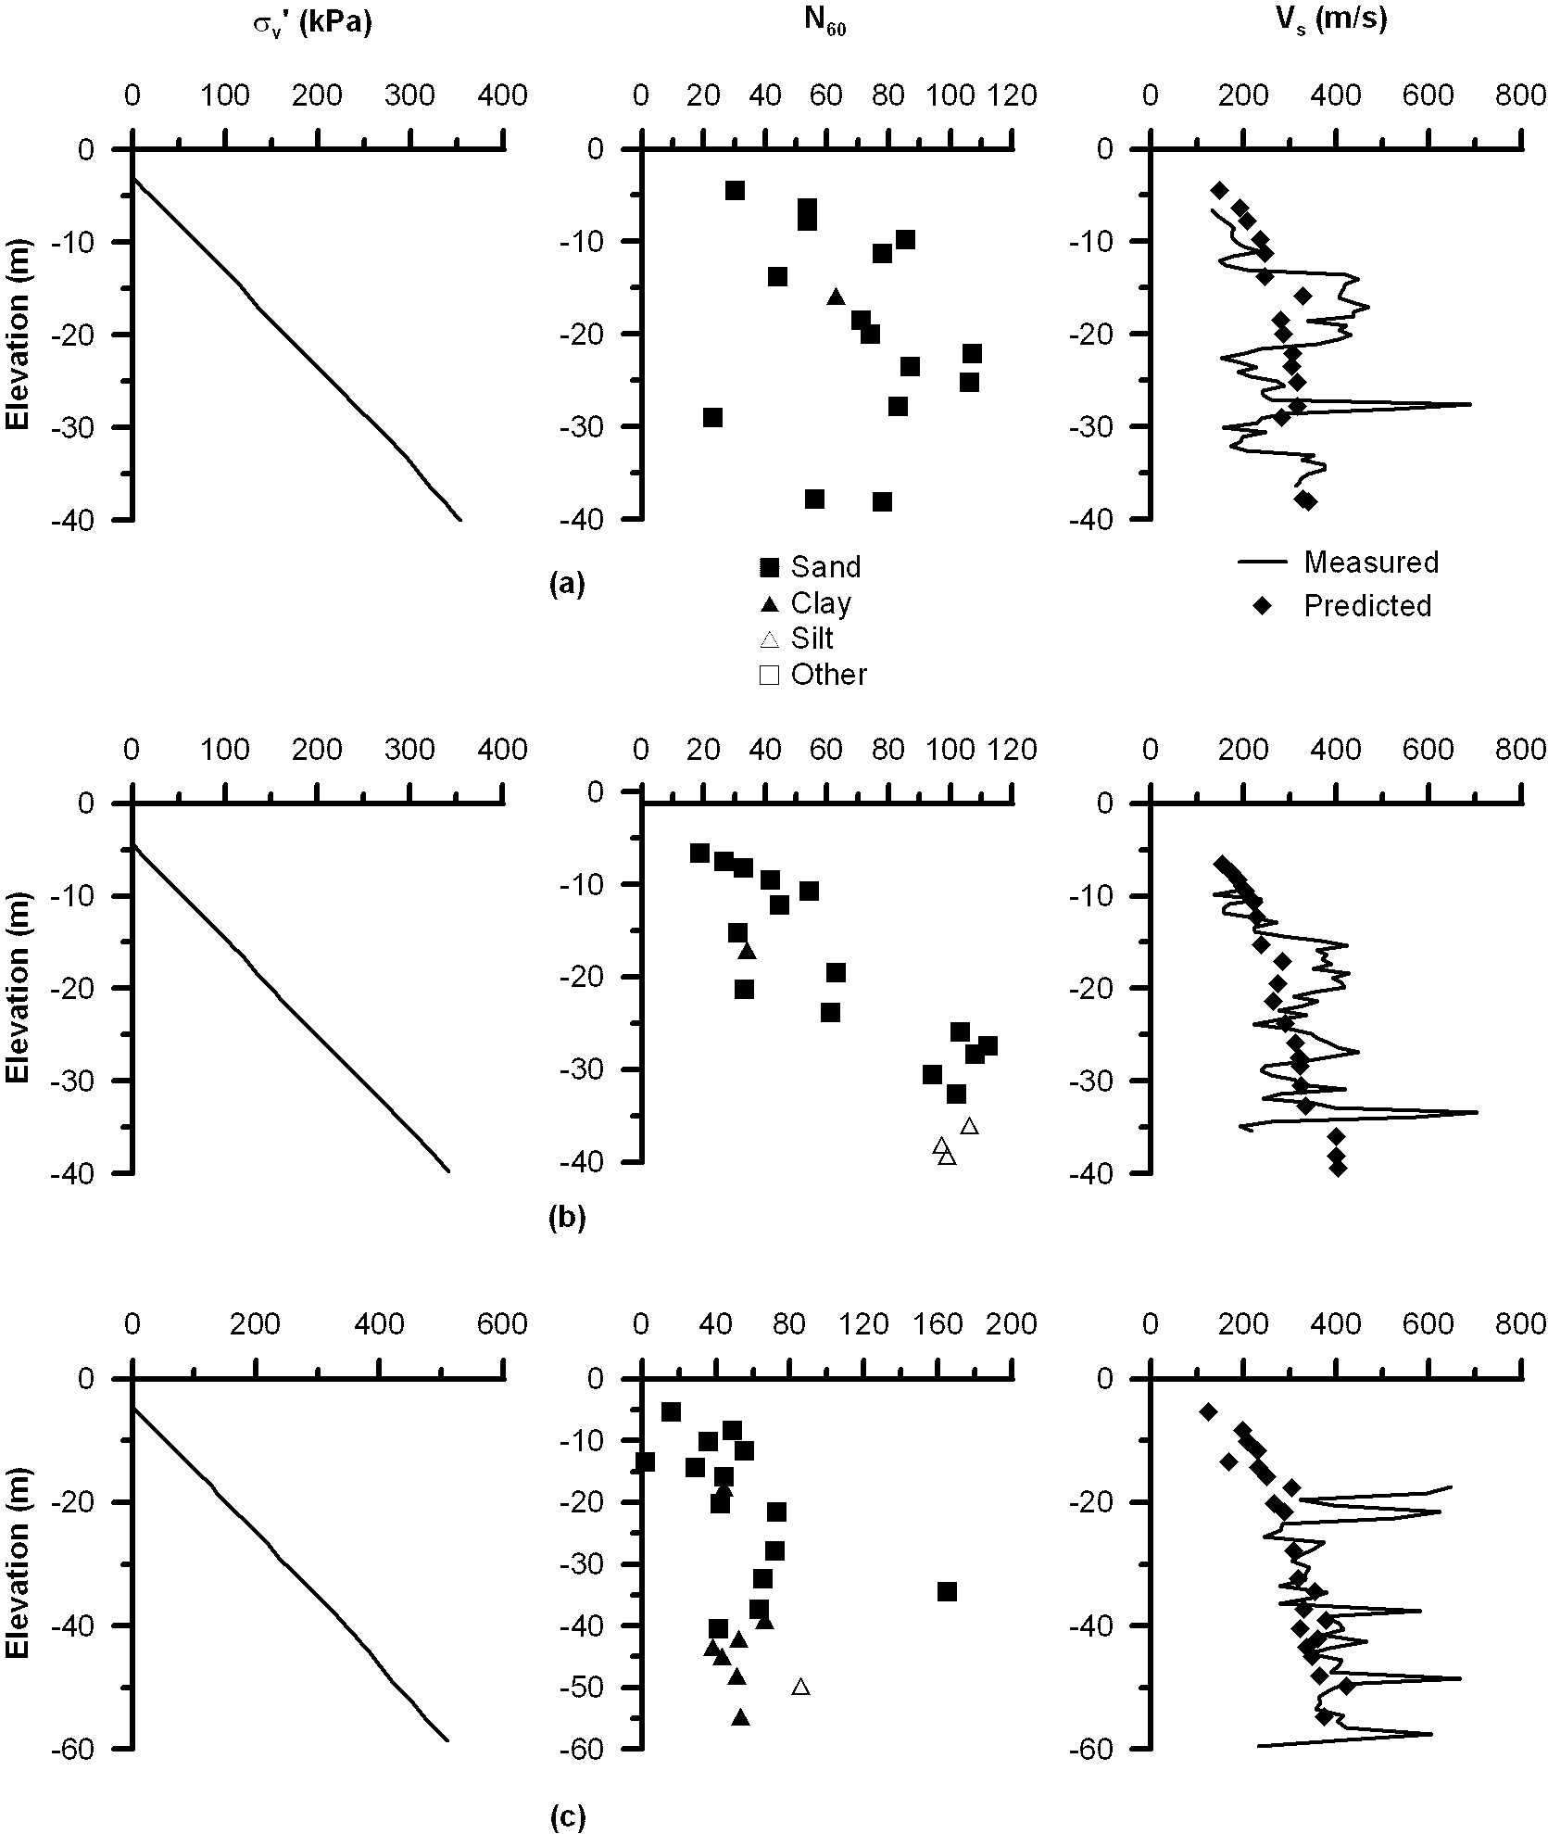
Figure 37. (a) Bridge no. 57-0857, boring no. 96-58 (b) Bridge no. 57-0857, boring no. 96-57 (c) Bridge no. 57-0857, boring no. 96-64

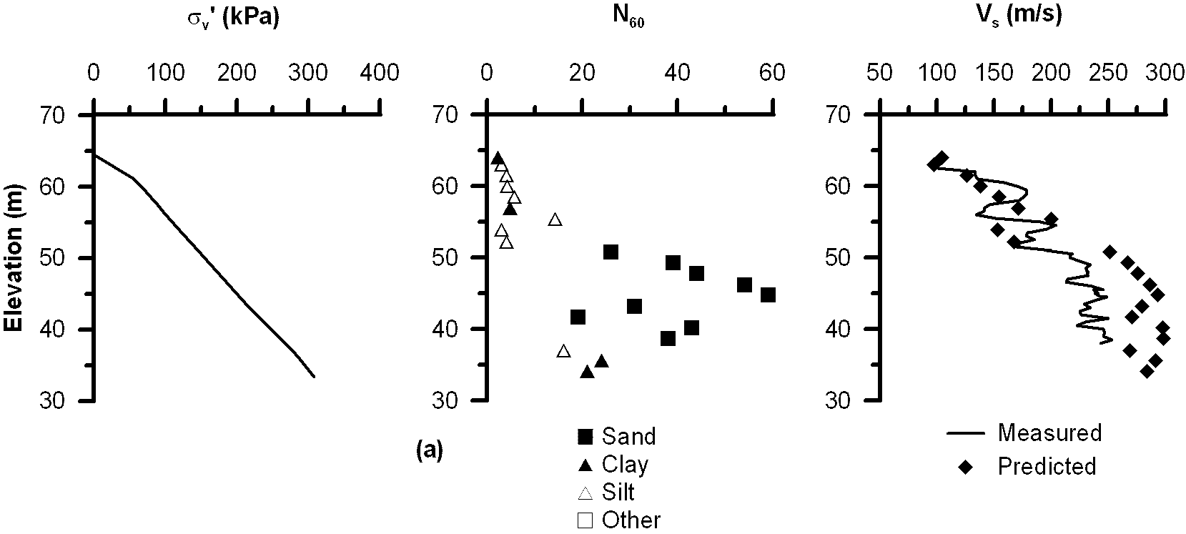

Figure 38. (a) Bridge no. 58-0335RL, boring no. B5-01

References

Andrus, R. D., Piratheepan, P., Ellis, B.S., Zhang, J., and Juang, C. H. (2004). “Comparing Liquefaction Evaluation Methods using Penetration-Vs relationships”, Soil Dynamics and Earthquake Engineering, 24, 713-721.
Athanasopoulos, G. A. (1995). “Empirical correlations Vs-NSPT for soils of Greece: a comparative study of reliability,” Proc. 7th Int. Conf. on Soil Dynamics and Earthquake Engineering (Chania, Crete) ed A S Cakmak (Southampton: Computational Mechanics), 19–36.
Barrow, B. L. and Stokoe, K. E. II (1983). “Field investigation of liquefaction sites in Northern California,” Geotechnical Engineering Thesis, GT 83-1, Civil Engineering Department, University of Texas at Austin, 12.
Boore, D. M., and Atkinson, G. M. (2008). “Ground-motion prediction equations for the average horizontal component of PGA, PGV, and 5%-damped PSA at spectral periods between 0.01 s and 10.0 s,” Earthquake Spectra, 24, 99–138.
Campbell, K.W. and Duke, C.M. (1976). “Correlations among seismic velocity, depth and geology in the Los Angeles area,” Report ENG-7662, University of California at Los Angeles School of Engineering and Applied Science.
Campbell, K. W., and Bozorgnia, Y. (2008). “Campbell-Bozorgnia NGA horizontal ground motion model for PGA, PGV, PGD and 5% damped linear elastic response spectra,” Earthquake Spectra, 24, 139–171.
Chiou, B., and Youngs, R. R. (2008). “An NGA model for the average horizontal component of peak ground motion and response spectra,” Earthquake Spectra, 24, 173–215.
Choi, Y. and Stewart, J.P. (2005). “Nonlinear site amplification as function of 30 m shear wave velocity,” Earthquake Spectra, 21 (1), 1-30.
Dejong, J. T., Fritzges, M. B., and Nusslein, K. (2006). “Microbially Induced Cementaion to Control Sand Response to Undrained Shear”, Journal of Geotechnical and Geoenvironmental Engineering, Vol. 132, No.11, 1381-1392.
Dikmen, U. (2009). “Statistical correlations of shear wave velocity and penetration resistance for soils,” Journal of Geophysics and Engineering, 6, 61-72.
Fujiwara, T. (1972). “Estimation of ground movements in actual destructive earthquakes,” Proc. 4th European Symp. Earthquake Engineering (London), 125–32.
Hasancebi, N. and Ulusay, R. (2006). “Empirical correlations between shear wave velocity and penetration resistance for ground shaking assessments,” Bull Eng Geol Environ, 66, 203-213.
Hayati, H., and Andrus, R. D. (2009). “Updated Liquefaction Resistance Correction Factors for Aged Sands”, Journal of Geotechnical and Geoenvironmental Engineering, Vol. 135, No.11, 1683-1692.
Imai, T. (1977). “P-and S-wave velocities of the ground in Japan,” Proc.9th Int. Conf. on Soil Mechanics and Foundation Engineering, vol 2, 127–32.
Imai, T. and Tonouchi, K. (1982). “Correlation of N-value with S-wave velocity and shear modulus,” Proc. 2nd European Symp. Of Penetration Testing (Amsterdam), 57–72.
Imai, T. and Yoshimura, Y. (1975). “The relation of mechanical properties of soils to P and S-wave velocities for ground in Japan,” Technical Note, OYO Corporation.
Iyisan, R. (1996). “Correlations between shear wave velocity and in-situ penetration test results,” Tech. J. Chamber Civil Eng. Turkey, 7, 1187–99 (in Turkish).
Jafari, M. K., Shafiee, A. and Ramzkhah, A. (2002). “Dynamic properties of the fine grained soils in south of Tehran,” J. Seismol. Earthq. Eng., 4, 25–35.
Jafari, M. K., Asghari, A. and Rahmani, I. (1997). “Empirical correlation between shear wave velocity (Vs) and SPT-N value for south of Tehran soils,” Proc. 4th Int. Conf. on Civil Engineering (Tehran, Iran) (in Persian).
Jinan, Z. (1987). “Correlation between seismic wave velocity and the number of blow of SPT and depth,” Chin. J. Geotech. Eng. (ASCE), 92–100 (selected papers).
Kanai, K. (1966). “Conf. on Cone Penetrometer The Ministry of Public Works and Settlement (Ankara, Turkey),” (presented by Y Sakai 1968).
Kiku, H., Yoshida, N., Yasuda, S., Irisawa, T., Nakazawa, H., Shimizu, Y., Ansal, A. and Erkan, A. (2001). “In-situ penetration tests and soil profiling in Adapazari, Turkey,” Proc. ICSMGE/TC4 Satellite Conf. on Lessons Learned from Recent Strong Earthquakes, 259–65.
Lee, S. H. (1990). “Regression models of shear wave velocities,” J. Chin. Inst. Eng., 13, 519–32.
Ohba, S. and Toriuma, I. (1970). “Dynamic response characteristics of Osaka Plain,” Proc. Ann. Meeting AIJ (in Japanese).
Ohsaki, Y. and Iwasaki, R. (1973). “On dynamic shear moduli and Poisson’s ratio of soil deposits,” Soil Found., 13, 61–73.
Ohta, Y. and Goto, N. (1978). “Empirical shear wave velocity equations in terms of characteristic soil indexes,” Earthq. Eng. Struct. Dyn., 6, 167–87.
Ohta, T., Hara, A., Niwa, M. and Sakano, T. (1972). “Elastic shear moduli as estimated from N-value,” Proc. 7th Ann. Convention of Japan Society of Soil Mechanics and Foundation Engineering, 265–8.
Okamoto, T., Kokusho, T., Yoshida, Y. and Kusuonoki, K. (1989). “Comparison of surface versus subsurface wave source for P–S logging in sand layer,” Proc. 44th Ann. Conf. JSCE, vol 3, 996–7 (in Japanese).
Owen, W. (1996), “Interim Report of PS Velocity for Borelog 96-2, SFOBB East Viaduct Seismic Retrofit,” Memorandum, State of California.
Pitilakis, K., Raptakis, D., Lontzetidis, K. T., Vassilikou, T. and Jongmans, D. (1999). “Geotechnical and geophysical description of Euro-Seistests, using field and laboratory tests, and moderate strong ground motions,” J. Earthq. Eng., 3, 381–409.
Seed, H. B. and Idriss, I. M. (1970). “Soil Moduli and Damping Factors for Dynamic Response Analyses,” Earthquake Engineering Research Center, University of California, Berkeley, California, Rep. No. EERC-70/10.
Seed, H. B. and Idriss, I. M. (1981). “Evaluation of liquefaction potential sand deposits based on observation of performance in previous earthquakes,” ASCE National Convention (MO), 81–544.
Shibata, T. (1970). “Analysis of liquefaction of saturated sand during cyclic loading,” Disaster Prevention Res. Inst. Bull., 13, 563–70.
Sisman, H. (1995). “The relation between seismic wave velocities and SPT, pressuremeter tests,” MSc Thesis, Ankara University (in Turkish).
Sykora, D. E. and Stokoe, K. H. (1983). “Correlations of in-situ measurements in sands of shear wave velocity,” Soil Dyn. Earthq. Eng., 20, 125–36.
Sykora, D. W. and Koester, P. J. (1988). “Correlations between dynamic shear resistance and standard penetration resistance in soils,” Earthq. Eng. Soil Dyn., 2, 389–404.
Tamura, I. and Yamazaki, F. (2002). “Estimation of S-wave velocity based on geological survey data for K-NET and Yokohama seismometer network,” J. Struct. Mech. Earthq. Eng., I, 237–48 (in Japanese).
Ulugergerli, U. E. and Uyanik, O. (2007). “Statistical correlations between seismic wave velocities and SPT blow counts and the relative density of soils,” J. Test. Eval., 35, 1–5.
Vucetic, M. and Dobry, R. (1991). "Effect of Soil Plasticity on Cyclic Response," ASCE Journal of Geotechnical Engineering, Vol. 117, No. 1, 89-107.
Yamada, S., Hyodo, M., Orense, R. P., and Dinesh, S. V. (2008). “Initial Shear Modulus of Remolded Sand-Clay Mixtures”, Journal of Geotechnical and Geoenvironmental Engineering, Vol. 134, No.7, 960-971.
Youd, T.L., Idriss, I.M., Andrus, R.D., Arango, I., Castro, G., Christian, J.T., Dobry, R., Finn, W.D.L., Harder Jr., L.F., Hynes, M.E., Ishihara, K., Koester, J.P., Liao, S.S.C., Marcuson III, W.F., Martin, G.R., Mitchell, J.K., Moriwaki, Y., Power, M.S., Robertson, P.K., Seed, R.B., and Stokoe II, K.H. (2001). “Liquefaction Resistance of Soils: Summary Report from the 1996 NCEER and 1998 NCEER/NSF Workshops on Evaluation of Liquefaction Resistance of Soils.” J. Geotech. Geoenvrion. Eng. 127(10), 817-833.

